|  |  |
| --- | --- |
| **Logo_FPT_University_doc** | **MINISTRY OF EDUCATION AND TRAINING** |

|  |
| --- |
| **FPT UNIVERSITY** |
| Capstone Project Document |
| E-BARTERING |
|  |
| |  |  | | --- | --- | | **Group 005** | | | **Group Members** | Huỳnh Tấn Lộc – LocHT60207  Mai Đỗ Thành Nhân – NhanMDT60184  Bạch Trần Lê Quân – QuanBTL60172  Trần Hải Sơn – SonTH60059 | | **Supervisor** | Lại Đức Hùng | | **Capstone Project code** |  | |
|  |

Table of Contents

[Table of Contents 2](#_Toc322621794)

[1 Report No.1: Introduction 7](#_Toc322621795)

[2 Report No.2: Software Project Management Plan (SPMP) 7](#_Toc322621796)

[2.1 Problem definition 7](#_Toc322621797)

[2.1.1 Purposes 7](#_Toc322621798)

[2.1.2 Problem Abstract 7](#_Toc322621799)

[2.1.3 The current systems 8](#_Toc322621800)

[2.1.4 The proposed systems 8](#_Toc322621801)

[2.1.5 Boundaries of the systems 8](#_Toc322621802)

[2.1.6 Developing environment 9](#_Toc322621803)

[2.2 Project Organization 9](#_Toc322621804)

[2.2.1 Software Process Model 9](#_Toc322621805)

[2.2.2 Roles and Responsibilities 10](#_Toc322621806)

[2.2.3 Tools and Techniques 11](#_Toc322621807)

[2.3 Project Management Plan 12](#_Toc322621808)

[2.3.1 General tasks 12](#_Toc322621809)

[2.3.2 Task Sheet: Assignments and Timetable 12](#_Toc322621810)

[2.3.3 Meeting Minutes 14](#_Toc322621811)

[2.4 Coding Conventions 14](#_Toc322621812)

[2.4.1 Naming Conventions 14](#_Toc322621813)

[2.4.2 Coding Styles 14](#_Toc322621814)

[2.4.3 Comments 14](#_Toc322621815)

[2.5 References 15](#_Toc322621816)

[3 Report No.3: Software Requirements Specifications (SRS) 15](#_Toc322621817)

[3.1 User Requirement Specification 15](#_Toc322621818)

[3.2 System Requirement Specification 17](#_Toc322621819)

[3.2.1 External Interfaces Requirement 18](#_Toc322621820)

[3.2.2 System Feature 19](#_Toc322621821)

[3.3 Software System Attributes 75](#_Toc322621822)

[3.3.1 Reliability 75](#_Toc322621823)

[3.3.2 Availability 75](#_Toc322621824)

[3.3.3 Security 75](#_Toc322621825)

[3.3.4 Maintainability 76](#_Toc322621826)

[3.3.5 Portability 76](#_Toc322621827)

[3.3.6 Performance 76](#_Toc322621828)

[3.4 Data Structure 77](#_Toc322621829)

[3.5 Other material (if any) 77](#_Toc322621830)

[4 Report No.4: Software Design Description (SDD) 78](#_Toc322621831)

[4.1 Design overview 78](#_Toc322621832)

[4.1.1 Introduction 78](#_Toc322621833)

[4.1.2 Definition, Acronyms and Abbreviation 78](#_Toc322621834)

[4.1.3 Reference 78](#_Toc322621835)

[4.2 System Architecture Design 78](#_Toc322621836)

[4.2.1 Physical 78](#_Toc322621837)

[4.2.2 Logical: 79](#_Toc322621838)

[4.3 Screen flow 80](#_Toc322621839)

[4.4 Class diagram 83](#_Toc322621840)

[4.4.1 BizItem: 84](#_Toc322621841)

[4.4.2 BizUser: 93](#_Toc322621842)

[4.4.3 BizTradeRequest: 99](#_Toc322621843)

[4.4.4 BizCategory: 103](#_Toc322621844)

[4.4.5 BizDistrict: 104](#_Toc322621845)

[4.4.6 BizImage: 106](#_Toc322621846)

[4.4.7 BizComment: 107](#_Toc322621847)

[4.4.8 BizEvaluatePrice: 108](#_Toc322621848)

[4.4.9 BizPrivateMessage: 109](#_Toc322621849)

[4.4.10 BizBookMark: 110](#_Toc322621850)

[4.4.11 BizRole: 111](#_Toc322621851)

[4.4.12 BizTradeTransaction: 112](#_Toc322621852)

[4.4.13 BizInventory: 117](#_Toc322621853)

[4.5 Sequence Diagram 118](#_Toc322621854)

[4.6 User interface design 123](#_Toc322621855)

[4.6.1 Web interface for user 123](#_Toc322621856)

[4.6.2 Web interface for admin 131](#_Toc322621857)

[4.7 Data structures 132](#_Toc322621858)

[4.8 Data Dictionary 134](#_Toc322621859)

[5 Report No.5: Software Test Documentation (STD) 137](#_Toc322621860)

[5.1 Introduction 137](#_Toc322621861)

[5.2 System Overview 137](#_Toc322621862)

[5.3 Test Approach 138](#_Toc322621863)

[5.3.1 Preparation before testing 138](#_Toc322621864)

[5.3.2 Test methods 139](#_Toc322621865)

[5.3.3 Product quality goals 139](#_Toc322621866)

[5.3.4 Testing goals 139](#_Toc322621867)

[5.4 Test Plan 140](#_Toc322621868)

[5.4.1 Features to be tested 140](#_Toc322621869)

[5.4.2 Features not to be tested 142](#_Toc322621870)

[5.5 Testing Tools and Environment 143](#_Toc322621871)

[5.5.1 Hardware 143](#_Toc322621872)

[5.5.2 Software 143](#_Toc322621873)

[5.5.3 Operating Systems 143](#_Toc322621874)

[5.6 Test cases 143](#_Toc322621875)

[5.6.1 BizUser\_Admin 143](#_Toc322621876)

[5.6.2 BizUser\_User 145](#_Toc322621877)

[5.6.3 BizItem\_Admin 148](#_Toc322621878)

[5.6.4 BizItem\_User 149](#_Toc322621879)

[5.6.5 BizTradeRequest 151](#_Toc322621880)

[5.6.6 BizCategory 153](#_Toc322621881)

[5.6.7 BizRole 154](#_Toc322621882)

[5.6.8 BizInventory 155](#_Toc322621883)

[5.6.9 BizDistrict 156](#_Toc322621884)

[5.7 Checklists 157](#_Toc322621885)

[5.8 Defect Log 158](#_Toc322621886)

[5.9 Other material (if any) 158](#_Toc322621887)

[6 Report No.6: Software User’s Manual 158](#_Toc322621888)

[6.1 Installation Guide 158](#_Toc322621889)

[6.1.1 Requirements 158](#_Toc322621890)

[6.1.2 Web Application Deployment 158](#_Toc322621891)

[6.2 User’s Guide 165](#_Toc322621892)

[6.2.1 User’s guide for guests: 165](#_Toc322621893)

[6.2.2 User’s guide for members: 169](#_Toc322621894)

[6.2.3 User’s guide for admin: 182](#_Toc322621895)

[Figure 1: General EB5 System 17](#_Toc322621896)

[Figure 2: Master page for Normal User 18](#_Toc322621897)

[Figure 3: Master page for Manager and Admin 19](#_Toc322621898)

[Figure 4: Data structure 77](#_Toc322621899)

[Figure 6: Explaination for 3-Tier architecture 78](#_Toc322621900)

[Figure 5: 3-Tier Architecture 79](#_Toc322621901)

[Figure 7: Screen flow (Members) 80](#_Toc322621902)

[Figure 8: Screen flow (Admin) 81](#_Toc322621903)

[Figure 9: Class Diagram 83](#_Toc322621904)

[Figure 10: Class diagram (Overview) 84](#_Toc322621905)

[Figure 11: Create bartering request 118](#_Toc322621906)

[Figure 12: Update bartering request 119](#_Toc322621907)

[Figure 13: Cancel bartering request 119](#_Toc322621908)

[Figure 14: Request shipping service 120](#_Toc322621909)

[Figure 15: Confirm bartering request 120](#_Toc322621910)

[Figure 16: Post new item 121](#_Toc322621911)

[Figure 17: Confirm request check shipping fee 121](#_Toc322621912)

[Figure 18: Ban user account 122](#_Toc322621913)

[Figure 19: GUI\_Homepage 123](#_Toc322621914)

[Figure 20: GUI\_Search page 124](#_Toc322621915)

[Figure 21:GUI\_View item details 125](#_Toc322621916)

[Figure 22:GUI\_Login 126](#_Toc322621917)

[Figure 23:GUI\_Register 126](#_Toc322621918)

[Figure 24: GUI\_Update user information 127](#_Toc322621919)

[Figure 25: GUI\_Manage item of user 128](#_Toc322621920)

[Figure 26: GUI\_View transaction history 129](#_Toc322621921)

[Figure 27:GUI\_Update item information 130](#_Toc322621922)

[Figure 28: GUI\_Admin\_Manage user 131](#_Toc322621923)

[Figure 29 GUI\_Admin\_Manage transactions 131](#_Toc322621924)

[Figure 30 GUI\_Admin\_Manage members and items 132](#_Toc322621925)

[Figure 31: Data Structure 134](#_Toc322621926)

[Figure 32: Checklists 157](#_Toc322621927)

[Figure 33: Defect Log 158](#_Toc322621928)

[Figure 34: Create web app in IIS folder 159](#_Toc322621929)

[Figure 35: Copy deployment packet and extract 159](#_Toc322621930)

[Figure 36: File .RAR can be removed after extracted 160](#_Toc322621931)

# Report No.1: Introduction

* Project name: **E-Battering**
* Product type: **Website**
* Project timeline**:** From **Jan-03-2012** To **April-21-2012**
* This document is our Capstone Project for FPT University. The initial idea is developing a web for bartering online. This document includes 6 reports which describe 6 stages of developing project:
  + Report No.1: Introduction
  + Report No.2: Software Project Management Plan (SPMP)
  + Report No.3: Software Requirements Specifications (SRS)
  + Report No.4: Software Design Description (SDD)
  + Report No.5: Software Test Documentation (STD)
  + Report No.6: Software User’s Manual (SUM)
* Although the idea of bartering online is not new, but there’s no website in Viet Nam specified for it. People used to trade items using money, and when they don’t need those items, they have to throw away or give them to others. It’s a waste of money because many items are still working well and a lot of people need it. Thus, why don’t we barter our items for other items in need? It not only save our money for buying items, but also save money for government to destroy or recycle those items.
* We are students from FPT University, a small group with only 4 members. We’re trying to make a new devolution – Green Economy.

# Report No.2: Software Project Management Plan (SPMP)

## Problem definition

### Purposes

This project is registered and implemented as the capstone project for the team members. The first purpose is to fulfill the requirements from FPT University studying program. The second purpose is to create a complete product for going live.

**Main Project Success Criteria:** the project should be approved by FPT University Educational Administration Board by the finish date

### Problem Abstract

E-bartering (electronic bartering)—bartering conducted online—can improve the matching process by attracting more partners to the barter. In addition, matching can be done faster, and as a result, better matches can be found. Items that are frequently bartered online include office space, storage, and factory space; idle facilities; and labor, products, and banner advertisements.

**Approach:**

* Collecting requirements from the sponsors
* Study current e-battering systems on the market (for example: u-exchange.com)

### The current systems

In fact, there’s no website in Vietnam that specifies in bartering. Even though there’re some web portals that allow people to exchange items for items, but they’re very limited in features, and often treated as sub-functions which are inferior to others such as: buying or selling functions.

About existing systems, in Vietnam we can take into account 5s.vn or vatgia.com. Both web portals allow people to barter items for items. But compare to a successful bartering website such as U-exchange.com, they lack of many features:

* Barter services
* Barter for vacations
* Council and permanent house exchange
* Home exchange for vacation
* Vehicle and boat exchange

### The proposed systems

Our proposal is a specified web portal that mainly focuses on bartering. This website will be implemented as a place for the users to post their own products (can be any kinds of their belongings) and barter them with others. As the details:

* Barter directly one set of products to another. Such as 3 cell phones for one laptop.
* Can barter products in different category. Such as 3 cell phones for one period of consultant service.
* Barter products with added values. For example, one user want to barter his 3 cell phones for one Hi-tech laptop, but he isn’t confident that he can succeed in this transaction, so he’ll offer some added values such as 500$ of cash along with his own cell phones. So in the end, his offer become 3 cell phones + 500$ in cash, and his success rate will be higher.
* All products that are posted to the portal will be evaluated by 2 means:
  + The owner will firstly give his expected trading value, measure in cash. For example, one user makes his post consists of 3 cell phones, and he expects to barter with products that have the value of 300$.
  + Then the other users will have the right to give their suggestion about the value (vote). For example, one user suggests that the 3 cell phones may worth 400$, another user say that they may worth 600$ at most. So the value which shown in the post will be (400+600)/2 = 500$.
* Provides quality assurance services.
* GUI with Vietnamese interface.

### Boundaries of the systems

The system is expected to handle up to 100 requests as the same time. The database is also expected to allow fast inquiries that can response at least within 5 seconds.

Due to Vietnamese culture, online payment seems to be unreliable, so all the payment for services will be collected using face-to-face method.

### Developing environment

* Developing using C# .NET languages.
* One free host to acts as a server to deploy the application.
* One free host to acts as a database center.

Database: MS SQL server 2005 or above.

## Project Organization

### Software Process Model

Our team chose Scrum process. Scrum is a process framework for creating your own agile process, meeting the goals of your particular organization.  Some aspects as to why we would use scrum (over some other non-agile or non-iterative process) are as follows:

* By using small steps and quick feedback (tests, customers) errors from misunderstandings are quickly addressed.
* Focusing on the most valuable and most risky aspect of the project up front reduce the cost of failure and therefore give a greater understanding of risk in the project.
* Leaving options open until the last responsible moment (avoiding big up front design) reduces the risk of wasted work and helps facilitate change in line with the business goal.  Architecture evolves instead of being fixed / ridged
* By releasing functionality early and often, feedback is greatly increased and real understanding of what is needed is quicker to arrive.
* Higher productivity and lower costs (small project with small group – 4 months with 4 developers).

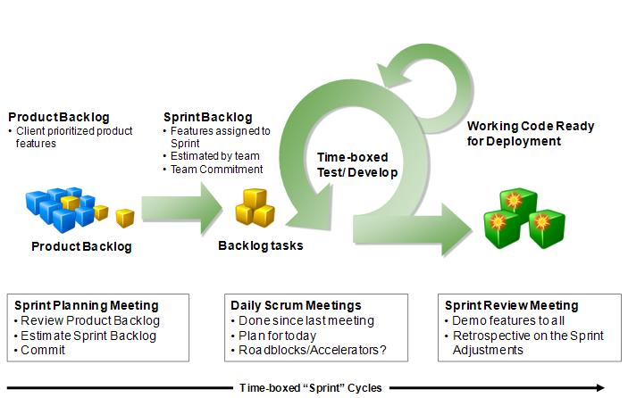

The following tasks will be loop during this stage:

* Writing Code; Review code
* Perform unit test; Fix bugs
* Perform Integration
* Get responsiveness from customer requests

### Roles and Responsibilities

|  |  |  |  |  |
| --- | --- | --- | --- | --- |
| No. | Name | Position | Responsibilities[[1]](#footnote-1) | Tel, Fax, Email |
| 1 | HungLD5 | PM | Manage development team in general. Also acts as supervisor and customer. | Tel:  Email:HunglD5@fpt.edu.vn |
| 2 | LocTH | TL | Control, review and task assignment.  Also in charge of development tasks. | Tel:  Email: locht60207@fpt.edu.vn |
| 3 | SonTH | TM | Designing application.  Developing application.  Reviewing and testing peer to peer. | Tel:  Email: sonth60059@fpt.edu.vn |
| 4 | NhanMDT | TM | Designing application.  Developing application.  Reviewing and testing peer to peer. | Tel:  Email: nhanmdt60184@fpt.edu.vn |
| 5 | QuanBTL | TM | Designing application.  Developing application.  Reviewing and testing peer to peer.  Secretary role. | Tel:  Email: quanbtl60172@fpt.edu.vn |

### Tools and Techniques

* Visual Studio 2010, Framework 3.5, Framework 4.0
* SQL Server 2005, SQL Server 2010
* AnkhSvn-2.3.10509.1073, TortoiseSVN-1.7.3.22386-win32-svn-1.7.2
* Microsoft Office 2007
* Yahoo Messenger 10

## Project Management Plan

### General tasks

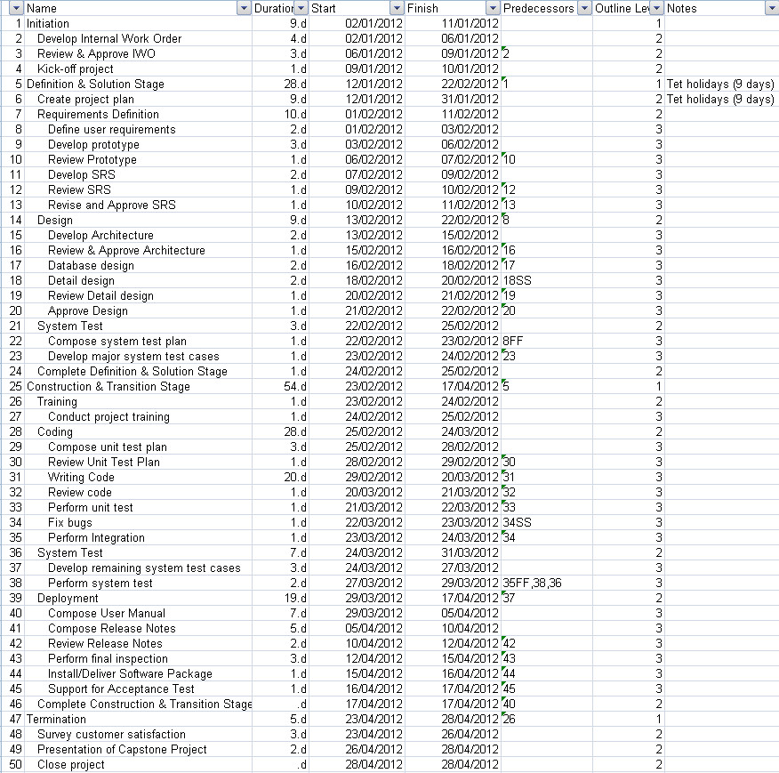

### Task Sheet: Assignments and Timetable

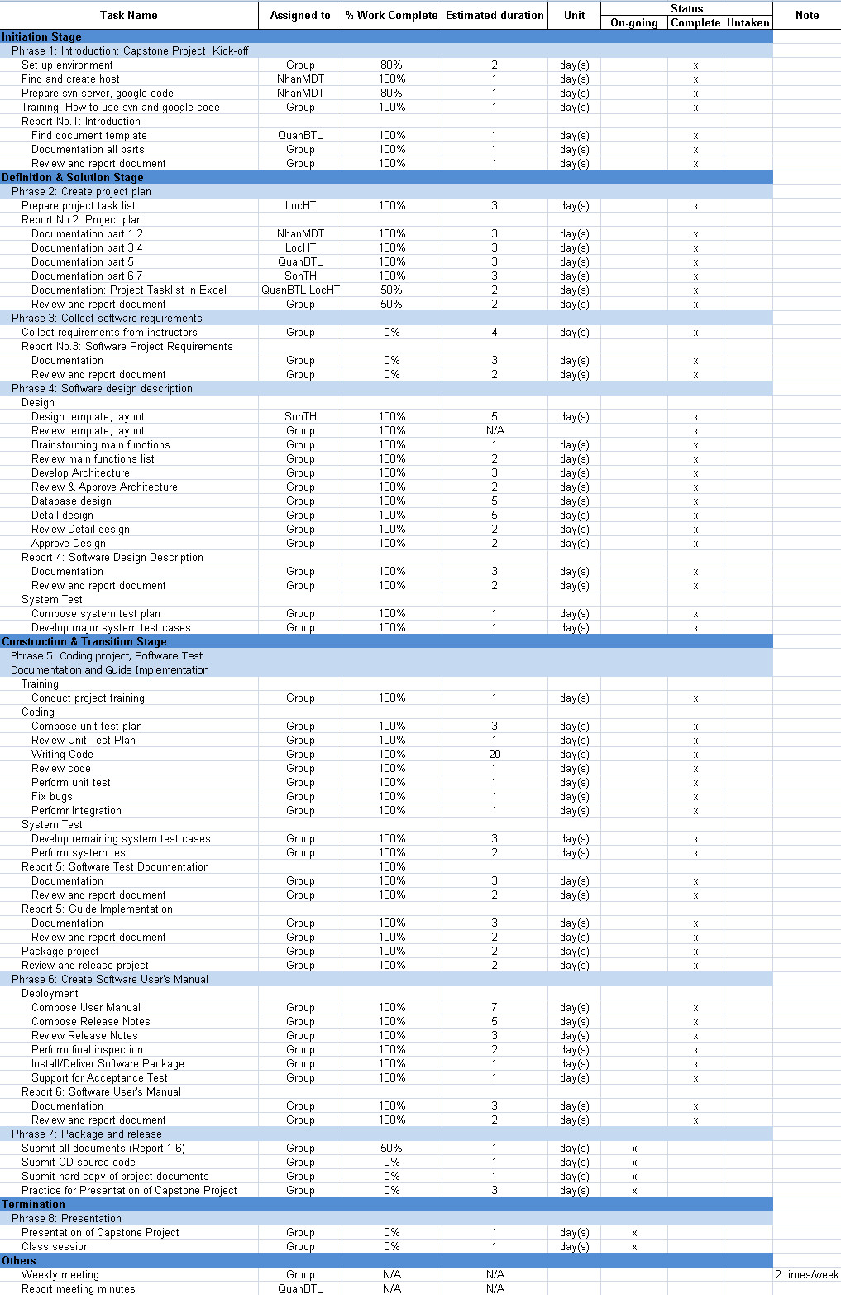

### Meeting Minutes

Reference folder Meeting Minutes, CD Source code E-Bartering

## Coding Conventions

The following rules follow the standard rules for developing applications using .NET and C#.

### Naming Conventions

The following terms describe different ways to case identifiers.

* Pascal Casing

The first letter in the identifier and the first letter of each subsequent concatenated word are capitalized. You can use Pascal case for identifiers of three or more characters. For example: BackColor

* Camel Casing

The first letter of an identifier is lowercase and the first letter of each subsequent concatenated word is capitalized. For example: backColor

* Uppercase

All letters in the identifier are capitalized. For example: IO

* Naming rules

Follow .NET naming rules.

### Coding Styles

Follow .NET coding styles.

### Comments

* Comments should be written in order to make code understandable and maintainable.
* Only write comments when necessary, do not write comments for every line of code and every variable declared.
* Use **//** or **///** for comments. Avoid using **/\* … \*/**
* Do not write comments if the code is easily understandable without comment. The drawback of having lot of comments is that if you change the code and forget to change the comment, it will lead to more confusion.
* Fewer lines of comments will make the code more elegant. But if the code is not clean/readable and there are less comments, that is worse.
* Writes clean, readable code such a way that it doesn't need any comments or very little to understand.
* Perform spelling check on comments and also make sure proper grammar and punctuation is used.

## References

[1] SCRUM model:

<http://en.wikipedia.org/wiki/Scrum_%28development%29>

[2] .NET Naming Guidelines:

<http://msdn.microsoft.com/en-us/library/ms229002.aspx>

[3] .NET Coding rules:

CSharpCodingStandards.pdf

# Report No.3: Software Requirements Specifications (SRS)

## User Requirement Specification

This website will be implemented as a place for the users to post their own products (can be any kinds of their belongings) and barter them with others, Vietnamese interface.

The **trader** objectives for the EB5 are to:

* Provide them with a huge selection of items (and barterers).
* Enable them to easily search for, find, and barter the items they want.
* Enable them to buy items by cash that they do not have items to barter.
* Make buying more convenient by allowing them to buy and barter items:
* Anytime (i.e., 24 hours a day and 7 days a week).
* Anywhere that the buyers have access to the Internet (e.g., at home, at work, and while traveling).
* Minimize risks associated with bartering over the Internet by using our services.

The **item owner** objectives for the EB5 are to:

* Provide them with a huge customer base of potential barterers.
* Enable them to easily target and personalize their marketing to appropriate potential traders.
* Enable them to barter items that they could not sell (e.g., by minimizing their overhead and transaction costs).
* Enable them to determine the market price of their items and set their prices accordingly.
* Make selling more convenient by allowing them to sell and barter items:
* Anytime (i.e., 24 hours a day and 7 days a week).
* Anywhere the item owners have access to the Internet (e.g., at home, at work, while traveling).
* Minimize risks associated with selling over the Internet by using our services

Users of this website can:

* Register for an account to be a member of website.
* Post items they want to barter with other users.
* Search other users’ items to request barter.
* When a user finds the items he need, he can refer shipping fee before sending bartering request. The item owner can view his request and check for shipping fee before making decision. If the item owner accepted his request, he will confirm and begin transaction; otherwise he can cancel request bartering.
* When both item owner and trader confirm bartering, transaction will begin. Both of them can request shipping from website, but the shipping fee depends on their items and distance.
* Request shipping from website: Users will confirm shipping time with website and trader. Payment will be done when website’s employees arrive their home and ship items. If the user cancel shipping request when employees arrive, they have to pay haft of shipping fee for the website.
* Website will ensure the bartering progress between users.
* Comment or evaluate price of other user’s posted items.
* Not allow to barter illegal items.
* Bartering as: Item A + Money >> Barter << Item B + Money



Figure 1: General EB5 System

## System Requirement Specification

* The system is expected to handle up to 100 requests as the same time. The database is also expected to allow fast inquiries that can response at best within 1 ->3 seconds.
* Browser: IE 7, 8, 9; Chrome 10; Firefox 3.5, 4, 5, enabled JavaScript and Cookies.
* Due to Vietnamese culture, online payment seems to be unreliable, so all the payment for services will be collected using face-to-face method.
* Operating: Microsoft Windows XP/Windows Vista/Windows 7

### External Interfaces Requirement

* + - * 1. User Interfaces
* All pages of the system are following a consistent theme and clear structure. The occurrence of errors should be minimized through the use of checkboxes, radio buttons and scroll down in order to reduce the amount of text input from user.
* JavaScript implement in HTML in order to provide a Data Check before submission. HTML Tables to display information to give a clear structure that easy to understand by user.
* Error message should be located beside the error input which clearly highlight and tell user how to solve it. If system error, it should provide the contact methods.
* It should provide a FAQ to minimize the workload of system administrator.
* GUI of EB5 must present the main idea of the web: Bartering (slightly different from website for buying and selling items)

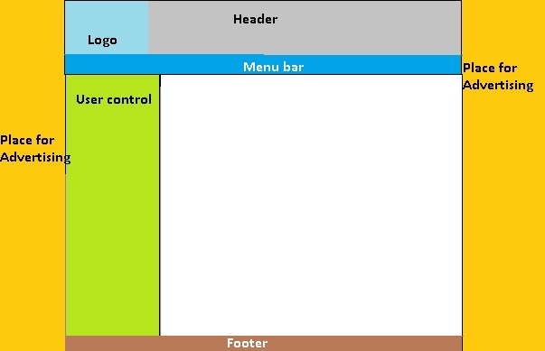

Figure 2: Master page for Normal User



Figure 3: Master page for Manager and Admin

* + - * 1. Hardware Interfaces
* Operating system: Window 7, XP, Vista.
* The system is a web based application; clients are requiring using a modern web browser such as Mozilla Firebox 3.6 or newer, Internet Explorer 7 and Enable Cookies, Chrome 10. The computer must have an Internet connection in order to be able to access the system.

* + - * 1. Software Interfaces
* SQL Server 2008, Visual Studio 2010, modern web browser.
  + - * 1. Communications Protocol
* The HTTP protocol will be used to facilitate communications between the client and server.
* Between team members:
  + Email, mobile phone.
  + Chat engine: Yahoo Messenger, Skype
  + Weekly meeting (45 minutes – direct meeting) on Tuesday and Thursday at Floor 5th FPT University.

### System Feature

#### Use case overview

* General
* Everyone can view items and search for items
* Guests
* Guests register for new accounts
* Members
* Members update their personal information.
* Members post new items on web.
* Members update their posts.
* Members remove their posts.
* Members view item’s owner information.
* Members request services.
* Members comment items.
* Members evaluate items.
* Members request barter.
* Members update barter request.
* Members view shipping fee for reference
* Members confirm barter.
* Members cancel barter.
* Members view their bartering history
* Admin
* Admin search for user account.
* Admin activate users account.
* Admin suspend users account.
* Admin delete users account.
* Admin update status of services
* Admin insert new item categories.
* Admin edit item categories.
* Admin remove item categories
* Admin delete items.
* Admin lock items.
* Admin unlock items.
* Admin delete comments.
* Admin insert suggested shipping fee info.
* Admin edit suggested shipping fee info.
* Admin delete suggested shipping fee info.
* Admin confirm shipping fee of item.
* System
* System rank members with successful bartering.

#### Everyone can search for items

* + - 1. Use case diagram



* + - 1. Use case specification

|  |  |  |  |  |
| --- | --- | --- | --- | --- |
| **USE CASE 1 SPECIFICATION** | | | | |
| **Use-case No.** | UC1 | **Use-case Version** | | v1.0 |
| **Use-case Name** | Everyone can view items and search for items | | | |
| **Author** | SonTH | | | |
| **Date** | 16/01/2012 | **Priority** | Normal | |
| **Actor:** Guests, Members, Admin  **Summary:** This function is put on the master page. Therefore, the users can use it wherever they are on the website. This function contains 1 textbox for entering the name of the product, 1 dropdown list for the category of the product and 1 search button. After the users enter the name of the product, choose the category then click search button. The recent page will lead to the result page where the result will be displayed.  **Goal:** This function helps users find the product match their key words quickly. Or helps them to do their quick research about the price. This function is useful for whom need fast but not accurate.  **Triggers:** Everyone (guests, members, admin) want to view or search for items on our website. Users do not need to login or have an account.  **Preconditions:** The page is fully loaded.  **Post Conditions:** All the result matches the key words, which the users have just entered, are displayed on the result page.  **Main Success Scenario:**   |  |  |  | | --- | --- | --- | | **Step** | **Actor Action** | **System Response** | | 1 | User enters text in the search textbox and chooses the category in the dropdown list. Then click search button. | Display search results. |   **Alternative Scenario:** N/A  **Exceptions:**   |  |  |  | | --- | --- | --- | | **Step** | **Actor Action** | **System Response** | | 1 | The user click search button without enter in the textbox | The page doesn’t submit to server and display “Xin Hãy Nhập Từ Khóa” |   Connection problems: Cannot display search results or search results not updated.  Cannot find any result match search conditions: display “No result found”  **Relationships:** N/A  **Business Rules:** N/A | | | | |

#### Guests register for new accounts

* + - 1. Use case diagram



* + - 1. Use case specification

|  |  |  |  |  |
| --- | --- | --- | --- | --- |
| **USE CASE 2– Register for new account SPECIFICATION** | | | | |
| **Use-case No.** | UC2 | **Use-case Version** | | 1.0 |
| **Use-case Name** | Register for new account | | | |
| **Author** | QuanBTL | | | |
| **Date** | 14/01/2011 | **Priority** | High | |
| **Actor:**  Guest.  **Summary:**  The users with role guest can register for a new account.  **Goal:**  The users with role guest successfully register for a new account.  **Triggers**  The user click “Đăng kí tài khoản” button.  **Preconditions:**  The users haven’t logged in.  **Post Conditions:**  The users with role guest successfully register for a new account.  **Main Success Scenario:**   |  |  |  | | --- | --- | --- | | **Step** | **Actor Action** | **System Response** | | 1 | The user click “Đăng kí tài khoản” button. | Display register page. | | 2 | The user fills all the required information.  The user clicks “Hoàn tất đăng kí” button. | Ask the user to confirm the information.  **”Bạn có chắc chắn muốn đăng kí tài khoản với những thông tin này không?”** | | 3 | The user clicks “Đồng ý” button. | Display the successful message.  **“Đăng kí thành công! Một email đã dc gửi đến địa chỉ của bạn, xin hãy kích hoạt tài khoản theo hướng dẫn bên trong email để hoàn tất đăng kí.”**. |   **Alternative Scenario:**  None  **Exceptions 1: Empty required information.**   |  |  |  | | --- | --- | --- | | **Step** | **Actor Action** | **System Response** | | 1 | The users leave some of the required information unfilled. | Display message:**”…. không dc phép để trống.”** next to the fields.  Disable “Hoàn tất đăng kí” button. |   **Exceptions 2: Invalid information.**   |  |  |  | | --- | --- | --- | | **Step** | **Actor Action** | **System Response** | | 1 | The users enter invalid information. | Display message:”**…. không hợp lệ”,** and gives the hint for the users to correct the informationnext to the fields.  Disable “Hoàn tất đăng kí” button. |   **Relationships:**  None  **Business Rules:** Registered account have role “Member” | | | | |

#### Members update their personal information

* + - 1. Use case diagram:



* + - 1. Use case specification:

|  |  |  |  |  |
| --- | --- | --- | --- | --- |
| **USE CASE 3 SPECIFICATION** | | | | |
| **Use-case No.** | UC3 | **Use-case Version** | | v1.0 |
| **Use-case Name** | Members update their personal information | | | |
| **Author** | LocHT | | | |
| **Date** | 16/01/2012 | **Priority** | Normal | |
| **Actor:** Members  **Summary:** This use case mention about users wants to update their personal information on web after registering account.  **Goal:** Member can view their personal information and update it to store in database of EB5 system.  **Triggers**: Users go to Edit personal information page, edit their information and click Save/Update.  **Preconditions:** The website must be fully loaded. The account of members is activated and not being banned or deleted. Login successfully with role “Member”.  **Post Conditions:** N/A  **Main Success Scenario:**   |  |  |  | | --- | --- | --- | | **Step** | **Actor Action** | **System Response** | | 1 | Go to Edit personal information page. Fill in data with correct formation input. Then click button “Lưu” | If data input in correct formation, update data in database and display message box: “Cập nhật thành công”. |   **Alternative Scenario:** N/A  **Exceptions 1: Invalid data format**   |  |  |  | | --- | --- | --- | | **Step** | **Actor Action** | **System Response** | | 1 | Go to Edit personal information page. Fill in data with incorrect formation input. Then click button “Lưu”. | Not request to server and display error message box at the place where error occurred |   **Exceptions 2: Data not empty**   |  |  |  | | --- | --- | --- | | **Step** | **Actor Action** | **System Response** | | 1 | Go to Edit personal information page. Fill in blank data. Then click button “Lưu”. | Not request to server and display error message box at the place where error occurred |   Internet connection problems or internal server error, display message box: “Cập nhật thất bại, xin vui lòng thử lại”. Session time out: Redirect to main page and require login again.  **Relationships:** N/A  **Business Rules:** Only registered users with role member, account is activated and not being locked or deleted can perform this use case. | | | | |

#### Members post new items on web

* + - 1. Use case diagram:



* + - 1. Use case specification:

|  |  |  |  |  |
| --- | --- | --- | --- | --- |
| **USE CASE 4 SPECIFICATION** | | | | |
| **Use-case No.** | UC4 | **Use-case Version** | | v1.0 |
| **Use-case Name** | Members post new items on web | | | |
| **Author** | SonTH | | | |
| **Date** | 16/01/2012 | **Priority** | Normal | |
| **Actor:** Members  **Summary:** In this use case, the users can post the item they want to exchange (include the price, quantity, status, description ...) and the item they are looking for (expected items). After that they can view and manage their post, update more information about the items, and close the post when the exchange is successful.  **Goal:** Members can post items, which they want to exchange to other items. They also post the price, pictures, quantity, contact information.  **Triggers:** Input data for posting and click the post button.  **Preconditions:** Login successfully, not session time out, then go to the post page and input the item’s property.  **Post Conditions:**  Successful: Display message box: “Đăng sản phẩm thành công”. The post will appear on the website so everyone can view it and exchange.  Failure: Display message box “Đăng sản phẩm thất bại, xin vui lòng thử lại”.  **Main Success Scenario:**   |  |  |  | | --- | --- | --- | | **Step** | **Actor Action** | **System Response** | | 1 | Go to Post item page. Fill in data with correct formation input. Then click button “Đăng” | If data input in correct formation, update data in database and display message box: “Đăng sản phẩm thành công”. |   **Alternative Scenario:** N/A  **Exceptions 1:Invalid data**   |  |  |  | | --- | --- | --- | | **Step** | **Actor Action** | **System Response** | | 1 | Go to Post item page. Fill in data with correct formation input. Then click button “Đăng”. | Not request to server and display error message box at the place where error occurred |   **Exceptions 2: Data not empty**   |  |  |  | | --- | --- | --- | | **Step** | **Actor Action** | **System Response** | | 1 | Go to Post personal information page. Fill in blank data. Then click button “Đăng”. | Not request to server and display error message box at the place where error occurred |   Internet connection problems or internal server error, display message box: “Đăng sản phẩm thất bại, xin vui lòng thử lại”  Session time out: Redirect to main page and require login again.  **Relationships:** Members update their posts, Members remove their posts.  **Business Rules:** Only registered users with role member, account is activated and not being locked or deleted can perform this use case | | | | |

#### Members update posted items

* + - 1. Use case diagram:



* + - 1. Use case specification:

|  |  |  |  |  |
| --- | --- | --- | --- | --- |
| **USE CASE 5– Update posted item information SPECIFICATION** | | | | |
| **Use-case No.** | UC5 | **Use-case Version** | | 1.0 |
| **Use-case Name** | Update posted item | | | |
| **Author** | QuanBTL | | | |
| **Date** | 14/01/2011 | **Priority** | High | |
| **Actor:**  Members.  **Summary:**  The users with role members can update their posted item.  **Goal:**  The users with role members successfully update their posted item.  **Triggers**  The user click “Cập nhật thông tin sản phẩm” button.  **Preconditions:**  The users have already posted the item.  **Post Conditions:**  The users with role members successfully update their posted item.  **Main Success Scenario:**   |  |  |  | | --- | --- | --- | | **Step** | **Actor Action** | **System Response** | | 1 | The user click “Cập nhật thông tin sản phẩm” button. | Display update posted item page. | | 2 | The user fills all the required information.  The user clicks “Hoàn tất” button. | Ask the user to confirm the information.  **”Bạn có chắc chắn muốn cập nhật sản phẩm với những thông tin này không?”** | | 3 | The user clicks “Đồng ý” button. | Display the successful message.  **“Cập nhật thành công!”** |   **Alternative Scenario:**  None  **Exceptions 1: Empty required information.**   |  |  |  | | --- | --- | --- | | **Step** | **Actor Action** | **System Response** | | 1 | The users leave some of the required information unfilled. | Display message:**”…. không dc phép để trống.”** next to the fields.  Disable “Hoàn tất” button. |   **Exceptions 2: Invalid information.**   |  |  |  | | --- | --- | --- | | **Step** | **Actor Action** | **System Response** | | 1 | The users enter invalid information. | Display message:”**…. không hợp lệ”,** and gives the hint for the users to correct the informationnext to the fields.  Disable “Hoàn tất” button. |   **Relationships:**  None  **Business Rules:**  None. | | | | |

#### Members remove their posted items

* + - 1. Use case diagram:



* + - 1. Use case specification:

|  |  |  |  |  |
| --- | --- | --- | --- | --- |
| **USE CASE 6– Remove owned posted item SPECIFICATION** | | | | |
| **Use-case No.** | UC6 | **Use-case Version** | | 1.0 |
| **Use-case Name** | Members remove their posted items | | | |
| **Author** | QuanBTL | | | |
| **Date** | 14/01/2011 | **Priority** | High | |
| **Actor:**  Members.  **Summary:**  The users with role members can remove their own posted item.  **Goal:**  The users with role members successfully remove their own posted item.  **Triggers**  The user click “Hủy đăng sản phẩm này” button.  **Preconditions:**  The users owned this posted item.  **Post Conditions:**  The users with role members successfully remove their own posted item.  **Main Success Scenario:**   |  |  |  | | --- | --- | --- | | **Step** | **Actor Action** | **System Response** | | 1 | The user click “Hủy đăng sản phẩm này” button. | Ask the user to confirm the action.  **”Hành động này không thể phục hồi dc, bạn có chắc chắn muốn tiếp tục?”** | | 2 | The user clicks “Đồng ý” button. | Display the successful message.  **“Hủy đăng sản phẩm thành công!”** |   **Alternative Scenario:**  None  **Exceptions: The users don’t own this item.**   |  |  |  | | --- | --- | --- | | **Step** | **Actor Action** | **System Response** | | 1 | The users don’t own this item. | Disable “Hủy đăng sản phẩm này” button. |   **Relationships:**  None  **Business Rules:**  None. | | | | |

#### Members view item’s owner information

* + - 1. Use case diagram:



* + - 1. Use case specification:

|  |  |  |  |  |
| --- | --- | --- | --- | --- |
| **USE CASE 7– View item’s owner information SPECIFICATION** | | | | |
| **Use-case No.** | UC7 | **Use-case Version** | | 1.0 |
| **Use-case Name** | Members view item’s owner information | | | |
| **Author** | QuanBTL | | | |
| **Date** | 14/01/2011 | **Priority** | High | |
| **Actor:**  Members.  **Summary:**  The users with role members can view item’s owner information.  **Goal:**  The users with role members successfully view item’s owner information.  **Triggers**  The users click the name of the item’s owner.  **Preconditions:**  The users have logged in.  **Post Conditions:**  The users with role members successfully view item’s owner information.  **Main Success Scenario:**   |  |  |  | | --- | --- | --- | | **Step** | **Actor Action** | **System Response** | | 1 | The users click the name of the item’s owner. | Display the item’s owner information. |   **Alternative Scenario:**  None  **Exceptions:**  None  **Relationships:**  None  **Business Rules:**  None. | | | | |

#### Members request shipping services

* + - 1. Use case diagram:



* + - 1. Use case specification:

|  |  |  |  |  |
| --- | --- | --- | --- | --- |
| **USE CASE 8 SPECIFICATION** | | | | |
| **Use-case No.** | UC8 | **Use-case Version** | | 1.0 |
| **Use-case Name** | Members request shipping services | | | |
| **Author** | LocHT | | | |
| **Date** | 28/01/2012 | **Priority** | High | |
| **Actor:** Members  **Summary:** Members can request shipping service and view the price of shipping before confirm bartering request.  **Goal:** Members know the shipping fee for bartering item.  **Triggers** Click “Yêu cầu giao sản phẩm” button.  **Preconditions** Login successfully, not session time out.  **Post Conditions:**  Successful: Message box: “Yêu cầu dịch vụ thành công”, members will wait for less than an hour for admin to check shipping fee. After admin check for item and update the shipping fee, member can now view the shipping fee.  Failure: Message box: “Yêu cầu dịch vụ thất bại.” System can display the related reasons (optional).  **Main Success Scenario:**   |  |  |  | | --- | --- | --- | | **Step** | **Actor Action** | **System Response** | | 1 | Click “Yêu cầu giao sản phẩm” button. | Save request shipping in database. Display Message box: “Yêu cầu dịch vụ thành công”. System will notify admin. |   **Alternative Scenario:**   |  |  |  | | --- | --- | --- | | **Step** | **Actor Action** | **System Response** | | 1 | Click “Yêu cầu giao sản phẩm” button. | Session time out: Redirect to main page and require login again. |     **Exceptions:** Internet connection problems or internal server error, display message box: “Yêu cầu dịch vụ thất bại”  Session time out: Redirect to main page and require login again.  **Relationships:** N/A  **Business Rules:** N/A | | | | |

#### Members comment items

* + - 1. Use case diagram:



* + - 1. Use case specification:

|  |  |  |  |  |
| --- | --- | --- | --- | --- |
| **USE CASE 9** | | | | |
| **Use-case No.** | UC9 | **Use-case Version** | | 1.0 |
| **Use-case Name** | Members comment items | | | |
| **Author** | SonTH | | | |
| **Date** | 13/01/2012 | **Priority** | High | |
| **Actor:** Member  **Summary:** When members view posts and view the comment of the items, they can view the previous comments and post a new one.  **Goal:** Members can view comment of themselves and other members.  **Trigger:** Members input their comments and click post comment button  **Preconditions:**  Login successfully, not session time out, viewing posted items.  **Post Conditions:** After the users comment successfully. The comment will appear on the item, so everyone can view it.  **Main Success Scenario:**   |  |  |  | | --- | --- | --- | | **Step** | **Actor Action** | **System Response** | | 1 | Enter the comment textbox in the comment area then click ‘Gửi Bình Luận’ | The user’s comment will be posted and displayed on the comment area with the previous comments |   **Alternative Scenario:**   |  |  |  | | --- | --- | --- | | **Step** | **Actor Action** | **System Response** | | 1 | Click “Gửi Bình Luận” without entering the comment. | The screen displays a popup “Xin vui lòng nhập nội dung bình luận” |   **Exceptions:** Slow internet connection makes the page is not fully loaded. So it may take this function is not work well  Session time out: Redirect to main page and require login again  **Relationships:** N/A  **Business Rules:** N/A | | | | |

#### Members evaluate items

* + - 1. Use case diagram:



* + - 1. Use case specification:

|  |  |  |  |  |
| --- | --- | --- | --- | --- |
| **USE CASE 10** | | | | |
| **Use-case No.** | UC10 | **Use-case Version** | | 1.0 |
| **Use-case Name** | Members evaluate items | | | |
| **Author** | SonTH | | | |
| **Date** | 13/01/2012 | **Priority** | High | |
| **Actor:** Member  **Summary:** When members view posts and view the price of the items, they can view the average price and post a new price.  **Goal:** Members can view the average voting price before doing bartering request.  **Trigger:** Members input their evaluated price and click vote button  **Preconditions:** Login successfully, not session time out, viewing posted items.  **Post Conditions:** After the users vote successfully. The average price will be updated, so everyone can view it.  **Main Success Scenario:**   |  |  |  | | --- | --- | --- | | **Step** | **Actor Action** | **System Response** | | 1 | Enter the comment textbox in the comment area then click “Đăng" | The average price will be updated and displayed. |   **Alternative Scenario:** None  **Exceptions 1:** **Incorrect format**   |  |  |  | | --- | --- | --- | | **Step** | **Actor Action** | **System Response** | | 1 | Enter price with incorrect format, click “Đăng”. | The error message box display “Không đúng định dạng kiểu số” |   **Exceptions 2:** **Price cannot empty**   |  |  |  | | --- | --- | --- | | **Step** | **Actor Action** | **System Response** | | 1 | Click “Đăng” without entering the price. | The screen displays a popup “Xin vui lòng nhập giá bạn chọn” |   Slow internet connection makes the page is not fully loaded. So it may take this function is not work well  Session time out: Redirect to main page and require login again  **Relationships:** N/A  **Business Rules:** N/A | | | | |

#### Members request bartering

* + - 1. Use case diagram:



* + - 1. Use case specification:

|  |  |  |  |  |
| --- | --- | --- | --- | --- |
| **USE CASE 11 – Create barter requests** | | | | |
| **Use-case No.** | UC11 | **Use-case Version** | | 1.0 |
| **Use-case Name** | Members request bartering | | | |
| **Author** | QuanBTL | | | |
| **Date** | 14/01/2011 | **Priority** | High | |
| **Actor:**  Member.  **Summary:**  After viewing item details, user requests to join in barter with this item.  **Goal:**  The user successfully creates a request to barter one of his items for this current item.  **Triggers**  Click to “Đề nghị trao đổi” button.  **Preconditions:**  The current user hasn’t requested to barter with this item yet.  **Post Conditions:**  Success: Create new bartering request.  Failure: Nothing happens, display message box for reasons of failure.  **Main Success Scenario:**   |  |  |  | | --- | --- | --- | | **Step** | **Actor Action** | **System Response** | | 1 | The user clicks “Đề nghị trao đổi” button. | List all the user’s own items, and ask the user to choose one of them to enter the barter.  **“Xin hãy lựa chọn một sản phẩm để tham gia trao đổi. Nếu bạn muốn dùng tiền mặt để mua sản phẩm này, xin hãy ghi vào phần ghi chú.”** | | 2 | The user chooses one item to join in the barter.  The user chooses the quantity, and adds the notes for the item.  The user clicks “Đồng ý” button. | Ask the user to confirm this transaction.  **”Bạn có chắc chắn muốn dùng sản phẩm này để tham gia trao đổi ko?”** | | 3 | The user clicks “Đồng ý” button. | Display the successful message.  **“Hoàn tất tạo mới đề nghị trao đồi. Trở về trang xem thông tin sản phẩm.”**  And ask the user to go back to item details page. | | 4 | The user clicks “Đồng ý” button. | Display item details page. |   **Alternative Scenario 1: Cancel request barter.**   |  |  |  | | --- | --- | --- | | **Step** | **Actor Action** | **System Response** | | 1 | Click “Đề nghị trao đổi” button in item details page. | List all the user’s own items, and ask the user to choose one of them to enter the barter.  **“Xin hãy lựa chọn một sản phẩm để tham gia trao đổi. Nếu bạn muốn dùng tiền mặt để mua sản phẩm này, xin hãy ghi vào phần ghi chú.”** | | 2 | The user clicks “Hủy bỏ” button. | Display item details page. |   **Alternative Scenario 2: Cancel after choosing item to barter.**   |  |  |  | | --- | --- | --- | | **Step** | **Actor Action** | **System Response** | | 1 | Click “Đề nghị trao đổi” button in item details page. | List all the user’s own items, and ask the user to choose one of them to enter the barter.  **“Xin hãy lựa chọn một sản phẩm để tham gia trao đổi. Nếu bạn muốn dùng tiền mặt để mua sản phẩm này, xin hãy ghi vào phần ghi chú.”** | | 2 | The user chooses one item to join in the barter.  The user chooses the quantity, and adds the notes for the item.  The user clicks “Đồng ý” button. | Ask the user to confirm this transaction. | | 3 | The user clicks “Hủy bỏ” button. | List all the user’s own items, and ask the user to choose one of them to enter the barter. |   **Exceptions 1: The user hasn’t posted any item to join in the barter.**   |  |  |  | | --- | --- | --- | | **Step** | **Actor Action** | **System Response** | | 1 | Click “Đề nghị trao đổi” button in item details page. | Display message, ask the user to either go back to item details page or to post items.  **“Bạn hiện chưa đăng kí bất kì một sản phẩm nào để có thể tham gia trao đổi, Bạn có muốn đăng kí sản phẩm ngay bây giờ ko?”** | | 2 | The user clicks “Đồng ý” button. | Display “Post items” page. |   **Exceptions 2: The user neither chooses any item nor adds the notes.**   |  |  |  | | --- | --- | --- | | **Step** | **Actor Action** | **System Response** | | 1 | The user neither chooses any item nor adds the notes. | Display message.  **“Bạn phải chọn ít nhất một sản phẩm, hoặc điền vào phần ghi chú để tham gia trao đổi.”** |   **Relationships:**  UC4  **Business Rules:**  None. | | | | |

#### Members update request bartering

* + - 1. Use case diagram:



* + - 1. Use case specification:

|  |  |  |  |  |
| --- | --- | --- | --- | --- |
| **USE CASE 12– Update request barter** | | | | |
| **Use-case No.** | UC12 | **Use-case Version** | | 1.0 |
| **Use-case Name** | Members update request bartering | | | |
| **Author** | QuanBTL | | | |
| **Date** | 14/01/2011 | **Priority** | High | |
| **Actor:**  Member.  **Summary:**  View request barter in the list, and then update the conditions in the request.  **Goal:**  The user successfully changes the barter conditions.  **Triggers**  The user clicks “Thay đổi điều kiên trao đổi” button in view barter request page.  **Preconditions:**  Logged into the system with user role and go to barter history page.  View barter request of one specific item.  The barter request had been created.  **Post Conditions:**  The user successfully changes the barter conditions.  **Main Success Scenario:**   |  |  |  | | --- | --- | --- | | **Step** | **Actor Action** | **System Response** | | 1 | The user clicks one of the barter item. | Display all barter requests. | | 2 | The user clicks “Thay đổi điều kiên trao đổi” button. | Display update barter request page. | | 3 | The user changes the barter conditions.  The user click “Sẵn sàng” button in “Barter request” page. | Ask the user to confirm this transaction.  **”Bạn có chắc chắn muốn hoàn tất việc thay đổi?”** | | 4 | The user clicks “Đồng ý” button. | Display all barter requests. |   **Alternative Scenario 1: Cancel updating request barter.**   |  |  |  | | --- | --- | --- | | **Step** | **Actor Action** | **System Response** | | 1 | The user clicks one of the barter items. | Display all barter requests. | | 2 | The user clicks “Thay đổi điều kiên trao đổi” button. | Display update barter request page. | | 3 | The user changes the barter conditions.  The user click “Hủy bỏ” button. | Display all barter requests. |   **Alternative Scenario 2: Cancel updating barter conditions.**   |  |  |  | | --- | --- | --- | | **Step** | **Actor Action** | **System Response** | | 1 | The user clicks one of the barter items. | Display all barter requests. | | 2 | The user clicks “Thay đổi điều kiên trao đổi” button. | Display update barter request page. | | 3 | The user changes the barter conditions.  The user click “Sẵn sàng” button. | Ask the user to confirm this transaction.  **”Bạn có chắc chắn muốn hoàn tất việc thay đổi?”** | | 4 | The user clicks “Hủy bỏ” button. | Display update barter request page. |   **Exceptions:**  None  **Relationships:**  None  **Business Rules:**  None. | | | | |

#### Members confirm bartering request

* + - 1. Use case diagram



* + - 1. Use case specification

|  |  |  |  |  |
| --- | --- | --- | --- | --- |
| **USE CASE 13– Confirm barter SPECIFICATION** | | | | |
| **Use-case No.** | UC13 | **Use-case Version** | | 1.0 |
| **Use-case Name** | Members confirm bartering request | | | |
| **Author** | QuanBTL | | | |
| **Date** | 14/01/2011 | **Priority** | High | |
| **Actor:**  Member.  **Summary:**  After viewing all request barter with this item, the user can choose one of them to barter.  **Goal:**  The user successfully confirms this transaction and obtains the Completed Transaction Code.  **Triggers**  The user click one request barters in the list.  **Preconditions:**  Logged into the system with user role and view barter history.  View barter request of one specific item.  **Post Conditions:**  The user successfully confirms this transaction and obtains the Completed Transaction Code.  **Main Success Scenario:**   |  |  |  | | --- | --- | --- | | **Step** | **Actor Action** | **System Response** | | 1 | The user clicks one of the barter items. | Display all barter requests. | | 2 | The user clicks “Xác nhận trao đổi” button. | Ask the user to confirm this transaction.  **”Bạn có chắc chắn muốn xác nhận trao đổi với sản phẩm này ko?”** | | 3 | The user clicks “Đồng ý” button. | Display the successful message.  **“Giao dịch hoàn tất! Mã số Giao Dịch Hòan Tất của bạn là :”**.  Display Completed Transaction Code.  Display all barter requests.  Fill Display Completed Transaction Code into the page. |   **Alternative Scenario: Cancel confirming barter.**   |  |  |  | | --- | --- | --- | | **Step** | **Actor Action** | **System Response** | | 1 | The user clicks “Xác nhận trao đổi” button. | Ask the user to confirm this transaction.  **”Bạn có chắc chắn muốn xác nhận trao đổi với sản phẩm này ko?”** | | 2 | The user clicks “Hủy bỏ” button. | Display all barter requests. |   **Exceptions:**  None  **Relationships:**  None  **Business Rules:**  None. | | | | |

#### Members view shipping fee for reference

* + - 1. Use case diagram



* + - 1. Use case specification

|  |  |  |  |  |
| --- | --- | --- | --- | --- |
| **USE CASE 14– View shipping fee for reference** | | | | |
| **Use-case No.** | UC15 | **Use-case Version** | | 1.0 |
| **Use-case Name** | Members view shipping fee for reference | | | |
| **Author** | NhanMDT | | | |
| **Date** | 14/01/2011 | **Priority** | High | |
| **Actor:** Member.  **Summary:** Members canview list of shipping fee for reference before confirm barter or request shipping service.  **Goal:** Members can have better estimation of cash before request shipping service.  **Triggers** Clicks “Tham khảo bảng giá chuyển hàng” button in view barter request page.  **Preconditions:**  Logged into the system with member role and go to barter history page.  View barter request of one specific item.  The barter request had been created.  **Post Conditions:**  The members can know more about the real money they have to pay.  **Main Success Scenario:**   |  |  |  | | --- | --- | --- | | **Step** | **Actor Action** | **System Response** | | 1 | The user clicks one of the barter items. | Display all barter requests. | | 2 | The user clicks “Tham khảo bảng giá chuyển hàng” button. | Display table shipping fee for reference. |   **Alternative Scenario:** None**.**  **Exceptions:** None  **Relationships:** None  **Business Rules:** None. | | | | |

#### Members cancel barter

* + - 1. Use case diagram:



* + - 1. Use case specification:

|  |  |  |  |  |
| --- | --- | --- | --- | --- |
| **USE CASE 16– Cancel barter SPECIFICATION** | | | | |
| **Use-case No.** | UC16 | **Use-case Version** | | 1.0 |
| **Use-case Name** | Cancel barter | | | |
| **Author** | QuanBTL | | | |
| **Date** | 14/01/2011 | **Priority** | High | |
| **Actor:**  Member.  **Summary:**  Once the barter requests have been created, the users may choose to cancel it.  **Goal:**  The users successfully cancel the barter requests.  **Triggers**  The user click “Hủy bỏ trao đổi này” button.  **Preconditions:**  The users’ barter requests have been created.  **Post Conditions:**  The users successfully cancel the barter requests.  **Main Success Scenario:**   |  |  |  | | --- | --- | --- | | **Step** | **Actor Action** | **System Response** | | 1 | The user click “Hủy bỏ trao đổi này” button.. | Ask the user to confirm.  **”Bạn có chắc chắn muốn hủy bỏ trao đổi với sản phẩm này ko?”** | | 2 | The user clicks “Đồng ý” button. | Display the successful message.  **“Hủy bỏ thành công”**. |   **Alternative Scenario:**  None  **Exceptions:**  None  **Relationships:**  None  **Business Rules:**  None. | | | | |

#### Members view their bartering history

* + - 1. Use case diagram:



* + - 1. Use case specification:

|  |  |  |  |  |
| --- | --- | --- | --- | --- |
| **USE CASE 17 SPECIFICATION** | | | | |
| **Use-case No.** | UC17 | **Use-case Version** | | 1.0 |
| **Use-case Name** | Members view their bartering history | | | |
| **Author** | LocHT | | | |
| **Date** | 14/01/2011 | **Priority** | High | |
| **Actor:** Member.  **Summary:** Member can view and search for their bartering history  **Goal:** Member can view and search for their bartering history  **Triggers** Members go to history page and enter search conditions (optional), click view.  **Preconditions:** Login successfully, not session time out  **Post Conditions:**  Success: List all their bartering history.  Failure: Nothing happens, display message box for reasons of failure.  **Main Success Scenario:**   |  |  |  | | --- | --- | --- | | **Step** | **Actor Action** | **System Response** | | 1 | Enter search conditions (optional) with correct data formation. Click “Tìm kiếm” | List all results found. |   **Alternative Scenario 1: No result found**   |  |  |  | | --- | --- | --- | | **Step** | **Actor Action** | **System Response** | | 1 | Enter search conditions (optional) with correct data formation. Click “Tìm kiếm” | Display “Không tìm thấy kết quả” |   **Alternative Scenario 1: List all results if not enter search conditions**   |  |  |  | | --- | --- | --- | | **Step** | **Actor Action** | **System Response** | | 1 | Click “Tìm kiếm” without enter search conditions | Display all records. |   **Exception: Incorrect data formation.**   |  |  |  | | --- | --- | --- | | **Step** | **Actor Action** | **System Response** | | 1 | Enter search conditions with incorrect data formation. Click “Tìm kiếm” | Not request to server, display error message box where the error occurred. |   Slow internet connection makes the page is not fully loaded. So it may take this function is not work well  Session time out: Redirect to main page and require login again  **Relationships:** N/A  **Business Rules:** N/A | | | | |

#### Admin search for user account

* + - 1. Use case diagram



* + - 1. Use case specification

|  |  |  |  |  |
| --- | --- | --- | --- | --- |
| **USE CASE 18 SPECIFICATION** | | | | |
| **Use-case No.** | UC18 | **Use-case Version** | | 1.0 |
| **Use-case Name** | Admin search for user account | | | |
| **Author** | NhanMDT | | | |
| **Date** | 14/01/2011 | **Priority** | High | |
| **Actor:** Admin.  **Summary:** The users with admin role can search for other user account.  **Goal:** List all user account matched search condition (username, created day, status…)  **Triggers** Admin enter account management page, input search condition and click “Tìm kiếm”  **Preconditions:** Logged into the system with admin role and go to account management page.  **Post Conditions:** List all user account matched search condition. Display “Không tìm thấy kết quả” in case of no result found.  **Main Success Scenario:**   |  |  |  | | --- | --- | --- | | **Step** | **Actor Action** | **System Response** | | 1 | Go to account management page, enter search condition, such as username, created day, tick checkbox status… Click “Tìm kiếm”. | List all results found matched search conditions |   **Alternative Scenario:**   |  |  |  | | --- | --- | --- | | **Step** | **Actor Action** | **System Response** | | 1 | Go to account management page, click “Tìm kiếm” without input search conditions. | List all user accounts in database |   **Exceptions:** Slow internet connection makes the page is not fully loaded. So it may take this function is not work well  Session time out: Redirect to main page and require login again  **Relationships:** N/A  **Business Rules:** N/A | | | | |

#### Admin activate user account

* + - 1. Use case diagram:



* + - 1. Use case specification:

|  |  |  |  |  |
| --- | --- | --- | --- | --- |
| **USE CASE 19 SPECIFICATION** | | | | |
| **Use-case No.** | UC19 | **Use-case Version** | | 1.0 |
| **Use-case Name** | Admin activate user account | | | |
| **Author** | QuanBTL | | | |
| **Date** | 14/01/2011 | **Priority** | High | |
| **Actor:** Admin.  **Summary:** The users with admin role can activate selected user account.  **Goal:** The user with adminrole successfully activates account.  **Triggers** Admin select user accounts and click activate button to activate user account  **Preconditions:** Logged into the system with admin role and go to management page.  **Post Conditions:**  Successful: Activate selected accounts, display message box “Kích hoạt tài khoản thành công”  Failure: Nothing happen, display message box “Kích hoạt tài khoản thất bại”  **Main Success Scenario:**   |  |  |  | | --- | --- | --- | | **Step** | **Actor Action** | **System Response** | | 1 | Click to select user account that need to activate. Click “Kích hoạt” | Display message.  **“Bạn có chắc chắn muốn kích hoạt những tài khoản này không?”** | | 2 | Click “Đồng ý”. | Activate selected user account and update them in database. Display message box “Cập nhật thành công”. |   **Alternative Scenario:**   |  |  |  | | --- | --- | --- | | **Step** | **Actor Action** | **System Response** | | 1 | Select deleted user accounts. Click “Kích hoạt” | Display message.  “Bạn có chắc chắn muốn kích hoạt những tài khoản này không?” | | 2 | Click “Đồng ý”. | Display message.  “Tài khoản đã bị xóa không thể kích hoạt” |   **Exceptions:** Slow internet connection makes the page is not fully loaded. So it may take this function is not work well  Session time out: Redirect to main page and require login again  **Relationships:** N/A  **Business Rules:** Deleted accounts cannot be activated. | | | | |

#### Admin suspend user account

* + - 1. Use case diagram:



* + - 1. Use case specification:

|  |  |  |  |  |
| --- | --- | --- | --- | --- |
| **USE CASE 20 SPECIFICATION** | | | | |
| **Use-case No.** | UC20 | **Use-case Version** | | 1.0 |
| **Use-case Name** | Admin suspend user account | | | |
| **Author** | LocHT | | | |
| **Date** | 14/01/2011 | **Priority** | High | |
| **Actor:** Admin.  **Summary:** The users with admin role can suspend selected user account.  **Goal:** The users with admin role successfully suspend account.  **Triggers** Admin select user accounts, input reasons and click suspend button to suspend user account  **Preconditions:** Logged into the system with admin role and go to management page.  **Post Conditions:**  Successful: Suspend selected accounts, display message box “Khóa tài khoản thành công”. Suspended account cannot login to website for a period of time.  Failure: Nothing happen, display message box “Khóa tài khoản thất bại”  **Main Success Scenario:**   |  |  |  | | --- | --- | --- | | **Step** | **Actor Action** | **System Response** | | 1 | Click to select user account that need to suspend, input reasons for suspending and click “Khóa” | Display message.  **“Bạn có chắc chắn muốn khóa những tài khoản này không?”** | | 2 | Click “Đồng ý”. | Suspend selected user account and update them in database. Display message box “Cập nhật thành công”. |   **Alternative Scenario:**   |  |  |  | | --- | --- | --- | | **Step** | **Actor Action** | **System Response** | | 1 | Select deleted user account input reasons for suspending and click “Khóa” | Display message.  “Bạn có chắc chắn muốn khóa những tài khoản này không?” | | 2 | Click “Đồng ý”. | Display message.  “Tài khoản bị xóa không thể bị khóa” |   **Exceptions:** Slow internet connection makes the page is not fully loaded. So it may take this function is not work well**.** Session time out: Redirect to main page and require login again.Empty exception: Cannot leave reasons as blank.  **Relationships:** N/A  **Business Rules:** Deleted accounts cannot be suspended. Suspended account cannot login to system anymore until suspending time ran out. Cannot delete accounts with “admin” role or self-deleted. Cannot self-suspend. | | | | |

#### Admin delete user account

* + - 1. Use case diagram:



* + - 1. Use case specification:

|  |  |  |  |  |
| --- | --- | --- | --- | --- |
| **USE CASE 21 SPECIFICATION** | | | | |
| **Use-case No.** | UC21 | **Use-case Version** | | v1.0 |
| **Use-case Name** | Admin delete user account | | | |
| **Author** | LocHT | | | |
| **Date** | 15/01/2012 | **Priority** | Normal | |
| **Actor:** Admin  **Summary:** This use case mention about how admin delete an account  **Goal:** Admin can view, search and delete account.  **Triggers**: Admin enter management page and click on Manage user’s account link, then mark “Xóa” the selected account and write down reasons.  **Preconditions:** Admin must login. The manage user’s account page must be fully loaded.  **Post Conditions:** Display text box “Xóa thành công”. Banned accounts cannot login to web anymore  **Main Success Scenario:**   |  |  |  | | --- | --- | --- | | **Step** | **Actor Action** | **System Response** | | 1 | Input correct username and password, click button “Đăng nhập” | If the user’s role is admin, go to management page. If not, go to main page. | | 2 | Click on link “Manage user’s account”. | Go to Manage user’s account page.  Display list of accounts. | | 3 | a. Input some information to search for accounts  c. Check the checkbox “Xóa” at the account that admin want to delete. Input the reasons of deleting at textbox “Lý do”. After all click button “Lưu”.  e. Click button “Xác nhận”. | b. Display list of accounts found.  d. Display Confirm box “Bạn có thật sự muốn xóa tài khoản này?”    f. Mark the selected account as “Delete” and save to Database. Display message box “Cập nhật thành công”. |   **Alternative Scenario:**   |  |  |  | | --- | --- | --- | | **Step** | **Actor Action** | **System Response** | | 3e | Click button “Hủy”. | Close the confirm box “Bạn có thật sự muốn xóa tài khoản này?” |   **Exceptions:** Slow internet connection makes the page is not fully loaded. So it may take this function is not work well**.** Session time out: Redirect to main page and require login again.Empty exception: Cannot leave reasons as blank.  **Relationships:** N/A  **Business Rules:**Deleted account cannot login to system anymore. Cannot delete accounts with “admin” role or self-deleted. | | | | |

#### Admin update status of services

* + - 1. Use case diagram:



* + - 1. Use case specification:

|  |  |  |  |  |
| --- | --- | --- | --- | --- |
| **USE CASE 22 SPECIFICATION** | | | | |
| **Use-case No.** | UC22 | **Use-case Version** | | v1.0 |
| **Use-case Name** | Admin update status of services | | | |
| **Author** | LocHT | | | |
| **Date** | 16/01/2012 | **Priority** | Normal | |
| **Actor:** Admin  **Summary:** This use case mention about how admin update status of services. There’re 2 services: “Kiểm tra” and “Chuyển giao”. Each service has 4 statuses: “Chờ”, “Đang tiến hành”, “Complete”, “Hủy”.  **Goal:** Admin can view, search and update status of services.  **Triggers**: Admin enter management page and click on Manage services link, then update status of services and confirm.  **Preconditions:** Admin must login. The management services page must be fully loaded.  **Post Conditions:** Redirect to management transaction page with text box “Cập nhật thành công”.  **Main Success Scenario:**   |  |  |  | | --- | --- | --- | | **Step** | **Actor Action** | **System Response** | | 1 | Click on link “Manage services”. | Go to Manage services page.  Display 2 tabs: “Kiểm tra” and “Chuyển giao”.  Tab “Kiểm tra” list all the requests of checking shipping fee services. Tab “Chuyển giao” list all the requests of shipping services. | | 3A | a. Choose checking tab  c. Input the price of shipping, then click Update | b. Display list of requests checking shipping fee.  d. Update shipping fee for bartering request of members. Display “Cập nhật thành công” | | 3B | a. Choose Shipping tab. Input some information to search for services (optional)  c. Click at drop down list at status column of the service need to update.  e. Select status, then click Save to update service status. | b. Display list of shipping found.  d. If status of selected services is “Chuẩn bị”, drop down list status of that service should display “Đang tiến hành” and “Hủy”.  If status of selected service is “Đang tiến hành”, drop down list status of that service should display “Hoàn tất” and “Hủy”.  If status of selected service is “Hoàn tất” or “Hủy”, drop down list is not selectable.  f. Display message box “Cập nhật thành công”. |   **Alternative Scenario:**   |  |  |  | | --- | --- | --- | | **Step** | **Actor Action** | **System Response** | | 1 | Input correct username and password, but user’s role is not admin. | Go to main page. | | 4 | Select status, then click cancel button | Not update the selected service status | | 4 | Select status, then start a new search and click search button | Display list of service found. |   **Exceptions:** Cannot find the needed services, internet connection problems or internal server error that cannot update transaction status. Session time out: Redirect to main page and require login again.  **Relationships:** UC\_8Members request services  **Business Rules:**N/A | | | | |

#### Admin insert new item categories

* + - 1. Use case diagram:



* + - 1. Use case specification:

|  |  |  |  |  |
| --- | --- | --- | --- | --- |
| **USE CASE 23– Insert new item category SPECIFICATION** | | | | |
| **Use-case No.** | UC23 | **Use-case Version** | | 1.0 |
| **Use-case Name** | Insert new item category | | | |
| **Author** | QuanBTL | | | |
| **Date** | 14/01/2011 | **Priority** | High | |
| **Actor:**  Admin.  **Summary:**  The users with role admin can insert new item categories.  **Goal:**  The users with role admin successfully insert new item categories.  **Triggers**  The users click “Thêm mới phân loại sản phẩm” button.  **Preconditions:**  The users have logged in as admin role.  **Post Conditions:**  The users with role admin successfully insert new item categories.  **Main Success Scenario:**   |  |  |  | | --- | --- | --- | | **Step** | **Actor Action** | **System Response** | | 1 | The user click “Thêm mới phân loại sản phẩm” button. | Display insert new category page. | | 2 | The user fills all the required information.  The user clicks “Hoàn tất” button. | Ask the user to confirm the information.  **”Bạn có chắc chắn muốn them mới phân loại sản phẩm này không?”** | | 3 | The user clicks “Đồng ý” button. | Display the successful message.  **“Thêm mới thành công”.** |   **Alternative Scenario:**  None  **Exceptions 1: Empty required fields.**   |  |  |  | | --- | --- | --- | | **Step** | **Actor Action** | **System Response** | | 1 | The users leave some required information unfilled. | Display message:**”…. không dc phép để trống.”** next to the fields.  Disable “Hoàn tất” button. |   **Exceptions: Invalid information**   |  |  |  | | --- | --- | --- | | **Step** | **Actor Action** | **System Response** | | 1 | The users enter some invalid information. | Display message:”**…. không hợp lệ”,** and gives the hint for the users to correct the informationnext to the fields.  Disable “Hoàn tất” button. |   **Relationships:**  None  **Business Rules:**  None. | | | | |

#### Admin edit item categories

* + - 1. Use case diagram:



* + - 1. Use case specification:

|  |  |  |  |  |
| --- | --- | --- | --- | --- |
| **USE CASE 24 SPECIFICATION** | | | | |
| **Use-case No.** | UC24 | **Use-case Version** | | 1.0 |
| **Use-case Name** | Admin edit item categories | | | |
| **Author** | LocHT | | | |
| **Date** | 14/01/2011 | **Priority** | High | |
| **Actor:** Admin  **Summary:** This use case mention about how admin edit item categories  **Goal:** Admin can view, search and edit item categories, after editing, it must be updated in database.  **Triggers**: Admin enter management page and go to item categories management page, edit category name and click update.  **Preconditions:** Successfully login as “Admin”.  **Post Conditions:**  Successful**:** Display message box “Cập nhật thành công”, update in database.  Failure: Nothing happen, display message box “Cập nhật thất bại”  **Main Success Scenario:**   |  |  |  | | --- | --- | --- | | **Step** | **Actor Action** | **System Response** | | 1 | Select item category want to edit. Input data, then click “Cập nhật” | Update in database and display message box “Cập nhật thành công” |   **Alternative Scenario:**   |  |  |  | | --- | --- | --- | | **Step** | **Actor Action** | **System Response** | | 1 | Click button “Hủy”. | Nothing happen |   **Exceptions:** Internet connection problems or internal server error that cannot save. Session time out: Redirect to main page and require login again. Cannot input empty data or invalid data formation.  **Relationships:** N/A  **Business Rules:**After updating, items of users in that edited category are unaffected, just change the category’s name. | | | | |

#### Admin remove item category

* + - 1. Use case diagram:



* + - 1. Use case specification:

|  |  |  |  |  |
| --- | --- | --- | --- | --- |
| **USE CASE 25– Remove category SPECIFICATION** | | | | |
| **Use-case No.** | UC25 | **Use-case Version** | | 1.0 |
| **Use-case Name** | Remove category | | | |
| **Author** | QuanBTL | | | |
| **Date** | 14/01/2011 | **Priority** | High | |
| **Actor:**  Admin.  **Summary:**  The users with role admin can remove item categories.  **Goal:**  The users with role admin successfully remove item categories.  **Triggers**  The users click “Chỉnh sửa phân loại sản phẩm” button.  **Preconditions:**  The users have logged in as admin role.  **Post Conditions:**  The users with role admin successfully edit item categories.  **Main Success Scenario:**   |  |  |  | | --- | --- | --- | | **Step** | **Actor Action** | **System Response** | | 1 | The users click “Chỉnh sửa phân loại sản phẩm” button. | Display update item category page.  Display all existed categories. | | 2 | The users click on “Hủy phân loại này” button next to the category name. | Ask the users to confirm:”**Bạn có chắc chắn muốn hủy phân loại này?**” | | 3 | The users click “Đồng ý” button. | Display successful message:**”Chỉnh sửa hoàn tất!”** |   **Alternative Scenario:**  None  **Exceptions:**  None  **Relationships:**  None  **Business Rules:**  None. | | | | |

#### Admin re-correct item category

* + - 1. Use case diagram



* + - 1. Use case specification

|  |  |  |  |  |
| --- | --- | --- | --- | --- |
| **USE CASE 26 SPECIFICATION** | | | | |
| **Use-case No.** | UC26 | **Use-case Version** | | 1.0 |
| **Use-case Name** | Admin re-correct item category | | | |
| **Author** | NhanMDT | | | |
| **Date** | 14/01/2011 | **Priority** | High | |
| **Actor:** Admin  **Summary:** This use case mention about how admin re-correct user’s posted item into correct categories  **Goal:** Admin can view, search and edit posted item’s category, after editing, it must be updated in database. Leave comments: “Đăng sai thể loại, đã chỉnh sửa lúc …. Ngày …”  **Triggers**: Admin view user’s post and find items in incorrect category, admin can re-correct those posted items.  **Preconditions:** Successfully login as “Admin”.  **Post Conditions:**  Successful**:** Display message box “Cập nhật thành công”, update in database.  Failure: Nothing happen, display message box “Cập nhật thất bại”  **Main Success Scenario:**   |  |  |  | | --- | --- | --- | | **Step** | **Actor Action** | **System Response** | | 1 | Select posted items that want to edit, choose the category for them. Input the reasons in textbox comment.  Click “Cập nhật” | Ask the users to confirm: “Bạn có chắc chắn muốn chuyển sản phẩm qua chủ đề khác?” | | 2 | Click “Đồng ý” | Update in database and display message box “Cập nhật thành công” |   **Alternative Scenario:**   |  |  |  | | --- | --- | --- | | **Step** | **Actor Action** | **System Response** | | 1 | Select posted items that want to edit, choose the category for them. Input the reasons in textbox comment.  Click “Cập nhật” | Ask the users to confirm: “Bạn muốn chuyển sản phẩm qua chủ đề khác**?**” | | 2 | Click “Hủy” | Close confirm message textbox, nothing happen |   **Exceptions:** Internet connection problems or internal server error that cannot save. Session time out: Redirect to main page and require login again. Cannot input empty data or invalid data formation  **Relationships:** UC05, UC06, UC07  **Business Rules:**After updating, items of that user will be moved to edited category. Insert a new comment for reasons of moving category. | | | | |

#### Admin delete posted items of members

* + - 1. Use case diagram:



* + - 1. Use case specification:

|  |  |  |  |  |
| --- | --- | --- | --- | --- |
| **USE CASE 27– Remove posted item SPECIFICATION** | | | | |
| **Use-case No.** | UC27 | **Use-case Version** | | 1.0 |
| **Use-case Name** | Admin delete posted items of members | | | |
| **Author** | QuanBTL | | | |
| **Date** | 14/01/2011 | **Priority** | High | |
| **Actor:** Admin.  **Summary:** The users with role admin can remove posted item.  **Goal:** The users with role admin successfully remove posted item.  **Triggers** The users click “Xóa sản phẩm” button.  **Preconditions:** The users have logged in as admin role.  **Post Conditions:** The users with role admin successfully delete posted items of members. When the users who posted those items view their post, they will see a comment on their post only: “Sản phẩm đã bị xóa vào lúc…ngày… vì…”  **Main Success Scenario:**   |  |  |  | | --- | --- | --- | | **Step** | **Actor Action** | **System Response** | | 1 | Select posted items need to be removed. Input the reasons of deleting posted items. Click “Xóa sản phẩm” button. | Ask the users to confirm:”**Bạn có chắc chắn muốn xóa sản phẩm này?**” | | 2 | Click “Đồng ý” button. | Display successful message:**”Hoàn tất!”** |   **Alternative Scenario:**   |  |  |  | | --- | --- | --- | | **Step** | **Actor Action** | **System Response** | | 1 | Select posted items need to be removed. Click “Xóa sản phẩm” button. | Ask the users to confirm:”**Bạn có chắc chắn muốn xóa sản phẩm này?**” | | 2 | Click “Đồng ý” button. | Display message: **“Vui lòng nhập lý do xóa”** |   **Exceptions:** Internet connection problems or internal server error that cannot save. Session time out: Redirect to main page and require login again. Cannot input empty data or invalid data formation  **Relationships:** N/A  **Business Rules:**None. | | | | |

#### Admin lock items/posts of members

* + - 1. Use case diagram:



* + - 1. Use case specification:

|  |  |  |  |  |
| --- | --- | --- | --- | --- |
| **USE CASE 28 SPECIFICATION** | | | | |
| **Use-case No.** | UC28 | **Use-case Version** | | v1.0 |
| **Use-case Name** | Admin lock items/posts of members | | | |
| **Author** | LocHT | | | |
| **Date** | 15/01/2012 | **Priority** | Normal | |
| **Actor:** Admin  **Summary:** Admin can lock posted items of users if their post violates the rules.  **Goal:** Lock items and update to database. The locked items cannot be view, barter with other users.  **Triggers**: Admin choose the items of members and click “Khóa”  **Preconditions** Successfully login as “Admin”.  **Post Conditions:**  Successful: Display message box “Cập nhật thành công”. Update to database.  Failure: Nothing happen. Display message box “Cập nhật thất bại”.  **Main Success Scenario:**   |  |  |  | | --- | --- | --- | | **Step** | **Actor Action** | **System Response** | | 1 | View post of members. Select the posted item want to lock, input the reasons and click “Khóa” | Display confirm message box “Bạn thật sự muốn khóa?” | | 2 | Click “Đồng ý” to confirm | Lock selected items and update to database. |   **Alternative Scenario:**   |  |  |  | | --- | --- | --- | | **Step** | **Actor Action** | **System Response** | | 1 | View post of members. Select the posted item want to delete, input the reasons, click “Khóa” | Display confirm message box “Bạn thật sự muốn khóa?” | | 2 | Click “Hủy” to confirm | Close the confirm message box. Nothing happen |   **Exception**   |  |  |  | | --- | --- | --- | | **Step** | **Actor Action** | **System Response** | | 1 | View post of members. Select the posted item want to delete, click “Khóa” | Display confirm message box “Bạn thật sự muốn khóa?” | | 2 | Click “Đồng ý” to confirm | Close the confirm message box. Display message box: “Vui lòng nhập lý do khóa” |   Internet connection problems or internal server error that cannot save. Session time out: Redirect to main page and require login again. Cannot input empty data or invalid data formation  **Relationships:** N/A  **Business Rules:** Lock items can only be viewed by their owner and cannot be trade/barter with other items. Admin must input the reasons for locking the items. | | | | |

#### Admin unlock items of members

* + - 1. Use case diagram:



* + - 1. Use case specification:

|  |  |  |  |  |
| --- | --- | --- | --- | --- |
| **USE CASE 29 SPECIFICATION** | | | | |
| **Use-case No.** | UC29 | **Use-case Version** | | v1.0 |
| **Use-case Name** | Admin unlock items/posts of members | | | |
| **Author** | LocHT | | | |
| **Date** | 15/01/2012 | **Priority** | Normal | |
| **Actor:** Admin  **Summary:** Admin can unlock posted items of users if their post follows the rules.  **Goal:** Unlock items and update to database. The unlocked items can be view, barter with other users.  **Triggers**: Admin choose the items of members and click “Mở khóa”  **Preconditions** Successfully login as “Admin”.  **Post Conditions:**  Successful: Display message box “Cập nhật thành công”. Update to database.  Failure: Nothing happen. Display message box “Cập nhật thất bại”.  **Main Success Scenario:**   |  |  |  | | --- | --- | --- | | **Step** | **Actor Action** | **System Response** | | 1 | View post of members. Select the posted item want to unlock and click “Mở khóa” | Display confirm message box “Bạn thật sự muốn mở khóa?” | | 2 | Click “Đồng ý” to confirm | Unlock selected items and update to database. |   **Alternative Scenario 1:**   |  |  |  | | --- | --- | --- | | **Step** | **Actor Action** | **System Response** | | 1 | View post of members. Select the posted item want to delete, input the reasons, click “Mở khóa” | Display confirm message box “Bạn thật sự muốn mở khóa?” | | 2 | Click “Hủy” to confirm | Close the confirm message box. Nothing happen |   **Exceptions:** Internet connection problems or internal server error that cannot save. Session time out: Redirect to main page and require login again.  **Relationships:** N/A  **Business Rules:** Unlock items can be viewed by other users and can be trade/barter with other items. | | | | |

#### Admin delete comments

* + - 1. Use case diagram



* + - 1. Use case specification

|  |  |  |  |  |
| --- | --- | --- | --- | --- |
| **USE CASE 30– Delete comment SPECIFICATION** | | | | |
| **Use-case No.** | UC30 | **Use-case Version** | | 1.0 |
| **Use-case Name** | Delete comment | | | |
| **Author** | QuanBTL | | | |
| **Date** | 14/01/2011 | **Priority** | High | |
| **Actor:**  Admin.  **Summary:**  The users with role admin can delete invalid comments.  **Goal:**  The users with role admin successfully delete invalid comments.  **Triggers**  The users click “Loại bỏ lời bình này” button.  **Preconditions:**  The users have logged in as admin role.  The items have been commented.  **Post Conditions:**  The users with role admin successfully delete invalid comments.  **Main Success Scenario:**   |  |  |  | | --- | --- | --- | | **Step** | **Actor Action** | **System Response** | | 1 | The users click “Loại bỏ lời bình này” button. | Ask the users to enter the reasons for deleting this comment. | | 2 | The users enter the reasons.  The users click “Đồng ý” button. | Display successful message:**”Hoàn tất!”** |   **Alternative Scenario:**  None  **Exceptions:**   |  |  |  | | --- | --- | --- | | **Step** | **Actor Action** | **System Response** | | 1 | The users click “Loại bỏ lời bình này” button. | Ask the users to enter the reasons for deleting this comment. | | 2 | The users leave the reasons unfilled.  The users click “Đồng ý” button. | Display successful message:**”Lí do không được phép để trống!”** next to the reasons. |   **Relationships:**  None  **Business Rules:**  None. | | | | |

#### Admin insert suggested shipping fee info

* + - 1. Use case diagram



* + - 1. Use case specification

|  |  |  |  |  |
| --- | --- | --- | --- | --- |
| **USE CASE 31 SPECIFICATION** | | | | |
| **Use-case No.** | UC31 | **Use-case Version** | | v1.0 |
| **Use-case Name** | Admin insert suggested shipping fee info | | | |
| **Author** | LocHT | | | |
| **Date** | 15/01/2012 | **Priority** | Normal | |
| **Actor:** Admin  **Summary:** Admin can insert the shipping fee for customer to reference. Shipping fee depends on weight, location and item’s category.  **Goal:** Insert shipping fee and save it to database. Members can view shipping fee when request bartering.  **Triggers**: Admin go to service management and choose insert shipping fee.  **Preconditions** Successfully login as “Admin”.  **Post Conditions:**  Successful: Display message box “Thêm mới thành công”. Update to database.  Failure: Nothing happen. Display message box “Thêm mới thất bại”.  **Main Success Scenario:**   |  |  |  | | --- | --- | --- | | **Step** | **Actor Action** | **System Response** | | 1 | Fill in data, such as category, weight, items… Then fill in the shipping fee. | Validate data input | | 2 | Click “Thêm mới” to confirm | Save to database, display message box “Thêm mới thành công” |   **Alternative Scenario 1:**   |  |  |  | | --- | --- | --- | | **Step** | **Actor Action** | **System Response** | | 1 | Fill in data, such as category, weight, items… Then fill in the shipping fee. | Validate data input | | 2 | Exit page | Nothing happen |   **Exceptions:** Internet connection problems or internal server error that cannot save. Session time out: Redirect to main page and require login again. Cannot input empty data or invalid data formation  **Relationships:** N/A  **Business Rules:** Shipping fee can be viewed by members (for reference). | | | | |
|  | | | | |

#### Admin edit suggested shipping fee info

* + - 1. Use case diagram



* + - 1. Use case specification

|  |  |  |  |  |
| --- | --- | --- | --- | --- |
| **USE CASE 32** | | | | |
| **Use-case No.** | UC32 | **Use-case Version** | | v1.0 |
| **Use-case Name** | Admin edit suggested shipping fee info | | | |
| **Author** | LocHT | | | |
| **Date** | 15/01/2012 | **Priority** | Normal | |
| **Actor:** Admin  **Summary:** Admin can edit the shipping fee for customer to reference. Shipping fee depends on weight, location and item’s category.  **Goal:** Edit shipping fee and save it to database. Members can view shipping fee when request bartering.  **Triggers**: Admin go to service management and choose edit shipping fee.  **Preconditions** Successfully login as “Admin”.  **Post Conditions:**  Successful: Display message box “Cập nhật thành công”. Update to database.  Failure: Nothing happen. Display message box “Cập nhật thất bại”.  **Main Success Scenario:**   |  |  |  | | --- | --- | --- | | **Step** | **Actor Action** | **System Response** | | 1 | Selected the shipping fee want to edit, then edit data, such as category, weight, items, shipping fee. | Validate data input | | 2 | Click “Cập nhật” to confirm | Save to database, display message box “Cập nhật thành công” |   **Alternative Scenario 1:**   |  |  |  | | --- | --- | --- | | **Step** | **Actor Action** | **System Response** | | 1 | Selected the shipping fee want to edit, then edit data, such as category, weight, items, shipping fee. | Validate data input | | 2 | Exit page | Nothing happen |   **Exceptions:** Internet connection problems or internal server error that cannot save. Session time out: Redirect to main page and require login again.  **Relationships:** N/A  **Business Rules:** Shipping fee can be viewed by members (for reference). | | | | |

#### Admin remove suggested shipping fee info

* + - 1. Use case diagram



* + - 1. Use case specification

|  |  |  |  |  |
| --- | --- | --- | --- | --- |
| **USE CASE 33 SPECIFICATION** | | | | |
| **Use-case No.** | UC33 | **Use-case Version** | | v1.0 |
| **Use-case Name** | Admin remove suggested shipping fee info | | | |
| **Author** | LocHT | | | |
| **Date** | 15/01/2012 | **Priority** | Normal | |
| **Actor:** Admin  **Summary:** Admin can remove the shipping fee. Shipping fee depends on weight, location and item’s category. Shipping fee records which are removed cannot be viewed.  **Goal:** Remove shipping fee and save it to database. Members can view shipping fee when request bartering.  **Triggers**: Admin go to service management and choose remove shipping fee.  **Preconditions** Successfully login as “Admin”.  **Post Conditions:**  Successful: Display message box “Xóa thành công”. Update to database.  Failure: Nothing happen. Display message box “Xóa thất bại”.  **Main Success Scenario:**   |  |  |  | | --- | --- | --- | | **Step** | **Actor Action** | **System Response** | | 1 | Selected the shipping fee want to remove, then click remove. | Confirm removing. | | 2 | Click “Chấp nhận” to confirm remove selected shipping price | Save to database, display message box “Xóa thành công” |   **Alternative Scenario 1:**   |  |  |  | | --- | --- | --- | | **Step** | **Actor Action** | **System Response** | | 1 | Selected the shipping fee want to remove, then click remove. | Confirm message box: “Bạn thật sự muốn xóa?” | | 2 | Click “Hủy” | Close confirm message box, nothing happen |   **Exceptions:** Internet connection problems or internal server error that cannot save. Session time out: Redirect to main page and require login again.  **Relationships:** N/A  **Business Rules:** Shipping fee can be viewed by members (for reference). | | | | |

## Software System Attributes

### Reliability

* Mean Time Between Failures (MTBF): more than 1 year.
* Mean Time To Repair (MTTR): less than 24 hours.
* Accuracy: 100%
* Maximum Bugs and Defect Rate: 0.5 bug per thousand lines of code (0.5 bug / KLOC).
* Request and response from the website should be less than 5 seconds. (Except internet problems)
* Critical bugs:
  + Loss of all data: Not any
  + Unable to use part of the system’s functionality: Not any

### Availability

* The system users are assumed to have very basic knowledge at using computer.
* The EB5 can help barter progress runs smoothly.
* By release 0, the EB5 shall complete at least 95%.
* By release 1, the EB5 shall complete at least 98%.
* By release 2, the EB5 shall complete at least 99.9%.

### Security

* Identification and Authentication Requirements: EB5 shall identify the users and their roles before permitting them to perform actions related with their roles.
* Immunity Requirements: (Scanning one time every 2 weeks)
  + **Scanning** – The EB5 will be scanned to detect and remove the published definitions of known computer viruses, worms, Trojan horses, and other similar harmful programs.
  + **Notification** – Notify a member of the security team if it detects a harmful program during a scan by mail or display message box on screen.
* Intrusion Detection: Login failed continuously for 5 times will leads to temporary locked account for 2 hours.
* Authorization: Notify the security officer within one minute if any actor attempts to perform a use case for which it is unauthorized.

### Maintainability

* There is no requirement for system maintenance task from the user, but server should maintenance at least one time per six months.

### Portability

* The web application is coding in C#.NET, therefore, it should be transferable between different OS and C#.NET container.
* PC with minimum of Pentium I chip, 16 Megabytes of RAM, and a 28.8 K modem.

### Performance

* Response time for receiving requests and load data:
  + Average: 3 seconds
  + Maximum: 8 seconds
* Hard disk:
  + Database: 40 Gigabytes or higher.
  + Clients: Depends on browsers, 30 Megabytes or higher.
* Operating System:
  + Microsoft Windows XP, Vista, Win 7
* Connection: 56 kilobit per second (56 kbps) or faster.

## Data Structure

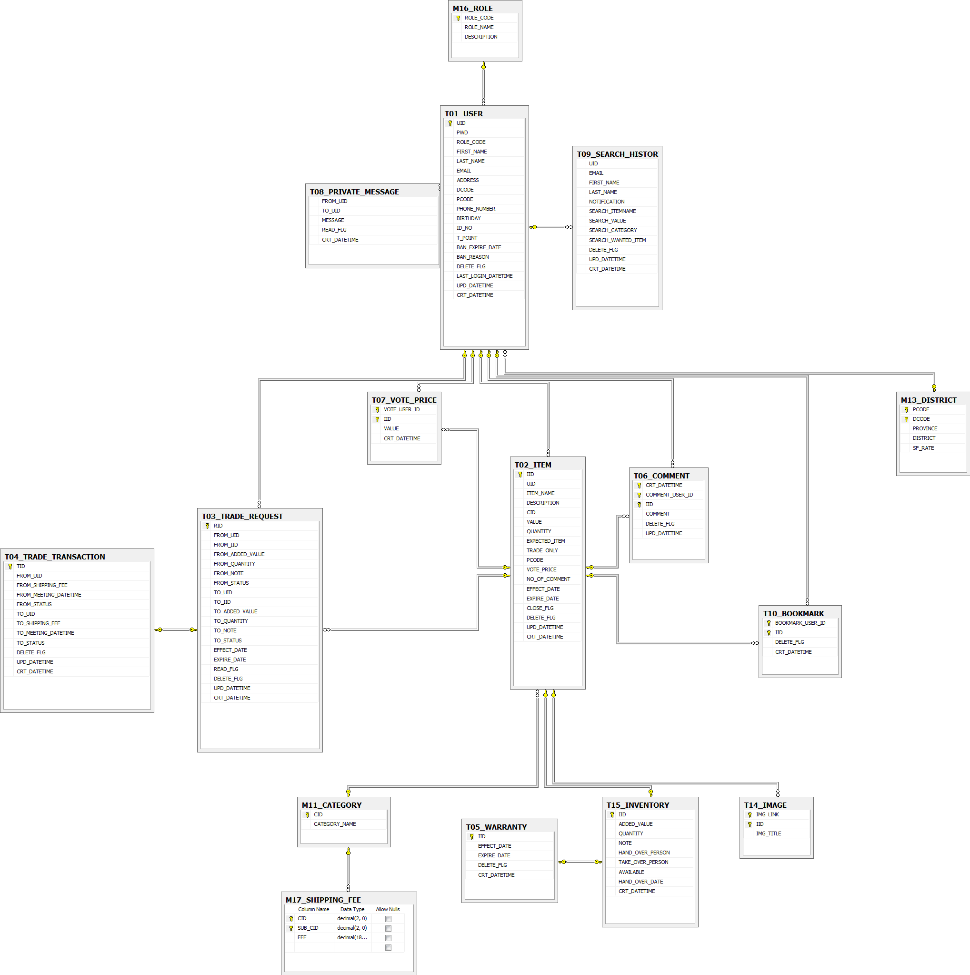

Figure : Data structure

## Other material (if any)

We assume that all requirements are provided by the sponsor and requirements are fully based on sponsor’s requests

Reference sample SRS at [www.opfro.org](http://www.opfro.org)

# Report No.4: Software Design Description (SDD)

## Design overview

### Introduction

The purpose of this document is to provide a software design description for the E-bartering website, fully handled by Team 5. The main objective of this document is to provide design specifications, class diagram, sequence diagram and other technical models involved in the project. This document will serve as the key foundation for the system implementation, and will be used by the developers to implement and integrate E-bartering system.

### Definition, Acronyms and Abbreviation

|  |  |  |
| --- | --- | --- |
| Abbreviations | Description | Comment |
| TBD | To be decided | It means “not decided yet” |
| Windows DDK | Windows Device Development Kit | Development Kit from Microsoft to develop device driver for Windows 2000/XP/Server 2003 OS |

### Reference

[**www.ddth.com**](http://www.ddth.com) **,** [**www.codeproject.com**](http://www.codeproject.com) **,** [**msdn.microsoft.com**](http://msdn.microsoft.com/en-us/library/bb384398.aspx)

## System Architecture Design

Our team decided to choose 3-Tier architecture. 3-Tier architecture is a client-server architecture which generally contains tier 1 (presentation tier, User interface tier), tier 2 (business objects, business logic tier) and tier 3 (data access tier). 3-Tier is more about where the code / processes run (physical location), and 3-Layer is more about how the code is logically grouped.

### Physical

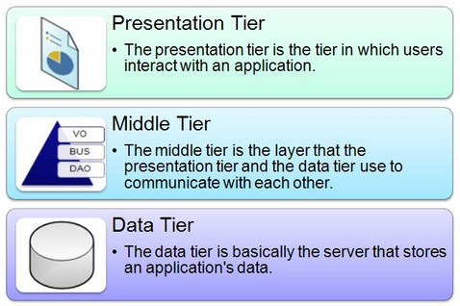

Figure : Explaination for 3-Tier architecture

* **Presentation Tier**  
  Presentation tier includes web browser that enable javascript and support jquery-ui, such as Google Chrome 10.0+, Firefox 3.6+, Internet Explorer 7.0+… This tier provide user-interface for end-user to interact and input data, then it send request and data input to application tier
* **Application Tier / Midle Tier**  
  Application tier is the tier that presentation tier and data tier use to communicate with each other, includes business logic, data access component, such as DataTableAdapter…
* **Data Tier**

This tier includes database server: SQL Server 2008 R2, which that store application’s data to process data-related commands.

### Logical:

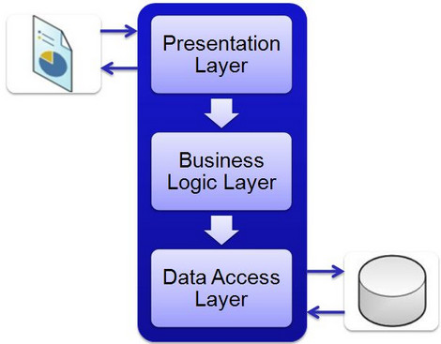

Figure : 3-Tier Architecture

* **Client Layer: Presentation Layer**  
  Presentation layer contains pages like .aspx or windows form where data is presented to the user or input is taken from the user.
* **Business Logic Layer (Biz-Class)**   
  Biz-Class contains business logic, validations or calculations related with the data, if needed. Data will be progressed before access to database.
* **Data Access Layer: Data Table Adapter**

Data table adapter contains methods that helps business layer to connect the data and perform required action, might be returning data or manipulating data (insert, update, delete etc).

Advantage:

* Transformation of the system is easy. Since the business logic is separate from the data access layer, changing the data access layer won’t affect the business logic module much.
* Change management of the system is easy. For example if tax rate change from 10% to 15%, we just need to update code in business logic component.
* Having separate functionality servers allows for parallel development of individual tiers.
* Reusability of the business logic component results in quick development. For example we have modules insert/update/delete customers from databases, we can reuse it in other similar project.

(Reference from [http://www.codeproject.com](http://www.codeproject.com/), last viewed on 20 March 2012)

## Screen flow

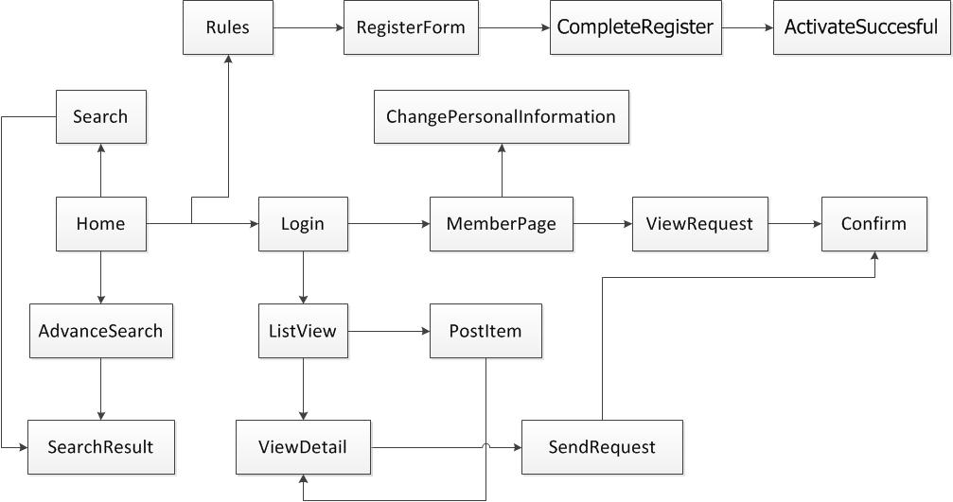

Figure : Screen flow (Members)

|  |  |  |
| --- | --- | --- |
| No | Screen Name | Description |
| 1 | Home | This is the home page of the website. On this screen will display the newest product of each category |
| 2 | ListView | Display all the products of one category |
| 3 | ViewDetail | Display detail of the product, also the page where user can recommend the price, post a comment for that product. This page is also containing battering button. Member can send a request for this product |
| 4 | Login | User us this page to login |
| 5 | MemberPage | After the user login successfully. User will go to this page and see their request or their barter. And member can view their personal information on this page |
| 6 | ForgotPassword | The members enter their ID and the system will change their password, then send them an email |
| 7 | PostItem | User can post item which they want to exchange on this page |
| 8 | AdvanceSearch | User can do more advance search on this page |
| 9 | SearchResult | Where the search result will be displayed |
| 10 | ViewRequest | View all the request of member’s item. On this page member can accept or deny the request |
| 11 | Rules | User will view and accept the rules of website to continue register |
| 12 | RegisterForm | User can register and become member |
| 13 | CompleteRegister | Notice that user register successfully, and send an activation email for user |
| 14 | ActivateSuccesful | Notice that user activates successfully, and send an activation email for user |
| 15 | Confirm | Member confirm the request |
| 16 | ChagePersonalInformation | Members can change their personal infomation |
| 17 | ErrorPage | When error occurs, the system will lead to this page(Error: 404, 500, …) |

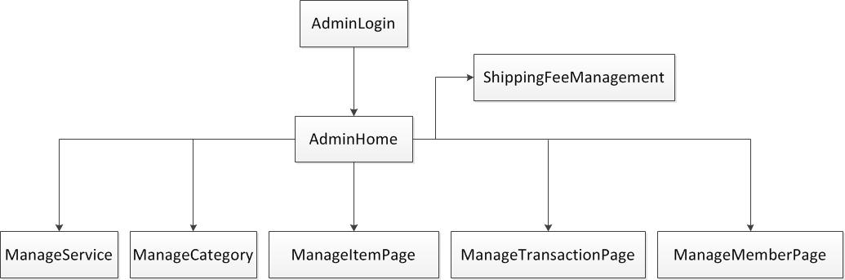

Figure : Screen flow (Admin)

|  |  |  |
| --- | --- | --- |
| No | Screen Name | Description |
| 1 | AdminLogin | Login page for admin |
| 2 | AdminHome | Homepage for admin with toolbar for management |
| 3 | ManageMemberPage | Admin can search for member, activate member, suspend member, delete member |
| 4 | ManageService | Admin update status of services |
| 5 | ManageTransactionPage | Admin can view, update status, and delete transaction |
| 6 | ManageCategory | Admin insert, edit, remove category |
| 7 | ManageItemPage | Admin views, locks, unlock, and delete items of members. In this page admin also delete comment of member |
| 8 | ShippingFeeManagement | Admin insert, edit, delete, and confirm shipping fee |

## Class diagram



Figure : Class Diagram

**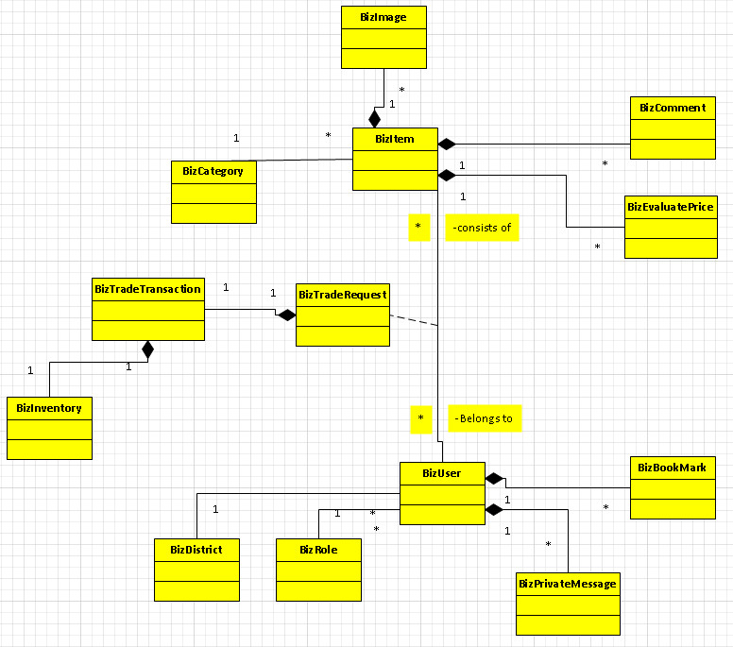**

Figure : Class diagram (Overview)

### BizItem:

Attributes:

N/A

Methods:

|  |  |  |
| --- | --- | --- |
| No | Method | Description |
| 01 | AdminDeleteItemByIid | Delete item by Item ID, used by admin. |
| 02 | AdminUnDeleteItemByIid | Undelete item by Item ID, used by admin. |
| 03 | AdvanceSearchItem | Search items using advance search, more search conditions are used. |
| 04 | AdvanceSearchItemByAdmin | Search items using advance search, more search conditions are used. Used by admin. |
| 05 | CloseItemByIid | Close 1 item using Item ID. |
| 06 | CloseItemByUid | Close all items belong to 1 User ID. |
| 07 | DeleteItemByUid | Delete all items belong to 1 User ID. |
| 08 | FillItemInfo | Load items info. |
| 09 | GetAllStickyItemByAdmin | Get all sticky items. |
| 10 | GetExpreStickyItemByAdmin | Get the expired sticky items, used by admin. |
| 11 | GetItemByIid | Get 1 item info by Item ID. |
| 12 | GetLastestItem | Get the latest items of each category. |
| 13 | GetMyItemsBeingRequested | Get 1 user’s items that being requested. |
| 14 | GetMyItemsRequesting | Get items that 1 user is currently making barter request with. |
| 15 | GetNewItem | Get new items. |
| 16 | GetStickyList | Get sticky list. |
| 17 | PostItem | Post new items to the web site. |
| 18 | QuickSearchItems | Search item using quick search, search by item name and category. |
| 19 | QuickSearchItemsByAdmin | Search item using quick search, search by item name and category. Used by admin. |
| 20 | UnCloseItemByIid | Unclose 1 item using Item id. |
| 21 | UnCloseItemByUid | Unclose all items that belong to 1 User ID. |
| 22 | UpdateItemByIid | Update 1 item info using item ID. |
| 23 | UpdateStickyExpireDate | Update the expire date of sticky item. |
| 24 | ViewItemsByUserId | View item using User ID. |
| 25 | ViewItemsByUserIdAdmin | View item using User ID. Used by admin. |
| 26 | ViewRequestItemByIid | View 1 requested item using Item ID. |
| 27 | OpenItemByIid | Open 1 closed item using item ID. |

##### AdminDeleteItemByIid:

|  |  |  |  |  |  |
| --- | --- | --- | --- | --- | --- |
| No | Parameter | Type | in/out | Default | Description |
| 01 | iid | string | in | blank | Item ID. |
| 02 | reason | string | in | blank | Reason for deletion. |
| 03 | result | int | out | 0 | 1 if succeeded, result otherwise. |

##### AdminUnDeleteItemByIid:

|  |  |  |  |  |  |
| --- | --- | --- | --- | --- | --- |
| No | Parameter | Type | in/out | Default | Description |
| 01 | iid | string | in | blank | Item ID. |
| 02 | result | boolean | out | 0 | 1 if succeeded, result otherwise. |

##### AdvanceSearchItem:

|  |  |  |  |  |  |
| --- | --- | --- | --- | --- | --- |
| No | Parameter | Type | in/out | Default | Description |
| 01 | itemname | string | in | blank | Item name. |
| 02 | category | decimal | in | 0 | Category ID. |
| 03 | expected | string | in | blank | Expected items. |
| 04 | userId | string | in | blank | User ID. |
| 05 | province | string | in | blank | Expected province. |
| 06 | from | string | in | blank | Effective date. |
| 07 | to | string | in | blank | Expire date. |
| 08 | price | decimal | in | 0 | Posted price. |
| 09 | BecItem.ItemDataTable | BecItem.ItemDataTable | out | null | Results data table. |

##### AdvanceSearchItemByAdmin:

|  |  |  |  |  |  |
| --- | --- | --- | --- | --- | --- |
| No | Parameter | Type | in/out | Default | Description |
| 01 | itemname | string | in | blank | Item name. |
| 02 | category | decimal | in | 0 | Category ID. |
| 03 | expected | string | in | blank | Expected items. |
| 04 | userId | string | in | blank | User ID. |
| 05 | province | string | in | blank | Expected province. |
| 06 | from | DateTime | in | blank | Effective date. |
| 07 | to | DateTime | in | blank | Expire date. |
| 08 | price | decimal | in | 0 | Posted price. |
| 09 | closed | string | in | blank | Close flag. |
| 10 | BecItem.ItemDataTable | BecItem.ItemDataTable | out | null | Results data table. |

##### CloseItemByIid:

|  |  |  |  |  |  |
| --- | --- | --- | --- | --- | --- |
| No | Parameter | Type | in/out | Default | Description |
| 01 | iid | string | in | blank | Item ID. |
| 02 | result | boolean | out | 0 | 1 if succeeded, result otherwise. |

##### CloseItemByUid:

|  |  |  |  |  |  |
| --- | --- | --- | --- | --- | --- |
| No | Parameter | Type | in/out | Default | Description |
| 01 | uid | string | in | blank | User ID. |
| 02 | result | boolean | out | 0 | 1 if succeeded, result otherwise. |

##### DeleteItemByUid:

|  |  |  |  |  |  |
| --- | --- | --- | --- | --- | --- |
| No | Parameter | Type | in/out | Default | Description |
| 01 | uid | string | in | blank | User ID. |
| 02 | result | boolean | out | 0 | 1 if succeeded, result otherwise. |

##### FillItemInfo:

|  |  |  |  |  |  |
| --- | --- | --- | --- | --- | --- |
| No | Parameter | Type | in/out | Default | Description |
| 01 | rowItem | BecItem.ItemRow | ref | Null |  |
| 02 | dtImage | BecImage.ImageDataTable | ref | Null |  |
|  | commentPage\_  Count | int | ref | 0 | Number of comment pages. |
|  | iid | string | in | blank | Item ID. |
|  | result | bool | out | True | True if succeeded, false otherwise. |

##### GetAllStickyItemByAdmin:

|  |  |  |  |  |  |
| --- | --- | --- | --- | --- | --- |
| No | Parameter | Type | in/out | Default | Description |
| 01 | result | BecItem.ItemDataTable | out | null | Item data table. |

##### GetExpreStickyItemByAdmin:

|  |  |  |  |  |  |
| --- | --- | --- | --- | --- | --- |
| No | Parameter | Type | in/out | Default | Description |
| 01 | result | BecItem.ItemDataTable | out | null | Item data table. |

##### GetItemByIid:

|  |  |  |  |  |  |
| --- | --- | --- | --- | --- | --- |
| No | Parameter | Type | in/out | Default | Description |
| 01 | iid | string | in | blank | Item ID. |
| 02 | result | boolean | out | 0 | 1 if succeeded, result otherwise. |

##### GetLastestItem:

|  |  |  |  |  |  |
| --- | --- | --- | --- | --- | --- |
| No | Parameter | Type | in/out | Default | Description |
| 01 | result | BecItem.ItemDataTable | out | null | Item data table. |

##### GetMyItemsBeingRequested:

|  |  |  |  |  |  |
| --- | --- | --- | --- | --- | --- |
| No | Parameter | Type | in/out | Default | Description |
| 01 | iid | string | in | blank | Item ID. |
| 02 | result | BecItem.ItemDataTable | out | null | Item data table. |

##### GetMyItemsRequesting:

|  |  |  |  |  |  |
| --- | --- | --- | --- | --- | --- |
| No | Parameter | Type | in/out | Default | Description |
| 01 | iid | string | in | blank | Item ID. |
| 02 | result | BecItem.ItemDataTable | out | null | Item data table. |

##### GetNewItem:

|  |  |  |  |  |  |
| --- | --- | --- | --- | --- | --- |
| No | Parameter | Type | in/out | Default | Description |
| 01 | category | decimal | in | 0 | Category ID. |
| 02 | result | BecItem.ItemDataTable | out | null | Item data table. |

##### GetStickyList:

|  |  |  |  |  |  |
| --- | --- | --- | --- | --- | --- |
| No | Parameter | Type | in/out | Default | Description |
| 01 | result | BecItem.ItemDataTable | out | null | Item data table. |

##### PostItem:

|  |  |  |  |  |  |
| --- | --- | --- | --- | --- | --- |
| No | Parameter | Type | in/out | Default | Description |
| 01 | item | BecItem.ItemRow | in | null | Item data table row. |
| 02 | result | boolean | out | 0 | 1 if succeeded, result otherwise. |

##### QuickSearchItems:

|  |  |  |  |  |  |
| --- | --- | --- | --- | --- | --- |
| No | Parameter | Type | in/out | Default | Description |
| 01 | category | decimal | in | 0 | Category ID. |
| 02 | searchText | string | in | blank | Item name. |
| 03 | result | BecItem.ItemDataTable | out | null | Item data table. |

##### QuickSearchItemsByAdmin:

|  |  |  |  |  |  |
| --- | --- | --- | --- | --- | --- |
| No | Parameter | Type | in/out | Default | Description |
| 01 | category | decimal | in | 0 | Category ID. |
| 02 | searchText | string | in | blank | Item name. |
| 03 | result | BecItem.ItemDataTable | out | null | Item data table. |

##### UpdateItemByIid:

|  |  |  |  |  |  |
| --- | --- | --- | --- | --- | --- |
| No | Parameter | Type | in/out | Default | Description |
| 01 | iid | string | in | blank | Item ID. |
| 02 | itemname | string | in | blank | Item name. |
| 03 | description | string | in | blank | Item description.. |
| 04 | cid | decimal | in | 0 | Category ID. |
| 05 | price | decimal | in | 0 | Posted price. |
| 06 | quantity | decimal | in | 0 | Item quantity. |
| 07 | expected | string | in | blank | Expected items. |
| 08 | tradeOnly | string | in | blank | True if the item owner only want to trade this item, not sell for cash. Flase otherwise. |
| 09 | pcode | decimal | in | blank | Expected province. |
| 10 | dcode | decimal | in | blank | Expected district. |
| 11 | expireDate | dateTime | in | blank | Expire date. |
| 12 | result | int | out | null | 1 if succeeded, result otherwise. |

##### UpdateStickyExpireDate:

|  |  |  |  |  |  |
| --- | --- | --- | --- | --- | --- |
| No | Parameter | Type | in/out | Default | Description |
| 01 | iid | string | in | blank | Item ID. |
| 02 | date | dateTime | in | null | New expire date. |
| 03 | result | int | out | 0 | 1 if succeeded, result otherwise. |

##### ViewItemsByUserId:

|  |  |  |  |  |  |
| --- | --- | --- | --- | --- | --- |
| No | Parameter | Type | in/out | Default | Description |
| 01 | iid | string | in | blank | Item ID. |
| 02 | result | BecItem.ItemDataTable | out | null | Item data table. |

##### ViewItemsByUserIdAdmin:

|  |  |  |  |  |  |
| --- | --- | --- | --- | --- | --- |
| No | Parameter | Type | in/out | Default | Description |
| 01 | iid | string | in | blank | Item ID. |
| 02 | result | BecItem.ItemDataTable | out | null | Item data table. |

##### ViewRequestItemByIid:

|  |  |  |  |  |  |
| --- | --- | --- | --- | --- | --- |
| No | Parameter | Type | in/out | Default | Description |
| 01 | iid | string | in | blank | Item ID. |
| 02 | result | BecItem.ItemDataTable | out | null | Item data table. |

##### OpenItemByIid:

|  |  |  |  |  |  |
| --- | --- | --- | --- | --- | --- |
| No | Parameter | Type | in/out | Default | Description |
| 01 | iid | string | in | blank | Item ID. |
| 02 | result | boolean | out | 0 | 1 if succeeded, result otherwise. |

### BizUser:

Attributes:

N/A

Methods:

|  |  |  |
| --- | --- | --- |
| No | Method | Description |
| 01 | ActivateUser | This method allows the users to activate their account, hence complete their registration. |
| 02 | BanUser | This method allows the users to ban one user account. |
| 03 | CheckEmailAvailability | Check to see if the email used for register has existed or not. |
| 04 | CheckUidAvailability | Check to see if the Uid used for register has existed or not. |
| 05 | DeleteUser | This method allows the users to delete one user account. |
| 06 | GetAllMember | Get members list. |
| 07 | GetLoginAdmin | Check Iid and Password of admin up on logging in. |
| 08 | GetLoginUser | Check Iid and Password of members up on logging in. |
| 09 | GetUserInactivate |  |
| 10 | RegisterUser | This method allows the users to register into the system. |
| 11 | ResetPassword | This method allows the users to reset their password using their USERID, an email will then be sent to notify them their new password. |
| 12 | UnbanUser | This method allows the users to activate one user account. |
| 13 | UpdatePassword | This method allows the users to reset their password using their EMAIL\_ADDRESS, an email will then be sent to notify them their new password. |
| 14 | UpdateUserAddress | Update user address. |
| 15 | UpdateUserBirthDay | Update user birthday. |
| 16 | UpdateUserDcode | Update user district code. |
| 17 | UpdateUserFirstName | Update user first name. |
| 18 | UpdateIDNO | Update user IDNO. |
| 19 | UpdateUserInfo | Update user information. |
| 20 | UpdateUserLastName | U Update user last name. |
| 21 | UpdateUserPcode | Update user province code. |
| 22 | UpdateUserPhone | Update user phone number. |

##### ActivateUser:

|  |  |  |  |  |  |
| --- | --- | --- | --- | --- | --- |
| No | Parameter | Type | in/out | Default | Description |
| 01 | uid | string | in | blank | User ID. |
| 02 | result | boolean | out | 0 | 1 if succeeded, result otherwise. |

##### BanUser:

|  |  |  |  |  |  |
| --- | --- | --- | --- | --- | --- |
| No | Parameter | Type | in/out | Default | Description |
| 01 | uid | string | in | blank | User ID. |
| 02 | banReason | string | in | blank | Ban reason. |
| 03 | banDate | DateTime | in | null | Ban expire date. |
| 04 | result | boolean | out | 0 | 1 if succeeded, result otherwise. |

##### CheckEmailAvailability:

|  |  |  |  |  |  |
| --- | --- | --- | --- | --- | --- |
| No | Parameter | Type | in/out | Default | Description |
| 01 | email | string | in | blank | User registed email. |
| 02 | result | boolean | out | 0 | 1 if succeeded, result otherwise. |

##### CheckUidAvailability:

|  |  |  |  |  |  |
| --- | --- | --- | --- | --- | --- |
| No | Parameter | Type | in/out | Default | Description |
| 01 | uid | string | in | blank | User ID. |
| 02 | result | boolean | out | 0 | 1 if succeeded, result otherwise. |

##### DeleteUser:

|  |  |  |  |  |  |
| --- | --- | --- | --- | --- | --- |
| No | Parameter | Type | in/out | Default | Description |
| 01 | uid | string | in | blank | User ID. |
| 02 | result | boolean | out | 0 | 1 if succeeded, result otherwise. |

##### GetAllMember:

|  |  |  |  |  |  |
| --- | --- | --- | --- | --- | --- |
| No | Parameter | Type | in/out | Default | Description |
| 01 | result | BecUser.UserDataTable | out | null | User data table. |

##### GetLoginAdmin:

|  |  |  |  |  |  |
| --- | --- | --- | --- | --- | --- |
| No | Parameter | Type | in/out | Default | Description |
| 01 | uid | string | in | blank | User ID. |
| 02 | pwd | string | in | blank | Password. |
| 03 | result | BecUser.UserRow | out | null | User data table row. |

##### GetLoginUser:

|  |  |  |  |  |  |
| --- | --- | --- | --- | --- | --- |
| No | Parameter | Type | in/out | Default | Description |
| 01 | uid | string | in | blank | User ID. |
| 02 | pwd | string | in | blank | Password. |
| 03 | result | BecUser.UserRow | out | null | User data table row. |

##### GetUserInactivate:

|  |  |  |  |  |  |
| --- | --- | --- | --- | --- | --- |
| No | Parameter | Type | in/out | Default | Description |
| 01 | uid | string | in | blank | User ID. |
| 02 | email | string | in | blank | User registed email. |
| 03 | result | BecUser.UserRow | out | null | User data table row. |

##### RegisterUser:

|  |  |  |  |  |  |
| --- | --- | --- | --- | --- | --- |
| No | Parameter | Type | in/out | Default | Description |
| 01 | user | BecUser.UserRow | in | null | User data table row. |
| 02 | result | boolean | out | 0 | 1 if succeeded, result otherwise. |

##### ResetPassword:

|  |  |  |  |  |  |
| --- | --- | --- | --- | --- | --- |
| No | Parameter | Type | in/out | Default | Description |
| 01 | uid | string | in | blank | User ID. |
| 02 | email | string | in | blank | User registed email. |
| 03 | newPass | string | in | blank | User’s new password. |
| 04 | result | BecUser.UserRow | out | null | User data table row. |

##### UnbanUser:

|  |  |  |  |  |  |
| --- | --- | --- | --- | --- | --- |
| No | Parameter | Type | in/out | Default | Description |
| 01 | uid | string | in | blank | User ID. |
| 02 | result | boolean | out | 0 | 1 if succeeded, result otherwise. |

##### UpdatePassword:

|  |  |  |  |  |  |
| --- | --- | --- | --- | --- | --- |
| No | Parameter | Type | in/out | Default | Description |
| 01 | uid | string | in | blank | User ID. |
| 02 | newPassword | string | in | blank | User’s new password. |
| 03 | oldPassword | string | in | blank | User’s old password. |
| 04 | result | boolean | out | 0 | 1 if succeeded, result otherwise. |

##### UpdateUserAddress:

|  |  |  |  |  |  |
| --- | --- | --- | --- | --- | --- |
| No | Parameter | Type | in/out | Default | Description |
| 01 | uid | string | in | blank | User ID. |
| 02 | address | string | in | blank | User’s address. |
| 04 | result | boolean | out | 0 | 1 if succeeded, result otherwise. |

##### UpdateUserBirthDay:

|  |  |  |  |  |  |
| --- | --- | --- | --- | --- | --- |
| No | Parameter | Type | in/out | Default | Description |
| 01 | uid | string | in | blank | User ID. |
| 02 | birthday | string | in | blank | User’s birthday. |
| 04 | result | boolean | out | 0 | 1 if succeeded, result otherwise. |

##### UpdateUserDcode:

|  |  |  |  |  |  |
| --- | --- | --- | --- | --- | --- |
| No | Parameter | Type | in/out | Default | Description |
| 01 | uid | string | in | blank | User ID. |
| 02 | dcode | decimal | in | 0 | District code. |
| 04 | result | boolean | out | 0 | 1 if succeeded, result otherwise. |

##### UpdateUserFirstName:

|  |  |  |  |  |  |
| --- | --- | --- | --- | --- | --- |
| No | Parameter | Type | in/out | Default | Description |
| 01 | uid | string | in | blank | User ID. |
| 02 | firstname | string | in | blank | User’s first name. |
| 04 | result | boolean | out | 0 | 1 if succeeded, result otherwise. |

##### UpdateIDNO:

|  |  |  |  |  |  |
| --- | --- | --- | --- | --- | --- |
| No | Parameter | Type | in/out | Default | Description |
| 01 | uid | string | in | blank | User ID. |
| 02 | IDNO | string | in | blank | IDNO. |
| 04 | result | boolean | out | 0 | 1 if succeeded, result otherwise. |

##### UpdateUserInfo:

|  |  |  |  |  |  |
| --- | --- | --- | --- | --- | --- |
| No | Parameter | Type | in/out | Default | Description |
| 01 | user | BecUser.UserRow | in | null | User data table row. |
| 04 | result | boolean | out | 0 | 1 if succeeded, result otherwise. |

##### UpdateUserLastName:

|  |  |  |  |  |  |
| --- | --- | --- | --- | --- | --- |
| No | Parameter | Type | in/out | Default | Description |
| 01 | uid | string | in | blank | User ID. |
| 02 | lastname | string | in | blank | User’s last name. |
| 04 | result | boolean | out | 0 | 1 if succeeded, result otherwise. |

##### UpdateUserPcode:

|  |  |  |  |  |  |
| --- | --- | --- | --- | --- | --- |
| No | Parameter | Type | in/out | Default | Description |
| 01 | uid | string | in | blank | User ID. |
| 02 | pcode | decimal | in | 0 | Province code. |
| 04 | result | boolean | out | 0 | 1 if succeeded, result otherwise. |

##### UpdateUserPhone:

|  |  |  |  |  |  |
| --- | --- | --- | --- | --- | --- |
| No | Parameter | Type | in/out | Default | Description |
| 01 | uid | string | in | blank | User ID. |
| 02 | phone | decimal | in | 0 | The user’s phone number. |
| 04 | result | boolean | out | 0 | 1 if succeeded, result otherwise. |

### BizTradeRequest:

Attributes:

N/A

Methods:

|  |  |  |
| --- | --- | --- |
| No | Method | Description |
| 01 | AcceptRequestToMe | Accept request from others to item owners. |
| 02 | AcceptRequestFromMe | Accept request from item owners to others. |
| 03 | CheckBothSideAccept | Check to see if both side statuses are ACCEPTED. |
| 04 | CreateBarterRequest | Create a new barter request. |
| 05 | GetPreviewRequest | Get preview request information of items. |
| 06 | GetRequestDetailsByRid | Get one request details using REQUEST\_ID. |
| 07 | GetRequestID | Get REQUEST\_ID. |
| 08 | GetRequestsOfItem | Get all requests of 1 item. |
| 09 | InsertTransaction | Create transaction up on both side accepts. |
| 10 | RejectRequest | Reject barter request. |
| 11 | SelectTransactionByUid | Get transactions of 1 specific USER\_ID. |
| 12 | UpdateRequestFromMe | Update request from item owners to others. |
| 13 | UpdateRequestToMe | Update request from others to item owners. |

##### AcceptRequestToMe:

|  |  |  |  |  |  |
| --- | --- | --- | --- | --- | --- |
| No | Parameter | Type | in/out | Default | Description |
| 01 | iid | string | in | blank | ITEM\_ID |
| 02 | result | boolean | out | 1 | 1 if succeeded, false otherwise. |

##### AcceptRequestFromMe:

|  |  |  |  |  |  |
| --- | --- | --- | --- | --- | --- |
| No | Parameter | Type | in/out | Default | Description |
| 01 | iid | string | in | blank | ITEM \_ID |
| 02 | result | boolean | out | 1 | 1 if succeeded, false otherwise. |

##### CheckBothSideAccept:

|  |  |  |  |  |  |
| --- | --- | --- | --- | --- | --- |
| No | Parameter | Type | in/out | Default | Description |
| 01 | rid | string | in | blank | REQUEST\_ID. |
| 02 | result | BecRequest.Request  DataTable | out | true | Request data table results. |

##### CreateBarterRequest:

|  |  |  |  |  |  |
| --- | --- | --- | --- | --- | --- |
| No | Parameter | Type | in/out | Default | Description |
| 01 | requestRow | BecRequest.Request  Row | in | null | Request data table rows. |
| 02 | result | boolean | out | 1 | 1 if succeeded, false otherwise. |

##### GetPreviewRequest:

|  |  |  |  |  |  |
| --- | --- | --- | --- | --- | --- |
| No | Parameter | Type | in/out | Default | Description |
| 01 | iid | string | in | blank | ITEM \_ID |
| 02 | result | BecRequest.Request  DataTable | out | true | Request data table results. |

##### GetRequestDetailsByRid:

|  |  |  |  |  |  |
| --- | --- | --- | --- | --- | --- |
| No | Parameter | Type | in/out | Default | Description |
| 01 | rid | string | in | blank | REQUEST\_ID. |
| 02 | result | BecRequest.Request  DataTable | out | true | Request data table results. |

##### GetRequestID:

|  |  |  |  |  |  |
| --- | --- | --- | --- | --- | --- |
| No | Parameter | Type | in/out | Default | Description |
| 01 | iid | string | in | blank | ITEM \_ID. |
| 02 | uid | string | in | blank | USER\_ID. |
| 03 | result | string | out | blank | REQUEST\_ID. |

##### GetRequestsOfItem:

|  |  |  |  |  |  |
| --- | --- | --- | --- | --- | --- |
| No | Parameter | Type | in/out | Default | Description |
| 01 | iid | string | in | blank | ITEM \_ID. |
| 02 | result | BecRequest.Request  DataTable | out | true | Request data table results. |

##### InsertTransaction:

|  |  |  |  |  |  |
| --- | --- | --- | --- | --- | --- |
| No | Parameter | Type | in/out | Default | Description |
| 01 | tid | string | in | blank | TRANSACTION\_ID. |
| 02 | fuid | string | in | blank | FROM\_USER\_ID. |
| 03 | tuid | string | in | blank | TO\_USER\_ID. |
| 04 | result | boolean | out | 1 | 1 if succeeded, false otherwise. |

##### RejectRequest:

|  |  |  |  |  |  |
| --- | --- | --- | --- | --- | --- |
| No | Parameter | Type | in/out | Default | Description |
| 01 | rid | string | in | blank | REQUEST\_ID. |
| 02 | result | boolean | out | 1 | 1 if succeeded, false otherwise. |

##### SelectTransactionByUid:

|  |  |  |  |  |  |
| --- | --- | --- | --- | --- | --- |
| No | Parameter | Type | in/out | Default | Description |
| 01 | uid | string | in | blank | USER\_ID. |
| 02 | result | BecRequest.Request  DataTable | out | true | Request data table results. |

##### UpdateRequestFromMe:

|  |  |  |  |  |  |
| --- | --- | --- | --- | --- | --- |
| No | Parameter | Type | in/out | Default | Description |
| 01 | rid | string | in | blank | REQUEST\_ID. |
| 02 | fromQuantity | decimal | in | 0 | From quantity. |
| 03 | fromMoney | decimal | in | 0 | From added values. |
| 04 | fromNote | string | in | blank | From notes. |
| 05 | result | boolean | out | 1 | 1 if succeeded, false otherwise. |

##### UpdateRequestToMe:

|  |  |  |  |  |  |
| --- | --- | --- | --- | --- | --- |
| No | Parameter | Type | in/out | Default | Description |
| 01 | rid | string | in | blank | REQUEST\_ID. |
| 02 | toQuantity | decimal | in | 0 | To quantity. |
| 03 | toMoney | decimal | in | 0 | To added values. |
| 04 | toNote | string | in | blank | To notes. |
| 05 | result | boolean | out | 1 | 1 if succeeded, false otherwise. |

### BizCategory:

Attributes:

N/A

Methods:

|  |  |  |
| --- | --- | --- |
| No | Method | Description |
| 01 | GetCategoryList | This method gets the list of all categories. |
| 02 | GetShippingFeeOf  \_Category | This method gets the list of all categories and their corresponding suggested shipping fee. |
| 03 | InsertCategory | This method allows the users to insert new categories. |
| 04 | UpdateCategory | This method allows the users to update categories. |
| 05 | DeleteCategory | This method allows the users to delete categories. |
| 06 | DeleteSubCategory | This method allows the users to delete sub-categories. |

##### GetCategoryList:

|  |  |  |  |  |  |
| --- | --- | --- | --- | --- | --- |
| No | Parameter | Type | in/out | Default | Description |
| 01 | GetCategoryList | Category[] | out | null | Instance of the data entity class Category consists of categories’ information. |

##### GetShippingFeeOfCategory:

|  |  |  |  |  |  |
| --- | --- | --- | --- | --- | --- |
| No | Parameter | Type | in/out | Default | Description |
| 01 | GetShippingFeeOfCategory | Category[] | out | null | Instance of the data entity class Category consists of categories’ information. |

##### InsertCategory:

|  |  |  |  |  |  |
| --- | --- | --- | --- | --- | --- |
| No | Parameter | Type | in/out | Default | Description |
| 01 | category | Category | in | null | Instance of the data entity class Category consists of categories’ information. |
| 02 | InsertCategory | boolean | out | true | True if succeeded, false otherwise. |

##### UpdateCategory:

|  |  |  |  |  |  |
| --- | --- | --- | --- | --- | --- |
| No | Parameter | Type | in/out | Default | Description |
| 01 | category | Category | in | null | Instance of the data entity class Category consists of categories’ information. |
| 02 | UpdateCategory | boolean | out | true | True if succeeded, false otherwise. |

##### DeleteCategory:

|  |  |  |  |  |  |
| --- | --- | --- | --- | --- | --- |
| No | Parameter | Type | in/out | Default | Description |
| 01 | cid | decimal | in | 0 | CATEGORY\_ID. |
| 02 | DeleteCategory | boolean | out | true | True if succeeded, false otherwise. |

##### DeleteSubCategory:

|  |  |  |  |  |  |
| --- | --- | --- | --- | --- | --- |
| No | Parameter | Type | in/out | Default | Description |
| 01 | cid | decimal | in | 0 | CATEGORY\_ID. |
| 02 | Sub\_cid | decimal | in | 0 | SUB\_CATEGORY\_ID |
| 03 | DeleteCategory | boolean | out | true | True if succeeded, false otherwise. |

### BizDistrict:

Attributes:

N/A

Methods:

|  |  |  |
| --- | --- | --- |
| No | Method | Description |
| 01 | GetDistrictList | This method gets the list of all districts. |
| 02 | GetProvinceList | This method gets the list of all provinces. |
| 03 | InsertDistrict | This method allows the users to insert new districts. |
| 04 | UpdateDistrict | This method allows the users to update districts. |
| 05 | DeleteProvince | This method allows the users to delete provinces. |
| 06 | DeleteDistrict | This method allows the users to delete districts |

##### GetDistrictList:

|  |  |  |  |  |  |
| --- | --- | --- | --- | --- | --- |
| No | Parameter | Type | in/out | Default | Description |
| 01 | GetDistrictList | District[] | out | null | Instance of the data entity class District consists of districts’ information. |

##### GetProvinceList:

|  |  |  |  |  |  |
| --- | --- | --- | --- | --- | --- |
| No | Parameter | Type | in/out | Default | Description |
| 01 | GetProvinceList | District[] | out | null | Instance of the data entity class District consists of districts’ information. |

##### InsertDistrict:

|  |  |  |  |  |  |
| --- | --- | --- | --- | --- | --- |
| No | Parameter | Type | in/out | Default | Description |
| 01 | district | District | in | null | Instance of the data entity class District consists of districts’ information. |
| 02 | InsertDistrict | boolean | out | true | True if succeeded, false otherwise. |

##### UpdateDistrict:

|  |  |  |  |  |  |
| --- | --- | --- | --- | --- | --- |
| No | Parameter | Type | in/out | Default | Description |
| 01 | district | District | in | null | Instance of the data entity class District consists of districts’ information. |
| 02 | UpdateDistrict | boolean | out | true | True if succeeded, false otherwise. |

##### DeleteProvince:

|  |  |  |  |  |  |
| --- | --- | --- | --- | --- | --- |
| No | Parameter | Type | in/out | Default | Description |
| 01 | pcode | decimal | in | 0 | PROVINCE\_CODE |
| 02 | DeleteProvince | boolean | out | true | True if succeeded, false otherwise. |

##### DeleteDistrict:

|  |  |  |  |  |  |
| --- | --- | --- | --- | --- | --- |
| No | Parameter | Type | in/out | Default | Description |
| 01 | pcode | decimal | in | 0 | PROVINCE\_CODE |
| 02 | dcode | decimal | in | 0 | DISTRICT\_CODE |
| 03 | DeleteProvince | boolean | out | true | True if succeeded, false otherwise. |

### BizImage:

Attributes:

N/A

Methods:

|  |  |  |
| --- | --- | --- |
| No | Method | Description |
| 01 | GetListImage | This method gets the list of all districts. |
| 02 | InsertImage | This method allows the users to insert new images. |
| 03 | UpdateImage | This method allows the users to update images. |
| 04 | DeleteImage | This method allows the users to delete images. |

##### GetListImage:

|  |  |  |  |  |  |
| --- | --- | --- | --- | --- | --- |
| No | Parameter | Type | in/out | Default | Description |
| 01 | GetListImage | Image[] | in | null | Instance of the data entity class Image consists of images’ information. |

##### InsertImage:

|  |  |  |  |  |  |
| --- | --- | --- | --- | --- | --- |
| No | Parameter | Type | in/out | Default | Description |
| 01 | images | Image | in | null | Instance of the data entity class Image consists of images’ information. |
| 02 | InsertImage | boolean | out | true | True if succeeded, false otherwise. |

##### UpdateImage:

|  |  |  |  |  |  |
| --- | --- | --- | --- | --- | --- |
| No | Parameter | Type | in/out | Default | Description |
| 01 | images | Image | in | null | Instance of the data entity class Image consists of images’ information. |
| 02 | UpdateImage | boolean | out | true | True if succeeded, false otherwise. |

##### DeleteImage:

|  |  |  |  |  |  |
| --- | --- | --- | --- | --- | --- |
| No | Parameter | Type | in/out | Default | Description |
| 01 | iid | decimal | in | 0 | IMAGE\_ID |
| 02 | DeleteImage | boolean | out | true | True if succeeded, false otherwise. |

### BizComment:

Attributes:

N/A

Methods:

|  |  |  |
| --- | --- | --- |
| No | Method | Description |
| 01 | GetListComment | This method gets the list of all comments. |
| 02 | InsertComment | This method allows the users to insert new comments. |
| 03 | RemoveComment | This method allows the users to remove comments. |

##### GetListComment:

|  |  |  |  |  |  |
| --- | --- | --- | --- | --- | --- |
| No | Parameter | Type | in/out | Default | Description |
| 01 | GetListComment | Comment[] | in | null | Instance of the data entity class Comment consists of comments’ information. |

##### InsertComment:

|  |  |  |  |  |  |
| --- | --- | --- | --- | --- | --- |
| No | Parameter | Type | in/out | Default | Description |
| 01 | comment | Comment | in | null | Instance of the data entity class Comment consists of comments’ information. |
| 02 | InsertComment | boolean | out | true | True if succeeded, false otherwise. |

##### RemoveComment:

|  |  |  |  |  |  |  |
| --- | --- | --- | --- | --- | --- | --- |
| No | Parameter | Type | in/out | | Default | Description |
| 01 | cid | decimal | in | 0 | | COMMENT\_ID |
| 02 | Remove  \_Comment | boolean | out | true | | True if succeeded, false otherwise. |

### BizEvaluatePrice:

Attributes:

N/A

Methods:

|  |  |  |
| --- | --- | --- |
| No | Method | Description |
| 01 | InsertEvaluatePrice | This method allows the users to insert new evaluate price. |
| 02 | CalculateAverageValue | This method calculates the average prices of the items. |
| 03 | GetEvaragePrice | This method gets the average price. |

##### GetEvaragePrice:

|  |  |  |  |  |  |
| --- | --- | --- | --- | --- | --- |
| No | Parameter | Type | in/out | Default | Description |
| 01 | GetEvaragePrice | Evaluate\_Price [] | in | null | Instance of the data entity class Evaluate\_Price consists of evaluate prices’ information. |

##### InsertEvaluatePrice:

|  |  |  |  |  |  |
| --- | --- | --- | --- | --- | --- |
| No | Parameter | Type | in/out | Default | Description |
| 01 | evaluate\_price | Evaluate\_Price | in | null | Instance of the data entity class Evaluate\_Price consists of evaluate price’s information. |
| 02 | InsertEvaluate  \_Price | boolean | out | true | True if succeeded, false otherwise. |

##### CalculateAverageValue:

|  |  |  |  |  |  |
| --- | --- | --- | --- | --- | --- |
| No | Parameter | Type | in/out | Default | Description |
| 01 | iid | String | in | null | ITEM\_ID |
| 02 | Calculate  \_AverageValue | boolean | out | true | True if succeeded, false otherwise. |

### BizPrivateMessage:

Attributes:

N/A

Methods:

|  |  |  |
| --- | --- | --- |
| No | Method | Description |
| 01 | GetListPM | This method gets the list of the users’ PM. |
| 02 | CreatePrivateMessage | This method allows the users to insert new PM. |
| 03 | RemovePrivateMessage | This method allows the users to remove their own PM. |
| 04 | Notification | This method notify the users that they have unread PMs. |
| 05 | GetPMDetails | This method gets a specific users’ PM. |

##### GetListPM:

|  |  |  |  |  |  |
| --- | --- | --- | --- | --- | --- |
| No | Parameter | Type | in/out | Default | Description |
| 01 | GetListPM | Private  \_Messag\_e [] | out | null | Instance of the data entity class PrivateMessage consists of private messages’ information. |

##### GetPMDetails:

|  |  |  |  |  |  |
| --- | --- | --- | --- | --- | --- |
| No | Parameter | Type | in/out | Default | Description |
| 01 | pid | String | in | null | PRIVATE\_MESSAGE\_ID. |
| 02 | GetListPM | Private  \_Messag\_e [] | out | null | Instance of the data entity class PrivateMessage consists of private messages’ information. |

##### CreatePrivateMessage:

|  |  |  |  |  |  |
| --- | --- | --- | --- | --- | --- |
| No | Parameter | Type | in/out | Default | Description |
| 01 | private message | Private  \_Messag\_e | in | null | Instance of the data entity class PrivateMessage consists of private messages’ information. |
| 02 | CreatePrivate  \_Message | boolean | out | true | True if succeeded, false otherwise. |

##### RemovePrivateMessage:

|  |  |  |  |  |  |  |
| --- | --- | --- | --- | --- | --- | --- |
| No | Parameter | Type | in/out | | Default | Description |
| 01 | pmid | decimal | in | 0 | | PRIVATE\_MESSAGE\_ID |
| 02 | Remove  \_Private  \_Message | boolean | out | true | | True if succeeded, false otherwise. |

##### Notification:

|  |  |  |  |  |  |
| --- | --- | --- | --- | --- | --- |
| No | Parameter | Type | in/out | Default | Description |
| 01 | from\_id | String | in | null | FROM\_ID |
| 02 | to\_id | String | in | null | TO\_ID |
| 03 | message | String | in | null | Message body. |
| 04 | Notification | boolean | out | true | True if succeeded, false otherwise. |

### BizBookMark:

Attributes:

N/A

Methods:

|  |  |  |
| --- | --- | --- |
| No | Method | Description |
| 01 | GetListBookMark | This method gets the list of the users’ bookmarks. |
| 02 | InsertNewBookMark | This method allows the users to insert new bookmarks. |
| 03 | RemovePrivateMessage | This method allows the users to remove their own bookmarks. |

##### GetListBookMark:

|  |  |  |  |  |  |
| --- | --- | --- | --- | --- | --- |
| No | Parameter | Type | in/out | Default | Description |
| 01 | GetListBookMark | Book  \_Mark[] | out | null | Instance of the data entity class BookMark consists of bookmarks’ information. |

##### InsertNewBookMark:

|  |  |  |  |  |  |
| --- | --- | --- | --- | --- | --- |
| No | Parameter | Type | in/out | Default | Description |
| 01 | bookmark | Book  \_Mark | in | null | Instance of the data entity class BookMark consists of bookmarks’ information. |
| 02 | InsertNewBookMark | boolean | out | true | True if succeeded, false otherwise. |

##### RemoveBookMark:

|  |  |  |  |  |  |  |
| --- | --- | --- | --- | --- | --- | --- |
| No | Parameter | Type | in/out | | Default | Description |
| 01 | bookmark\_user\_id | String | in | null | | BOOKMARK\_USER\_ID |
| 02 | iid | String | in | null | | ITEM\_ID |
| 03 | RemoveBook  \_Mark | boolean | out | true | | True if succeeded, false otherwise. |

### BizRole:

Attributes:

N/A

Methods:

|  |  |  |
| --- | --- | --- |
| No | Method | Description |
| 01 | GetListRole | This method gets the list of roles. |
| 02 | InsertNewRole | This method allows the users to insert new roles. |
| 03 | UpdateRole | This method allows the users to update roles. |
| 04 | RemovePrivateMessage | This method allows the users to remove roles. |

##### GetListRole:

|  |  |  |  |  |  |
| --- | --- | --- | --- | --- | --- |
| No | Parameter | Type | in/out | Default | Description |
| 01 | GetListRole | Role[] | out | null | Instance of the data entity class Role consists of roles’ information. |

##### InsertNewRole:

|  |  |  |  |  |  |
| --- | --- | --- | --- | --- | --- |
| No | Parameter | Type | in/out | Default | Description |
| 01 | role | Role | in | null | Instance of the data entity class Role consists of roles’ information. |
| 02 | InsertNewRole | boolean | out | true | True if succeeded, false otherwise. |

##### UpdateRole:

|  |  |  |  |  |  |
| --- | --- | --- | --- | --- | --- |
| No | Parameter | Type | in/out | Default | Description |
| 01 | role | Role | in | null | Instance of the data entity class Role consists of roles’ information. |
| 02 | UpdateRole | boolean | out | true | True if succeeded, false otherwise. |

##### RemoveRole:

|  |  |  |  |  |  |
| --- | --- | --- | --- | --- | --- |
| No | Parameter | Type | in/out | Default | Description |
| 01 | Role\_code | String | in | null | ROLE\_CODE |
| 02 | RemoveRole | boolean | out | true | True if succeeded, false otherwise. |

### BizTradeTransaction:

Attributes:

N/A

Methods:

|  |  |  |
| --- | --- | --- |
| No | Method | Description |
| 01 | CheckTransactionByTID | Check transaction by TRANSACTION\_ID. |
| 02 | CheckTransactionByTIDAndUID | Check transaction by TRANSACTION\_ID and USER\_ID. |
| 03 | DeleteTransactionByTID | Delete transaction by TRANSACTION\_ID. |
| 04 | GetAllTransactions | Get all transactions. |
| 05 | GetAvailableTransactions | Get available transactions. |
| 06 | GetTransactionByTID | Get 1 specific transactions by TRANSACTION\_ID. |
| 07 | UpdateFromStatusByTID | Update FROM\_STATUS using TRANSACTION\_ID. |
| 08 | UpdateToStatusByTID | Update TO\_STATUS TRANSACTION\_ID. |
| 09 | UpdateTransactionFrom  \_RecieveDateByTID | Update FROM\_RECIEVE\_DATETIME. |
| 10 | UpdateTransactionFrom  \_SentDateByTID | Update FROM\_SENT\_DATETIME. |
| 11 | UpdateTransactionFrom  \_ShippingFeeByTID | Update FROM\_SHIPPING\_FEE. |
| 12 | UpdateTransactionStatus  \_ByIID | Update TRASACTION\_STATUS. |
| 13 | UpdateTransactionTo  \_RecieveDateByTID | Update TO\_RECIEVE\_DATETIME. |
| 14 | UpdateTransactionTo  \_SentDateByTID | Update TO\_SENT\_DATETIME. |
| 15 | UpdateTransactionTo  \_ShippingFeeByTID | Update TO\_SHIPPING\_FEE. |

##### CheckTransactionByTID:

|  |  |  |  |  |  |
| --- | --- | --- | --- | --- | --- |
| No | Parameter | Type | in/out | Default | Description |
| 01 | tid | string | in | blank | TRANSACTION\_ID. |
| 02 | result | int | out | 1 | 1 if succeeded, 0 otherwise. |

##### CheckTransactionByTIDAndUID:

|  |  |  |  |  |  |
| --- | --- | --- | --- | --- | --- |
| No | Parameter | Type | in/out | Default | Description |
| 01 | tid | string | in | blank | TRANSACTION\_ID. |
| 02 | uid | string | in | blank | USER\_ID. |
| 03 | result | int | out | 1 | 1 if succeeded, 0 otherwise. |

##### DeleteTransactionByTID:

|  |  |  |  |  |  |
| --- | --- | --- | --- | --- | --- |
| No | Parameter | Type | in/out | Default | Description |
| 01 | tid | string | in | blank | TRANSACTION\_ID. |
| 02 | date | string | in | blank | Delete date time. |
| 03 | result | int | out | 1 | 1 if succeeded, 0 otherwise. |

##### GetAllTransactions:

|  |  |  |  |  |  |
| --- | --- | --- | --- | --- | --- |
| No | Parameter | Type | in/out | Default | Description |
| 01 | result | BecTransaction.Transaction  \_DataTable | out | null | Transaction data table results. |

##### GetAvailableTransactions:

|  |  |  |  |  |  |
| --- | --- | --- | --- | --- | --- |
| No | Parameter | Type | in/out | Default | Description |
| 01 | result | BecTransaction.Transaction  \_DataTable | out | null | Transaction data table results. |

##### GetTransactionByTID:

|  |  |  |  |  |  |
| --- | --- | --- | --- | --- | --- |
| No | Parameter | Type | in/out | Default | Description |
| 01 | tid | string | in | blank | TRANSACTION\_ID. |
| 02 | result | BecTransaction.Transaction  \_DataTable | out | null | Transaction data table results. |

##### UpdateFromStatusByTID:

|  |  |  |  |  |  |
| --- | --- | --- | --- | --- | --- |
| No | Parameter | Type | in/out | Default | Description |
| 01 | tid | string | in | blank | TRANSACTION\_ID. |
| 02 | fromStt | string | in | blank | FROM\_STATUS. |
| 03 | result | int | out | 1 | 1 if succeeded, 0 otherwise. |

##### UpdateToStatusByTID:

|  |  |  |  |  |  |
| --- | --- | --- | --- | --- | --- |
| No | Parameter | Type | in/out | Default | Description |
| 01 | tid | string | in | blank | TRANSACTION\_ID. |
| 02 | toStt | string | in | blank | TO\_STATUS. |
| 03 | result | int | out | 1 | 1 if succeeded, 0 otherwise. |

##### UpdateTransactionFromRecieveDateByTID:

|  |  |  |  |  |  |
| --- | --- | --- | --- | --- | --- |
| No | Parameter | Type | in/out | Default | Description |
| 01 | tid | string | in | blank | TRANSACTION\_ID. |
| 02 | fromRecieve  \_Date | string | in | blank | FROM\_RECIEVE\_DATETIME. |
| 03 | result | int | out | 1 | 1 if succeeded, 0 otherwise. |

##### UpdateTransactionFromSentDateByTID:

|  |  |  |  |  |  |
| --- | --- | --- | --- | --- | --- |
| No | Parameter | Type | in/out | Default | Description |
| 01 | tid | string | in | blank | TRANSACTION\_ID. |
| 02 | fromSent  \_Date | string | in | blank | FROM\_SENT\_DATETIME. |
| 03 | result | int | out | 1 | 1 if succeeded, 0 otherwise. |

##### UpdateTransactionFromShipingFeeByTID:

|  |  |  |  |  |  |
| --- | --- | --- | --- | --- | --- |
| No | Parameter | Type | in/out | Default | Description |
| 01 | tid | string | in | blank | TRANSACTION\_ID. |
| 02 | fromShipping  \_Fee | string | in | blank | FROM\_SHIPPING\_FEE. |
| 03 | result | int | out | 1 | 1 if succeeded, 0 otherwise. |

##### UpdateTransactionStatusByTID:

|  |  |  |  |  |  |
| --- | --- | --- | --- | --- | --- |
| No | Parameter | Type | in/out | Default | Description |
| 01 | tid | string | in | blank | TRANSACTION\_ID. |
| 02 | stt | string | in | blank | TRANSACTION \_STATUS. |
| 03 | result | int | out | 1 | 1 if succeeded, 0 otherwise. |

##### UpdateTransactionToRecieveDateByTID:

|  |  |  |  |  |  |
| --- | --- | --- | --- | --- | --- |
| No | Parameter | Type | in/out | Default | Description |
| 01 | tid | string | in | blank | TRANSACTION\_ID. |
| 02 | toRecieve  \_Date | string | in | blank | TO\_RECIEVE\_DATETIME. |
| 03 | result | int | out | 1 | 1 if succeeded, 0 otherwise. |

##### UpdateTransactionToSentDateByTID:

|  |  |  |  |  |  |
| --- | --- | --- | --- | --- | --- |
| No | Parameter | Type | in/out | Default | Description |
| 01 | tid | string | in | blank | TRANSACTION\_ID. |
| 02 | toSent  \_Date | string | in | blank | TO\_SENT\_DATETIME. |
| 03 | result | int | out | 1 | 1 if succeeded, 0 otherwise. |

##### UpdateTransactionToShipingFeeByTID:

|  |  |  |  |  |  |
| --- | --- | --- | --- | --- | --- |
| No | Parameter | Type | in/out | Default | Description |
| 01 | tid | string | in | blank | TRANSACTION\_ID. |
| 02 | toShipping  \_Fee | string | in | blank | TO\_SHIPPING\_FEE. |
| 03 | result | int | out | 1 | 1 if succeeded, 0 otherwise. |

### BizInventory:

Attributes:

N/A

Methods:

|  |  |  |
| --- | --- | --- |
| No | Method | Description |
| 01 | InsertInventory | This method allows the users to insert new item into inventory. |
| 02 | UpdateInventoryStatus | This method allows the users to update in-stock items’ info. |
| 03 | GetListInventory | This method gets the list of in-stock items. |
| 04 | GetInventoryDetails | This method gets one in-stock items info. |

##### InsertInventory:

|  |  |  |  |  |  |
| --- | --- | --- | --- | --- | --- |
| No | Parameter | Type | in/out | Default | Description |
| 01 | inventory | Inventory | in | null | Instance of the data entity class Inventory consists of inventories’ information. |
| 02 | InsertInventory | boolean | out | true | True if succeeded, false otherwise. |

##### UpdateInventoryStatus:

|  |  |  |  |  |  |
| --- | --- | --- | --- | --- | --- |
| No | Parameter | Type | in/out | Default | Description |
| 01 | inventory | Inventory | in | null | Instance of the data entity class Inventory consists of inventories’ information. |
| 02 | Update  \_Inventory  \_Status | boolean | out | true | True if succeeded, false otherwise. |

##### GetListInventory:

|  |  |  |  |  |  |
| --- | --- | --- | --- | --- | --- |
| No | Parameter | Type | in/out | Default | Description |
| 01 | GetListInventory | Inventory[] | in | null | Instance of the data entity class Inventory consists of inventories’ information. |

##### GetInventoryDetails:

|  |  |  |  |  |  |
| --- | --- | --- | --- | --- | --- |
| No | Parameter | Type | in/out | Default | Description |
| 01 | iid |  |  |  |  |
| 02 | GetInventory  \_Details | Inventory | in | null | Instance of the data entity class Inventory consists of inventories’ information. |

## Sequence Diagram

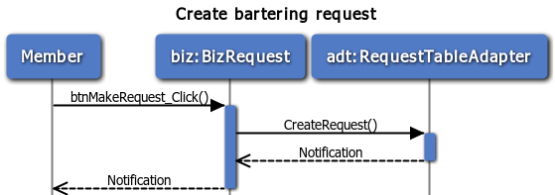

Figure : Create bartering request

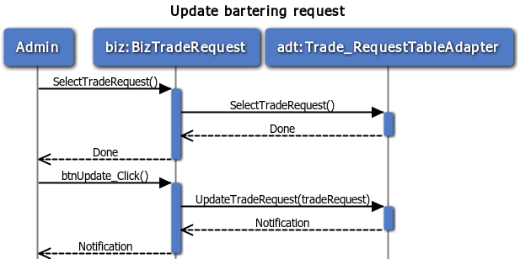

Figure : Update bartering request

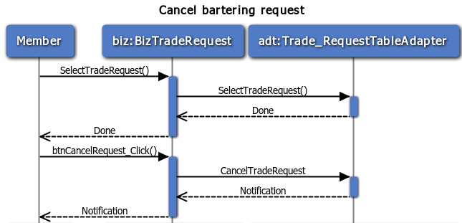

Figure : Cancel bartering request

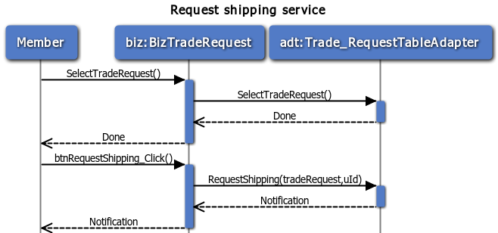

Figure : Request shipping service

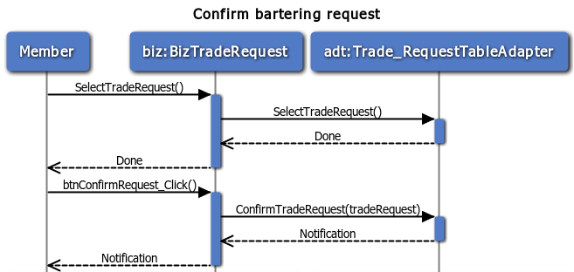

Figure : Confirm bartering request

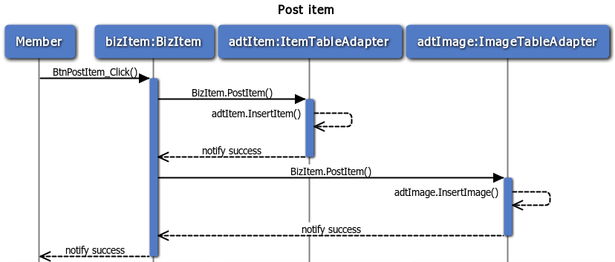

Figure : Post new item

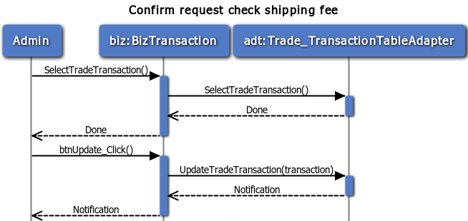

Figure : Confirm request check shipping fee

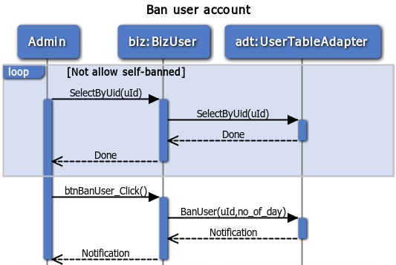

Figure : Ban user account

## User interface design

### Web interface for user

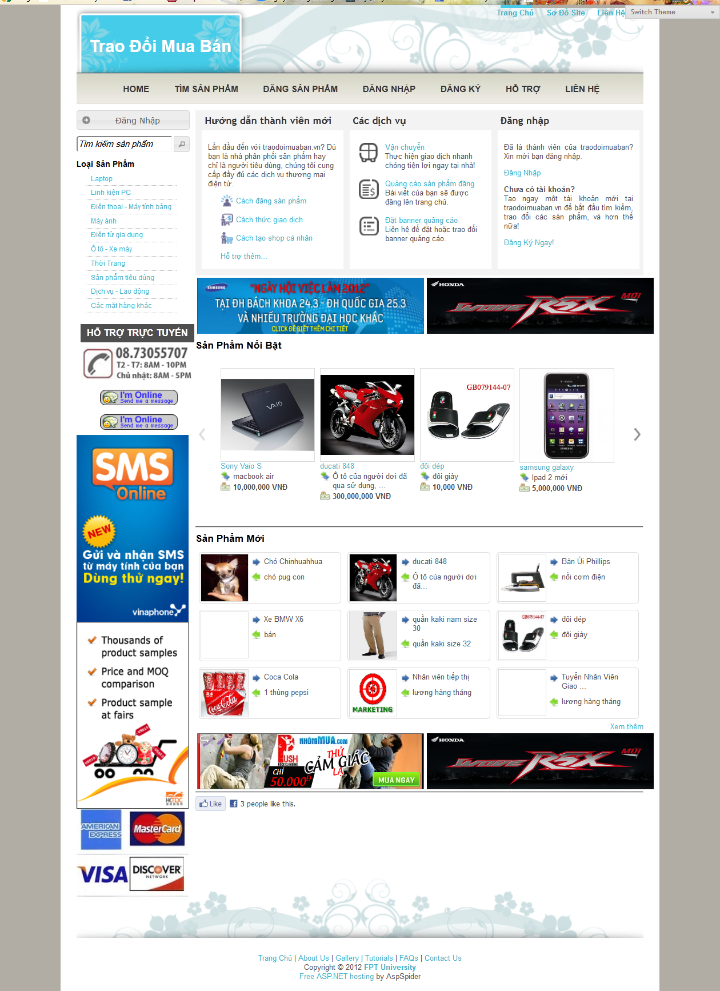

Figure : GUI\_Homepage

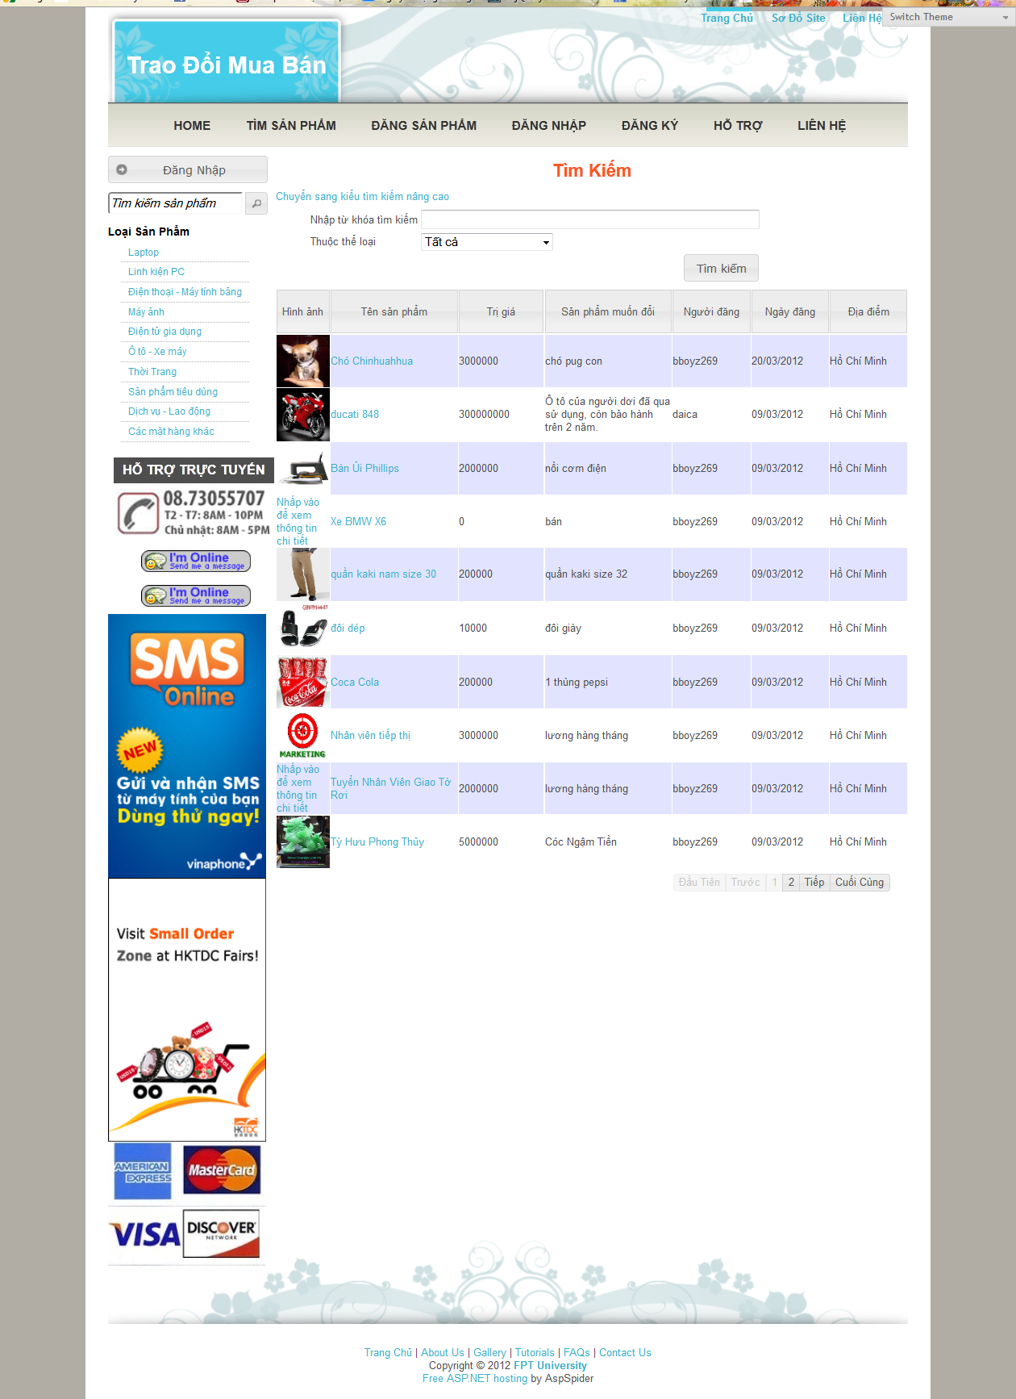

Figure : GUI\_Search page

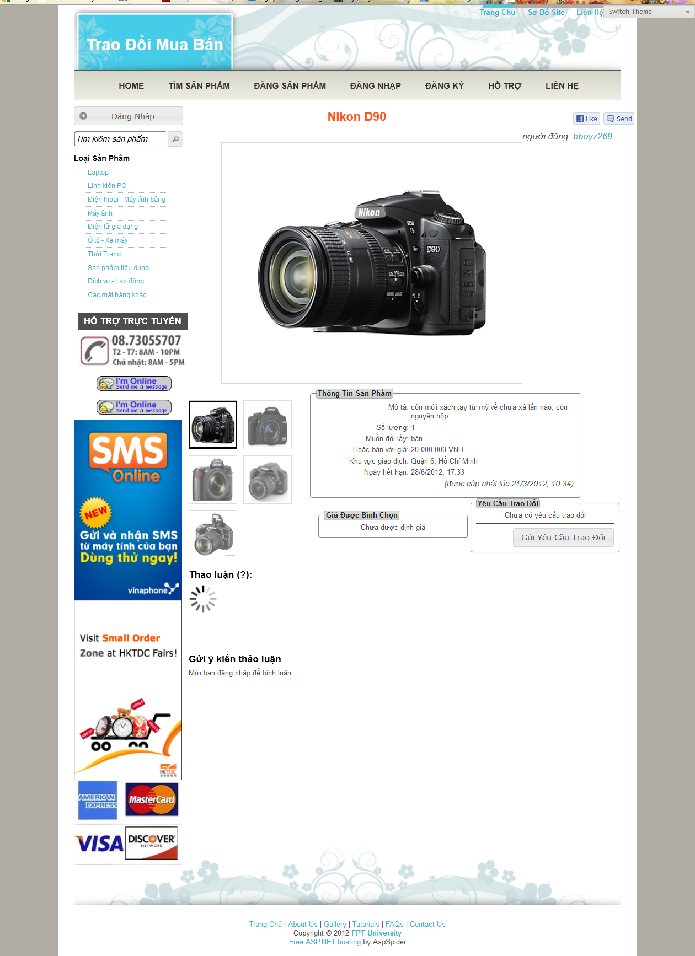

Figure :GUI\_View item details

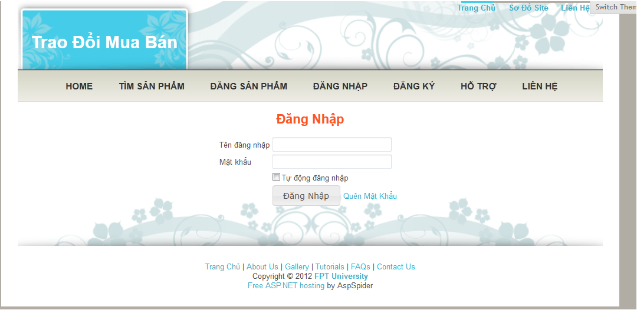

Figure :GUI\_Login

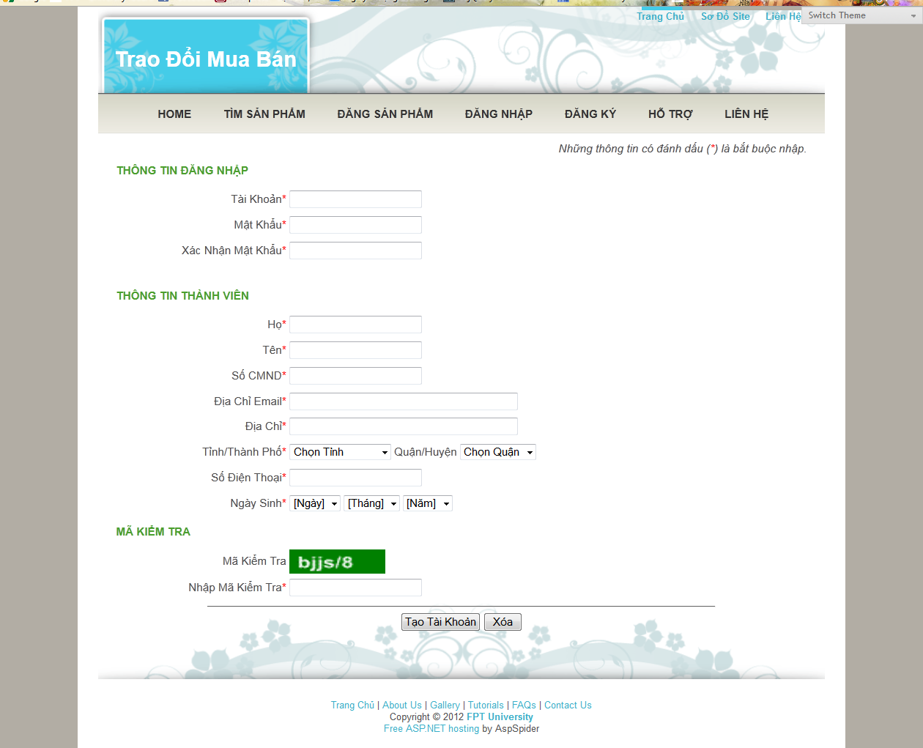

Figure :GUI\_Register

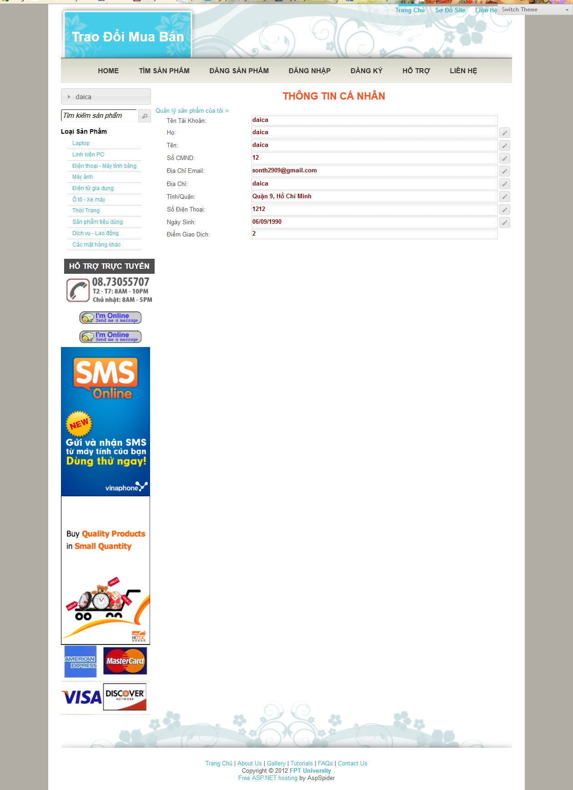

Figure : GUI\_Update user information

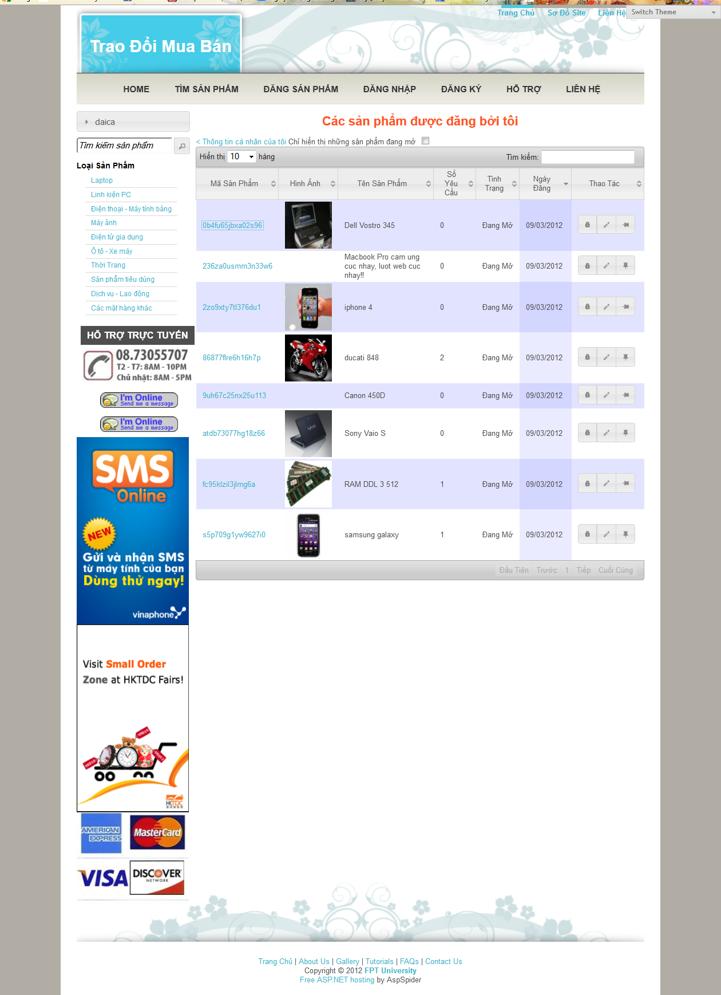

Figure : GUI\_Manage item of user

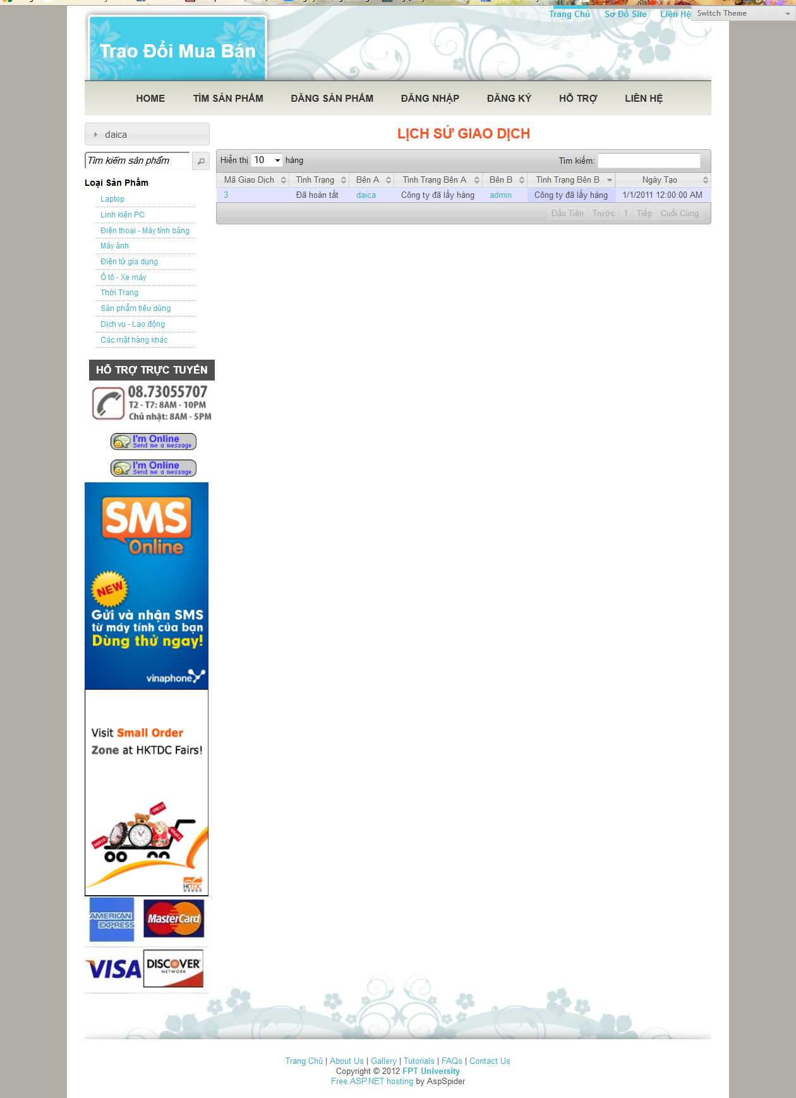

Figure : GUI\_View transaction history

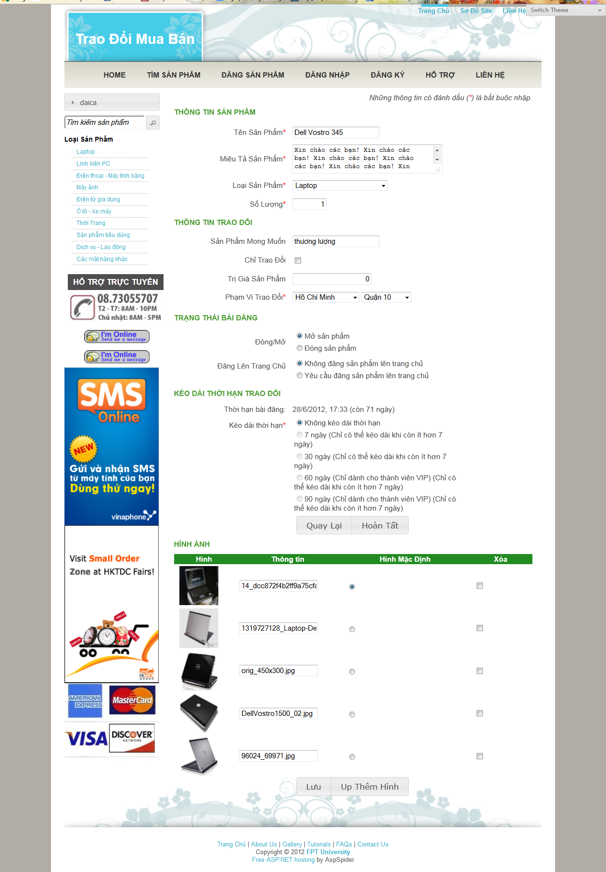

Figure :GUI\_Update item information

### Web interface for admin

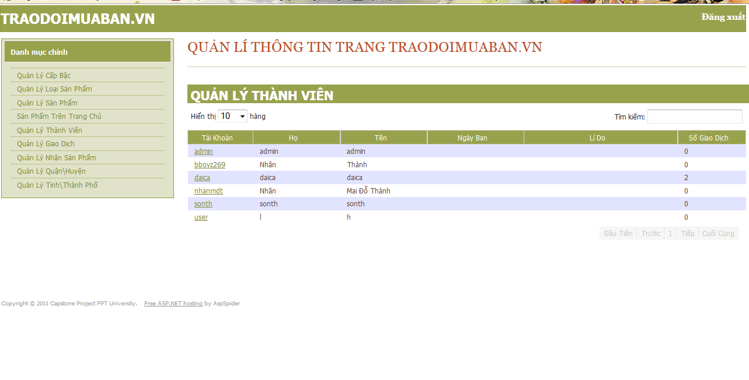

Figure : GUI\_Admin\_Manage user

**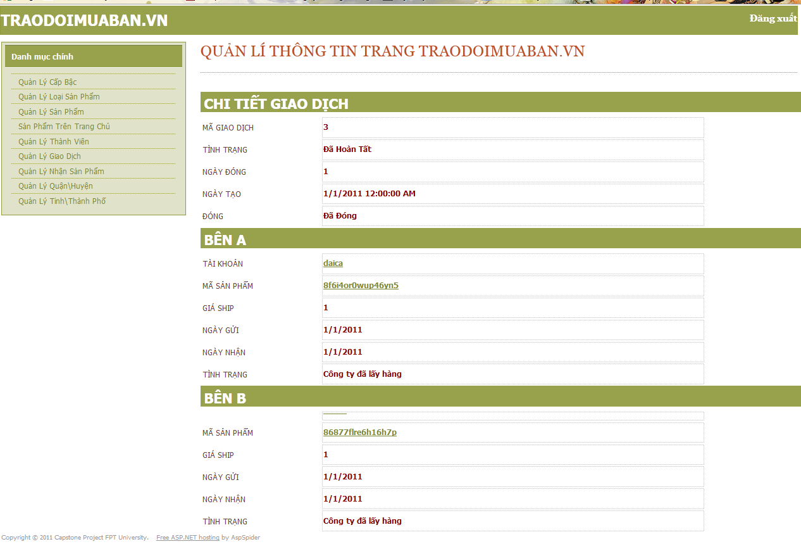**

Figure GUI\_Admin\_Manage transactions

**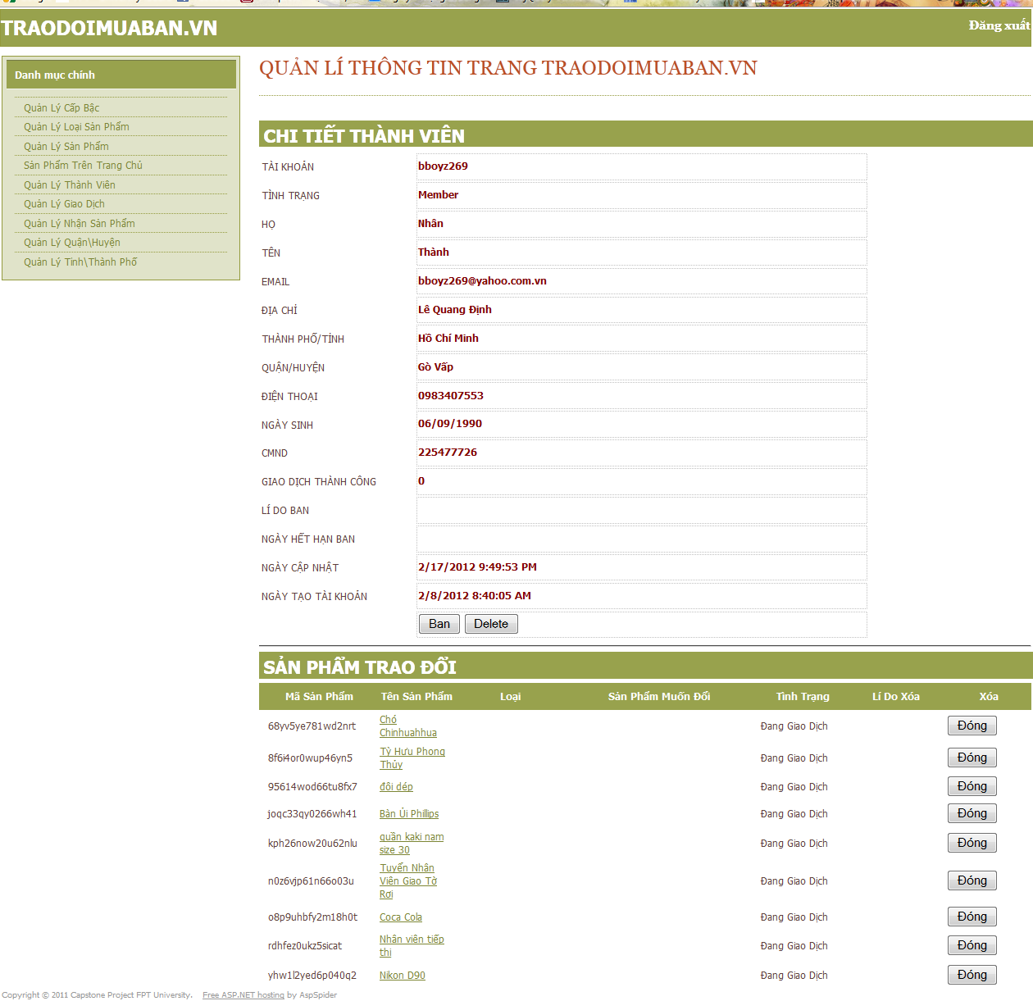**

Figure GUI\_Admin\_Manage members and items

## Data structures



Figure : Data Structure

## Data Dictionary

|  |  |  |  |  |  |
| --- | --- | --- | --- | --- | --- |
| **Table** | **Column** | **Datatype** | **Size** | **Nullable** | **PrimaryKey** |
| M11\_CATEGORY | CID | Decimal (2,0) | 5 | N | Y |
| M11\_CATEGORY | CATEGORY\_NAME | NVarChar (200) | 200 | N | N |
| M11\_CATEGORY | SUB\_CID | Decimal (2,0) | 5 | N | Y |
| M11\_CATEGORY | DESCRIPTION | NVarChar (200) | 200 | N | N |
| M11\_CATEGORY | FEE | Decimal (18,0) | 9 | Y | N |
| M12\_ROLE | ROLE\_CODE | Decimal (2,0) | 5 | N | Y |
| M12\_ROLE | ROLE\_NAME | NVarChar (100) | 100 | N | N |
| M12\_ROLE | DESCRIPTION | NVarChar (100) | 100 | Y | N |
| M13\_DISTRICT | PCODE | Decimal (3,0) | 5 | N | Y |
| M13\_DISTRICT | DCODE | Decimal (2,0) | 5 | N | Y |
| M13\_DISTRICT | PROVINCE | NVarChar (50) | 50 | Y | N |
| M13\_DISTRICT | DISTRICT | NVarChar (50) | 50 | N | N |
| M13\_DISTRICT | SF\_RATE | Decimal (3,1) | 5 | N | N |
| T01\_USER | UID | NVarChar (20) | 20 | N | Y |
| T01\_USER | PWD | NVarChar (20) | 20 | N | N |
| T01\_USER | ROLE\_CODE | Decimal (2,0) | 5 | N | N |
| T01\_USER | FIRST\_NAME | NVarChar (50) | 50 | N | N |
| T01\_USER | LAST\_NAME | NVarChar (50) | 50 | N | N |
| T01\_USER | EMAIL | NVarChar (50) | 50 | N | N |
| T01\_USER | ADDRESS | NVarChar (50) | 50 | N | N |
| T01\_USER | DCODE | Decimal (2,0) | 5 | N | N |
| T01\_USER | PCODE | Decimal (3,0) | 5 | N | N |
| T01\_USER | PHONE\_NUMBER | NVarChar (20) | 20 | N | N |
| T01\_USER | BIRTHDAY | NVarChar (8) | 8 | N | N |
| T01\_USER | ID\_NO | NVarChar (9) | 9 | Y | N |
| T01\_USER | T\_POINT | Decimal (5,0) | 5 | N | N |
| T01\_USER | BAN\_EXPIRE\_DATE | DateTime | 8 | Y | N |
| T01\_USER | BAN\_REASON | NVarChar (1000) | 1000 | Y | N |
| T01\_USER | DELETE\_FLG | NVarChar (1) | 1 | N | N |
| T01\_USER | LAST\_LOGIN\_DATETIME | DateTime | 8 | Y | N |
| T01\_USER | UPD\_DATETIME | DateTime | 8 | Y | N |
| T01\_USER | CRT\_DATETIME | DateTime | 8 | N | N |
| T02\_ITEM | IID | NVarChar (16) | 16 | N | Y |
| T02\_ITEM | UID | NVarChar (20) | 20 | N | N |
| T02\_ITEM | ITEM\_NAME | NVarChar (50) | 50 | N | N |
| T02\_ITEM | DESCRIPTION | NVarChar (1000) | 1000 | N | N |
| T02\_ITEM | CID | Decimal (2,0) | 5 | N | N |
| T02\_ITEM | SUB\_CID | Decimal (2,0) | 5 | N | N |
| T02\_ITEM | VALUE | Decimal (12,0) | 9 | Y | N |
| T02\_ITEM | QUANTITY | Decimal (5,0) | 5 | N | N |
| T02\_ITEM | EXPECTED\_ITEM | NVarChar (1000) | 1000 | N | N |
| T02\_ITEM | TRADE\_ONLY | NVarChar (1) | 1 | N | N |
| T02\_ITEM | PCODE | Decimal (3,0) | 5 | N | N |
| T02\_ITEM | DCODE | Decimal (2,0) | 5 | N | N |
| T02\_ITEM | VOTE\_VALUE | Decimal (18,0) | 9 | Y | N |
| T02\_ITEM | NO\_OF\_COMMENT | Decimal (3,0) | 5 | Y | N |
| T02\_ITEM | EXPIRE\_DATETIME | DateTime | 8 | N | N |
| T02\_ITEM | USER\_CLOSE\_FLG | NVarChar (1) | 1 | N | N |
| T02\_ITEM | ADMIN\_CLOSE\_FLG | NVarChar (1) | 1 | N | N |
| T02\_ITEM | ADMIN\_CLOSE\_REASON | NVarChar (1000) | 1000 | Y | N |
| T02\_ITEM | UPD\_DATETIME | DateTime | 8 | Y | N |
| T02\_ITEM | CRT\_DATETIME | DateTime | 8 | N | N |
| T03\_TRADE\_REQUEST | RID | NVarChar (16) | 16 | N | Y |
| T03\_TRADE\_REQUEST | FROM\_UID | NVarChar (20) | 20 | N | N |
| T03\_TRADE\_REQUEST | FROM\_IID | NVarChar (16) | 16 | Y | N |
| T03\_TRADE\_REQUEST | FROM\_ADDED\_VALUE | Decimal (18,0) | 9 | Y | N |
| T03\_TRADE\_REQUEST | FROM\_QUANTITY | Decimal (5,0) | 5 | Y | N |
| T03\_TRADE\_REQUEST | FROM\_NOTE | NVarChar (1000) | 1000 | Y | N |
| T03\_TRADE\_REQUEST | FROM\_STATUS | NVarChar (1) | 1 | N | N |
| T03\_TRADE\_REQUEST | TO\_UID | NVarChar (20) | 20 | N | N |
| T03\_TRADE\_REQUEST | TO\_IID | NVarChar (16) | 16 | N | N |
| T03\_TRADE\_REQUEST | TO\_ADDED\_VALUE | Decimal (18,0) | 9 | N | N |
| T03\_TRADE\_REQUEST | TO\_QUANTITY | Decimal (5,0) | 5 | N | N |
| T03\_TRADE\_REQUEST | TO\_NOTE | NVarChar (1000) | 1000 | Y | N |
| T03\_TRADE\_REQUEST | TO\_STATUS | NVarChar (1) | 1 | N | N |
| T03\_TRADE\_REQUEST | EXPIRE\_DATETIME | DateTime | 8 | N | N |
| T03\_TRADE\_REQUEST | DENY\_FLG | NVarChar (1) | 1 | N | N |
| T03\_TRADE\_REQUEST | UPD\_DATETIME | DateTime | 8 | N | N |
| T03\_TRADE\_REQUEST | CRT\_DATETIME | DateTime | 8 | N | N |
| T04\_TRADE\_TRANSACTION | TID | NVarChar (16) | 16 | N | Y |
| T04\_TRADE\_TRANSACTION | FROM\_UID | NVarChar (20) | 20 | N | N |
| T04\_TRADE\_TRANSACTION | FROM\_SHIPPING\_FEE | Decimal (18,0) | 9 | Y | N |
| T04\_TRADE\_TRANSACTION | FROM\_SEND\_DATETIME | DateTime | 8 | N | N |
| T04\_TRADE\_TRANSACTION | FROM\_RECEIVE\_DATETIME | DateTime | 8 | N | N |
| T04\_TRADE\_TRANSACTION | FROM\_STATUS | NVarChar (1) | 1 | N | N |
| T04\_TRADE\_TRANSACTION | TO\_UID | NVarChar (20) | 20 | N | N |
| T04\_TRADE\_TRANSACTION | TO\_SHIPPING\_FEE | Decimal (18,0) | 9 | Y | N |
| T04\_TRADE\_TRANSACTION | TO\_SEND\_DATETIME | DateTime | 8 | N | N |
| T04\_TRADE\_TRANSACTION | TO\_RECEIVE\_DATETIME | DateTime | 8 | N | N |
| T04\_TRADE\_TRANSACTION | TO\_STATUS | NVarChar (1) | 1 | N | N |
| T04\_TRADE\_TRANSACTION | DELETE\_FLG | NVarChar (1) | 1 | N | N |
| T04\_TRADE\_TRANSACTION | TRANSACTION\_STATUS | NVarChar (1) | 1 | N | N |
| T04\_TRADE\_TRANSACTION | TRANSACTION\_CLOSE\_DATE | NVarChar (8) | 8 | Y | N |
| T04\_TRADE\_TRANSACTION | UPD\_DATETIME | DateTime | 8 | N | N |
| T04\_TRADE\_TRANSACTION | CRT\_DATETIME | DateTime | 8 | N | N |
| T06\_COMMENT | CRT\_DATETIME | DateTime | 8 | N | Y |
| T06\_COMMENT | COMMENT\_USER\_ID | NVarChar (20) | 20 | N | Y |
| T06\_COMMENT | IID | NVarChar (16) | 16 | N | Y |
| T06\_COMMENT | COMMENT | NVarChar (1000) | 1000 | N | N |
| T06\_COMMENT | DELETE\_FLG | NVarChar (1) | 1 | N | N |
| T07\_VOTE\_VALUE | VOTE\_UID | NVarChar (20) | 20 | N | Y |
| T07\_VOTE\_VALUE | VOTE\_UID | NVarChar (20) | 20 | N | Y |
| T07\_VOTE\_VALUE | IID | NVarChar (16) | 16 | N | Y |
| T07\_VOTE\_VALUE | VOTE\_VALUE | Decimal (18,0) | 9 | N | N |
| T07\_VOTE\_VALUE | CRT\_DATETIME | DateTime | 8 | N | N |
| T08\_PRIVATE\_MESSAGE | FROM\_UID | NVarChar (20) | 20 | N | N |
| T08\_PRIVATE\_MESSAGE | TO\_UID | NVarChar (20) | 20 | N | N |
| T08\_PRIVATE\_MESSAGE | MESSAGE | NVarChar (1000) | 1000 | N | N |
| T08\_PRIVATE\_MESSAGE | READ\_FLG | NVarChar (1) | 1 | N | N |
| T08\_PRIVATE\_MESSAGE | CRT\_DATETIME | DateTime | 8 | N | N |
| T09\_SEARCH\_HISTORY | UID | NVarChar (20) | 20 | N | N |
| T09\_SEARCH\_HISTORY | EMAIL | NVarChar (16) | 16 | N | N |
| T09\_SEARCH\_HISTORY | FIRST\_NAME | NVarChar (50) | 50 | N | N |
| T09\_SEARCH\_HISTORY | LAST\_NAME | NVarChar (50) | 50 | N | N |
| T09\_SEARCH\_HISTORY | NOTIFICATION | NVarChar (1) | 1 | N | N |
| T09\_SEARCH\_HISTORY | SEARCH\_ITEMNAME | NVarChar (50) | 50 | Y | N |
| T09\_SEARCH\_HISTORY | SEARCH\_VALUE | Decimal (18,0) | 9 | Y | N |
| T09\_SEARCH\_HISTORY | SEARCH\_CATEGORY | NVarChar (20) | 20 | Y | N |
| T09\_SEARCH\_HISTORY | SEARCH\_WANTED\_ITEM | NVarChar (1000) | 1000 | Y | N |
| T09\_SEARCH\_HISTORY | DELETE\_FLG | NVarChar (1) | 1 | N | N |
| T09\_SEARCH\_HISTORY | UPD\_DATETIME | NChar (10) | 10 | N | N |
| T09\_SEARCH\_HISTORY | CRT\_DATETIME | NChar (10) | 10 | N | N |
| T10\_BOOKMARK | BOOKMARK\_USER\_ID | NVarChar (20) | 20 | N | Y |
| T10\_BOOKMARK | IID | NVarChar (16) | 16 | N | Y |
| T10\_BOOKMARK | DELETE\_FLG | NVarChar (1) | 1 | N | N |
| T10\_BOOKMARK | CRT\_DATETIME | DateTime | 8 | N | N |
| T14\_IMAGE | IMG\_URL | NVarChar (200) | 200 | N | Y |
| T14\_IMAGE | IID | NVarChar (16) | 16 | N | Y |
| T14\_IMAGE | THUMBNAIL\_URL | NVarChar (200) | 200 | Y | N |
| T14\_IMAGE | IMG\_INFO | NVarChar (100) | 100 | Y | N |
| T14\_IMAGE | DEFAULT\_FLG | NVarChar (1) | 1 | Y | N |
| T15\_INVENTORY | TID | NVarChar (16) | 16 | N | Y |
| T15\_INVENTORY | UID | NVarChar (20) | 20 | N | Y |
| T15\_INVENTORY | ADDED\_VALUE | Decimal (18,0) | 9 | N | N |
| T15\_INVENTORY | QUANTITY | Decimal (5,0) | 5 | N | N |
| T15\_INVENTORY | NOTE | NVarChar (1000) | 1000 | Y | N |
| T15\_INVENTORY | HAND\_OVER\_PERSON | NVarChar (100) | 100 | N | N |
| T15\_INVENTORY | TAKE\_OVER\_PERSON | NVarChar (100) | 100 | N | N |
| T15\_INVENTORY | AVAILABLE | NVarChar (1) | 1 | N | N |
| T15\_INVENTORY | HAND\_OVER\_DATE | NVarChar (50) | 50 | N | N |
| T15\_INVENTORY | CRT\_DATETIME | DateTime | 8 | N | N |

# Report No.5: Software Test Documentation (STD)

## Introduction

This document describes the approach and methodologies used by the testing group to plan, organize and manage the testing of the EB5 application. It does not describe implementation details of test cases or technical details of how the product features should work.

## System Overview

Our proposal is a specified web portal that mainly focuses on bartering. This website will be implemented as a place for the users to post their own products (can be any kinds of their belongings) and barter them with others. As the details:

* Barter directly one set of products to another. Such as 3 cell phones for one laptop.
* Can barter products in different category. Such as 3 cell phones for one period of consultant service.
* Barter products with added values. For example, one user want to barter his 3 cell phones for one Hi-tech laptop, but he isn’t confident that he can succeed in this transaction, so he’ll offer some added values such as 500$ of cash along with his own cell phones. So in the end, his offer become 3 cell phones + 500$ in cash, and his success rate will be higher.
* All products that are posted to the portal will be evaluated by 2 means:
  + The owner will firstly give his expected trading value, measure in cash. For example, one user makes his post consists of 3 cell phones, and he expects to barter with products that have the value of 300$.
  + Then the other users will have the right to give their suggestion about the value (vote). For example, one user suggests that the 3 cell phones may worth 400$, another user say that they may worth 600$ at most. So the value which shown in the post will be (400+600)/2 = 500$.
* Provides quality assurance services.
* GUI with Vietnamese interface.

Users of this website can:

* Register for an account to be a member of website.
* Post items they want to barter with other users.
* Search other users’ items to request barter.
* When a user finds the items he need, he can refer shipping fee before sending bartering request. The item owner can view his request and check for shipping fee before making decision. If the item owner accepted his request, he will confirm and begin transaction; otherwise he can cancel request bartering.
* When both item owner and trader confirm bartering, transaction will begin. Both of them can request shipping from website, but the shipping fee depends on their items and distance.
* Request shipping from website: Users will confirm shipping time with website and trader. Payment will be done when website’s employees arrive their home and ship items. If the user cancel shipping request when employees arrive, they have to pay haft of shipping fee for the website.
* Website will ensure the bartering progress between users.
* Comment or evaluate price of other user’s posted items.
* Not allow to barter illegal items.

Bartering as: Item A + Money >> Barter << Item B + Money

## Test Approach

### Preparation before testing

* Collecting requirements from the sponsors
* Study current e-battering systems on the market (for example: u-exchange.com)
* Weekly review with instructor (2 times / week) to find out problems of template, code…
* Weekly meeting between group members to check the project’s progress.
* Brainstorming to ensure the logical flow of project.

### Test methods

* Cross review and cross test between members.
* Exception and errors should be logged in file log.txt
* Instructor will be customer and make requirements for the systems.
* Logical and coding convention follow Software requirement document.
* Using template test case provided by CMS.
* Report test case follow Student Guide template, provided by CMS.

### Product quality goals

* Important qualities include:
  + Reliability, proper functioning as specified and expected.
  + Robustness, acceptable response to unusual inputs, loads and conditions.
  + Timeliness, timely and expected delivery schedule.
  + Efficiency of use by the frequent users
  + Easy, attractive and helpful for the less frequent users

### Testing goals

* Important testing goals include:
  + Identify and publish the scope and substance of the testing effort (test case coverage report).
  + Identify and publish risks to the successful completion of the project.
  + Verify functional correctness (critical path must work).
  + Report on the status of the product regarding the tests and measures (weekly status reports).
  + Confirm consistency in design and implementation within the application.
  + Confirm consistency with standards in other applications.
  + Test product robustness and stability.
  + Measure performance ‘hot spots’ (locations or features that are problem areas).

## Test Plan

### Features to be tested

|  |  |  |
| --- | --- | --- |
| No | Method | Description |
| 1 | PostItem | This method allows the users to post their items. The items’ info will be insert into database. |
| 2 | UpdateitemInfo | This method allows the users to modify all of the information that belong to their posted items. |
| 3 | UpdateItemStatus | This method allows the users to change the posted items’ status. Such as CLOSE or OPEN. |
| 4 | LockItem | This method allows the users to lock the posted items. Status then change to LOCKED. |
| 5 | UnlockItem | This method allows the users to unlock the locked items. Status then change to OPEN. |
| 6 | QuickSearch | This method allows the users to search for their expected items. The users can search by ITEM\_NAMES or CATEGORY. |
| 7 | GetItemDetails | This method gets the item details of one specific item. |
| 8 | RegisterUser | This method allows the users to register into the system. |
| 9 | ActivateUser | This method allows the users to activate their account, hence complete their registration. |
| 10 | ResetPwdByUid | This method allows the users to reset their password using their USERID, an email will then be sent to notify them their new password. |
| 11 | ResetPwsByEmail | This method allows the users to reset their password using their EMAIL\_ADDRESS, an email will then be sent to notify them their new password. |
| 12 | GetUserLogin | This method gets the list of all logged users at the moment. |
| 13 | GetUserInfo | This method gets all the information that relates to the users. |
| 14 | BanUser | This method allows the users to ban one user account. |
| 15 | UnbanUser | This method allows the users to activate one user account. |
| 16 | DeleteUser | This method allows the users to delete one user account. |
| 17 | CreateTradeRequest | This method allows the users to create barter requests with other items. |
| 18 | UpdateTradeRequest | This method allows the users to create a barter request conditions. |
| 19 | ConfirmTradeRequest | This method allows the users to confirm the barter, hence complete the transaction. |
| 20 | CancelTradeRequest | This method allows the users to cancel their barter requests. |
| 21 | RequestShipping | This method allows the users to request shipping services. |
| 22 | GetListTradeRequest | This method gets the list of all trade requests relates to the users. |
| 23 | GetTradeRequestDetails | This method gets the info of one specific trade request. |
| 24 | GetCategoryList | This method gets the list of all categories. |
| 25 | GetShippingFeeOf  \_Category | This method gets the list of all categories and their corresponding suggested shipping fee. |
| 26 | InsertCategory | This method allows the users to insert new categories. |
| 27 | UpdateCategory | This method allows the users to update categories. |
| 28 | DeleteCategory | This method allows the users to delete categories. |
| 29 | DeleteSubCategory | This method allows the users to delete sub-categories. |
| 30 | GetDistrictList | This method gets the list of all districts. |
| 31 | GetProvinceList | This method gets the list of all provinces. |
| 32 | InsertDistrict | This method allows the users to insert new districts. |
| 33 | UpdateDistrict | This method allows the users to update districts. |
| 34 | DeleteProvince | This method allows the users to delete provinces. |
| 35 | DeleteDistrict | This method allows the users to delete districts |
| 36 | GetListImage | This method gets the list of all districts. |
| 37 | InsertImage | This method allows the users to insert new images. |
| 38 | UpdateImage | This method allows the users to update images. |
| 39 | DeleteImage | This method allows the users to delete images. |
| 40 | GetListComment | This method gets the list of all comments. |
| 41 | InsertComment | This method allows the users to insert new comments. |
| 42 | RemoveComment | This method allows the users to remove comments. |
| 43 | InsertEvaluatePrice | This method allows the users to insert new evaluate price. |
| 44 | CalculateAverageValue | This method calculates the average prices of the items. |
| 45 | GetEvaragePrice | This method gets the average price. |
| 46 | GetListRole | This method gets the list of roles. |
| 47 | InsertNewRole | This method allows the users to insert new roles. |
| 48 | UpdateRole | This method allows the users to update roles. |
| 49 | RemovePrivateMessage | This method allows the users to remove roles. |
| 50 | CreateTradeTransaction | This method creates barter request transactions. |
| 51 | UpdateTradeTransaction\_Status | This method updates barter request transaction status. |
| 52 | CancelTradeTransaction | This method updates barter request transaction status. Status then change to cancel. |
| 53 | GetListTradeTransaction | This method gets the list of all trade request transaction relates to the users. |
| 54 | GetTradeTransaction  \_Details | This method gets the info of one specific trade request transaction. |
| 55 | InsertInventory | This method allows the users to insert new item into inventory. |
| 56 | UpdateInventoryStatus | This method allows the users to update in-stock items’ info. |
| 57 | GetListInventory | This method gets the list of in-stock items. |
| 58 | GetInventoryDetails | This method gets one in-stock items info. |

### Features not to be tested

|  |  |  |
| --- | --- | --- |
| No | Method | Description |
| 1 | GetListPM | This method gets the list of the users’ PM. |
| 2 | CreatePrivateMessage | This method allows the users to insert new PM. |
| 3 | RemovePrivateMessage | This method allows the users to remove their own PM. |
| 4 | Notification | This method notify the users that they have unread PMs. |
| 5 | GetPMDetails | This method gets a specific users’ PM. |
| 6 | GetListBookMark | This method gets the list of the users’ bookmarks. |
| 7 | InsertNewBookMark | This method allows the users to insert new bookmarks. |
| 8 | RemovePrivateMessage | This method allows the users to remove their own bookmarks. |

## Testing Tools and Environment

### Hardware

* Intel (R) Core(TM) 2 Duo CPU 1,5 Ghz, RAM 1 GB
* Windows 7, XP, Vista 32 bits

### Software

* Web browser: Mozilla Firebox 8.0, Internet Explorer 7.0 (enable cookies), Chrome 10.
* Visual Studio 2010

### Operating Systems

* The product will be tested in: Windows 7, Windows XP SP3
* The product will **NOT** be tested in: Windows NT 4.0, Mac OS…

## Test cases

### BizUser\_Admin

|  |  |  |  |
| --- | --- | --- | --- |
| **Admin Login** | **Precondition** | **Test case procedure** | **Expected output** |
| The admin go to admin page, choose the "Đăng Nhập" link and go to the login page | Go to admin site | Click on "Đăng Nhập" link | Display Login Page |
| At the login page, admin doesn't enter his/her account and password but click on the "Đăng Nhập" button | Go to login page | 1. Click "Đăng nhập" button without enter account and password. 2. Click "Đăng nhập" button without enter account. 3. Click "Đăng nhập" button without enter password. | 1. Display the red title "Xin Nhập Tài Khoản Và Mật Khẩu" 2.Display the red title "Xin Nhập Tài Khoản" 3.Display the red title "Xin Nhập Mật Khẩu" 4.The "Đăng Nhập" button doesn't response to the server |
| … | … | … | … |
| **Admin View All Member** | |  |  |
| The admin go to the "Quản Lý Thành Viên" page to view all all the members | 1.Login 2.Go to "Quản Lý Thành viên" page | 1. All the members are displayed on the list. 2.The member account is a hyperlink for admin to click to view detail | Display all the member |
| Can not display members because of lost connection with server or tha data is empty | 1.Login 2.Go to "Quản Lý Thành viên" page | Go to "Quản Lý Thành Viên" page. But the connetion is lost or some error have occur and there is no data to display | Redirect to "Error" pagre. And display "Có Lôi Xảy Ra Trong Quá Trình Truyền Dữ Liệu" |
| … | … | … | … |
| **Admin View Member Detail** | |  |  |
| View all the information about that member including the items of that member | 1.Login 2.Go to "Quản Lý Thành viên" page 3.Click on a member account | 1.Choose a specific member to view | 1.Display all the member information 2.Display all the member's item |
| Can not display that member because of lost connection with server or tha data is empty | 1.Login 2.Go to "Quản Lý Thành viên" page 3.Click on a member account | 1.Choose a specific member to view | Redirect to "Error" pagre. And display "Có Lôi Xảy Ra Trong Quá Trình Truyền Dữ Liệu" |
| … | … | … | … |
| **Ban User** |  |  |  |
| Admin ban one specific member | 1.Login 2.Go to "Quản Lý Thành viên" page 3.Click on a member account 4.That account is unban | 1. Log in with admin role. 2. View one unbanned account. | Show button "Khoá tài khoản". |
| Ban user | 1.Login 2.Go to "Quản Lý Thành viên" page 3.Click on a member account 4.That account is unban | 1. Log in with admin role. 2. View one member account. 3.Click "Ban" button 4.Enter the reason and the days ban | 1. That member can not access to the website. 2.The "Ban" button change to "Unban" button |
| … | … | ... | … |
| **Unban User** |  |  |  |
| Admin unban ban member | 1.Login 2.Go to "Quản Lý Thành viên" page 3.Click on a member account 4.That account is banned | 1. Log in with admin role. 2. View one unbanned account. | Show button "Unban". |
| Unban user | 1.Login 2.Go to "Quản Lý Thành viên" page 3.Click on a member account 4.That account is banned | 1. Log in with admin role. 2. View banned member account. 3.Click "Unban" button 4.Enter the reason and the days ban | 1. That member can not access to the website. 2.The "Ban" button change to "Unban" button |
| … | … | … | … |

### BizUser\_User

|  |  |  |  |
| --- | --- | --- | --- |
| **Register user** | **Precondition** | **Test case procedure** | **Expected output** |
| Checking number and control type of required fields | None | 1. Click "Đăng kí tài khoàn" link. | Register from is display with the following fields: +UID : textbox +Password : textbox +Confirm password : textbox +ID\_No : textbox +First name : textbox +Last name : textbox +Email : textbox +Address : textbox +District : dropdownlist +Province : dropdownlist  +Phone No : textbox +Birthday\_day : dropdownlist +Birthday\_month : dropdownlist +Birthday\_year : dropdownlist +ConfirmationCode\_image : image +ConfirmationCode : textbox +Register : button +Reset : button |
| Checking max length of required fields | None | 1.Viewing Register form | Max lengtht of text boxes: +UID : 20 +Password : 20 +Confirm password : 20 +First name : 50 +Last name : 50 +Email : 50 +Address : 50 +District : Fixed +Province : Fixed +Phone No : 20 +Birthday\_day : Fixed +Birthday\_month : Fixed +Birthday\_year : Fixed +ConfirmationCode\_image : fixed +ConfirmationCode : 20 |
| Checking empty required fields | None | 1.Viewing Register form 2.Leave any of the required fields empty | Show message:"[required field] xin nhập giá trị". |
| … | … | … | … |
| **Activate user** | **Precondition** | **Test case procedure** | **Expected output** |
| Activate user account | Pass test cases  [BizUser - ] to [BizUser-14] | 1. Check the email generated by the login function. 2. Click the active account link. | Show message: "Bạn đã kích hoạt tài khoản thành công." |
| … | … | … | … |
| **Reset Password by Email** | **Precondition** | **Test case procedure** | **Expected output** |
| Reset password by Email form required fields | None | 1.Click "Làm mới password bằng email." button | Show reset pasword form with the following fields: +Email : textbox +Reset password: button |
| Reset password by Email | None | 1.Inputed Email 2.Click "Làm mới." button | Show message:"Làm mới password thành công. Xin hãy kiểm tra email bạn đã đăng kí để biết password mới". One mail is sent to the user's registed email consists of the new password. |
| … | … | … | … |
| **View User Information detail** | **Precondition** | **Test case procedure** | **Expected output** |
| Number and control type of required fields | None | 1. Logged in as UID "daica". 2. Click "Xem thông tin tài khoàn" link. | Register from is display with the following fields: +UID : label +Password : label +Confirm password : label +First name : label +Last name : label +Email : label +Address : label +District : label +Province : label  +Phone No : label +Birthday\_day : label +Birthday\_month : label +Birthday\_year : label |
| **Update User Information** | **Precondition** | **Test case procedure** | **Expected output** |
| Checking number and control type of required fields | None | 1. Click "Chỉnh sửa thông tin tài khoàn" link. | Update user info from is display with the following fields: +UID : textbox +Password : textbox +Confirm password : textbox +ID\_No : textbox +First name : textbox +Last name : textbox +Email : textbox +Address : textbox +District : dropdownlist +Province : dropdownlist  +Phone No : textbox +Birthday\_day : dropdownlist +Birthday\_month : dropdownlist +Birthday\_year : dropdownlist +ConfirmationCode\_image : image +ConfirmationCode : textbox +Update : button +Reset : button |
| Checking max length of required fields | None | 1.Viewing Update user info form | Max lengtht of text boxes: +UID : 20 +Password : 20 +Confirm password : 20 +First name : 50 +Last name : 50 +Email : 50 +Address : 50 +District : Fixed +Province : Fixed +Phone No : 20 +Birthday\_day : Fixed +Birthday\_month : Fixed +Birthday\_year : Fixed +ConfirmationCode\_image : fixed +ConfirmationCode : 20 |
| Checking empty required fields | None | 1.Viewing Update item info form 2.Leave any of the required fields empty | Show message :"[required field] không được phép để trống". |
| … | … | … | … |
| **Members change password** | **Precondition** | **Test case procedure** | **Expected output** |
| Member change the password | 1.Login User 2.Go to "Đổi Mật Khẩu" page | 1. Enter old password 2. Enter new password 3. Enter confirm old password 4. Click "Cập Nhật" button | Redirect to successful page. Display "Đổi mật khẩu thành công" |
| Member change the password without change the information | 1.Login User 2.Go to "Đổi Mật Khẩu" page | 1. Do not enter old password 2. Do not enter new password 3. Do not enter confirm old password 4. Click "Cập Nhật" button | 1. Display "Xin Nhập Mật Khẩu Cũ" 2. Display "Xin Nhập Mật Khẩu Mới" 3. Display "Xin Nhập Xác Nhận Mật Khẩu" |
| … | … | … | … |
| **Members request re-send activate email** | **Precondition** | **Test case procedure** | **Expected output** |
| When the new member can not recceive activate mail | 1. Login as Unactivate member. 2.Redirect to "Gửi Lại Mail Kích Hoạt" page | 1. Enter the email that member has registered. 2. Click "Gửi Lại" button | Redirect to successful page. Display "Gửi mail kích hoạt thành công" |
| When the new member can not recceive activate mail. Then go to re-send activate mail link.But do not enter the email | 1. Login as Unactivate member. 2.Redirect to "Gửi Lại Mail Kích Hoạt" page | 1. Do not enter the email that member has registered. 2. Click "Gửi Lại" button | Display "Xin Nhập Email Đã Đăng Kí" |
| … | … | … | … |

### BizItem\_Admin

|  |  |  |  |
| --- | --- | --- | --- |
| **ManageItem** | **Precondition** | **Test case procedure** | **Expected output** |
| [ManageItem] Load item from db | 1. Logged as admin | 1. Go to ManageItem page | 1. Display all item 2. Search and filter by fields |
| [ManageItem] Update item status to close | 1. Logged as admin | 1. Go to ManageItem page 2. Choose one item  - Check close flag  - Close reason: 1000 chars | 1. Update item:  - ADMIN\_CLOSE\_FLG: 1  - ADMIN\_CLOSE\_REASON: 1000 chars |
| … | … | … | … |

### BizItem\_User

|  |  |  |  |
| --- | --- | --- | --- |
| **PostItem** | **Precondition** | **Test case procedure** | **Expected output** |
| [PostItem] Check empty input fields | 1. Logged in member 2. Go to PostItem page | 1. Input:  - Tên sản phẩm: empty  - Miêu tả sản phẩm: empty  - Loại sản phẩm: not picked  - Số lượng: empty  - Sản phẩm mong muốn: empty  - Chỉ trao đổi: not checked  - Trị giá sản phẩm: empty  - Phạm vi trao đổi: not picked  - Quận/Huyện: not picked  - Thời hạn đăng: 7 ngày  - Mã kiểm tra: empty 2. Click Đăng sản phẩm | 1. Stay on PostItem page, display:  - Tên sản phẩm: required input error message  - Miêu tả sản phẩm: required input error message  - Loại sản phẩm: required input error message  - Số lượng: update to previous value  - Sản phẩm mong muốn: required input error message  - Chỉ trao đổi: not checked  - Trị giá sản phẩm: update to previous value  - Phạm vi trao đổi: required input error message  - Quận/Huyện: required input error message  - Thời hạn đăng: current datetime - 7  - Mã kiểm tra: required input error message |
| [PostItem] Check max value of input fields | 1. Logged in member 2. Go to PostItem page | 1. Input:  - Tên sản phẩm: 50 chars  - Miêu tả sản phẩm: 200 chars  - Loại sản phẩm: Laptop  - Số lượng: 99999  - Sản phẩm mong muốn: 200 chars  - Chỉ trao đổi: not checked  - Trị giá sản phẩm: 999999999999  - Phạm vi trao đổi: Hồ Chí Minh  - Quận/Huyện: Bình Thạnh  - Thời hạn đăng: 30 ngày  - Mã kiểm tra: correct capcha \* Click Đăng sản phẩm | 1. Go to PostItemImage page, display:  - Tên sản phẩm: 50 chars  - Miêu tả sản phẩm: 200 chars  - Loại sản phẩm: one of categories  - Số lượng: 99999  - Sản phẩm mong muốn: 200 chars  - Trị giá sản phẩm: 999999999999  - Phạm vi trao đổi: Hồ Chí Minh  - Quận/Huyện: Bình Thạnh  - Thời hạn đăng: current datetime - 30 |
| … | … | … | … |
| **UpdateItem** | **Precondition** | **Test case procedure** | **Expected output** |
| [UpdateItem]Check load item info | 1. Go to UpdateItem page | 1. User incorrect parameter iid | 1. Go to error page |
| [UpdateItem]Check load item info | 1. Log in as owner of item 2. Go to UpdateItem page | 2. Use corect paramter iid | 2. Display item info:  - Tên sản phẩm: load from db  - Miêu tả sản phẩm: load from db  - Loại sản phẩm: load from db  - Số lượng: load from db  - Sản phẩm mong muốn: load from db  - Chỉ trao đổi: load from db  - Trị giá sản phẩm: load from db  - Phạm vi trao đổi: load from db  - Thời hạn bài đăng: load from db |
| … | … | … | … |
| **ViewItem** | **Precondition** | **Test case procedure** | **Expected output** |
| [ViewItem]Check load item info | 1. Go to ViewItem page | 1. Use incorect paramter iid | 1. Go to error page |
| [ViewItem]Check load item info | 1. Go to ViewItem page | 1. Use corect paramter iid | 1. Display item info:  - Người đăng: load from db  - Tên sản phẩm: load from db  - Miêu tả sản phẩm: load from db  - Loại sản phẩm: load from db  - Số lượng: load from db  - Sản phẩm mong muốn: load from db  - Giá bán mong muốn: load from db  - Phạm vi trao đổi: load from db  - Thời gian cập nhật mới nất: load from db  - Thời hạn bài đăng: load from db |
| … | … | … | … |
| **QuickSearch** | **Precondition** | **Test case procedure** | **Expected output** |
| [QuickSearch] Check input format on interface | \* Go to search page | \* Load advance search | The quick search form is Displayn with the following fields: -Label\_keywords: : label -Keywords : textbox -Category : dropdownlist -Search : image -Label\_itemNumber : label -Label\_itemName : label -Label\_itemImage : label -Label\_itemOwner : label -Label\_expectedItem : label -ItemNumber : label -ItemName : label -ItemImage : label -ItemOwner : label -ExpectedItem : label |
| [QuickSearch] Check search function | \* Go to search page | \* Leave keyword blank. \* Leave the category blank. \* Click "Tìm kiếm" button. | Display all the results. |
| … | … | … | … |
| **Go to ViewItem page** |  |  |  |
| [ViewItem]Check load lock/unlock button | \* Go to ViewItem page | \* Use corect paramter iid | \* Hide lock/unlock button |
| [ViewItem]Check lock/unlock function | \* Go to ViewItem page \* Logged in as owner of item | \* Use corect paramter iid \* Item is closed \* Item is expired \* Click mở sản phẩm | \* Update status open to item \* Display: sản phẩm hiện đã hết hạn đăng, bạn có muốn gia hạn thêm cho sản phẩm? \* Go to UpdateItem page |
| … | … | … | … |

### BizTradeRequest

|  |  |  |  |
| --- | --- | --- | --- |
| **CreateBarterRequest** | **Precondition** | **Test case procedure** | **Expected output** |
| Check logical flow of create barter request | Login as member of website (role: user) | Case 1. Click on an item to view details information.  If the items had been requested, displayed button "Xem thông tin trao đổi".  If the items had not been requested display button "Gửi yêu cầu trao đổi". Case 2. Cannot send the same request multiple times Case 3. Cannot request to yourself | Case 1. If button "Xem thông tin trao đổi" is clicked, go to Confirm barter request page. If button "Gửi yêu cầu trao đổi" is clicked, go to Create barter request page. Case 2. Display message box: "Bạn đã yêu cầu trao đổi sản phẩm này rồi". Case 3. Display message box: "Không thể yêu cầu trao đổi với chính bạn" |
| Check required field of create barter request page | Pass test case [BizTradeRequest-] | 1. Click on "Gửi yêu cầu trao đổi" button, go to create barter request page. 2. The page fully loaded | Create barter request item form is shown with the following fields: +From Item name : textbox +From Item image : slideshow +From Note : text area +From Quantity: textbox +From Added value : textbox +From Province: dropdownlist +From District: dropdownlist +From Effective date : calendar +From Expire date : calendar +To UID : label +To item name : label +To item image: image +To Province: label +To District: label +To Effective date : label +To Expire date : label |
| … | … | … | … |
| **ViewBarter Request** | **Precondition** | **Test case procedure** | **Expected output** |
| Check required fields and control type of view barter request form. | Login as member of website (role: user) | 1. Click on an item to view details information. 2. View the requests related with the items listed below item's information. | View barter request form : +From Item name : textbox +From Item image : slideshow +From Note : text area +From Quantity: textbox +From Added value : textbox +From Province: dropdownlist +From District: dropdownlist +From Effective date : calendar +From Expire date : calendar +To UID : label +To item name : label +To item image: image +To Province: label +To District: label +To Effective date : label +To Expire date : label +Sugessted shipping fee : button +Update : button +Confirm : button +Cancel : button |
| … | … | … | … |
| **Update Barter Request** | **Precondition** | **Test case procedure** | **Expected output** |
| Check required fields and control type of confirm barter request form. | Login as member of website (role: user) | 1. Click any barter request to view barter request details. | Barter request form : +From Item name : textbox +From Item image : slideshow +From Note : text area +From Quantity: textbox +From Added value : textbox +From Province: dropdownlist +From District: dropdownlist +From Effective date : calendar +From Expire date : calendar +To UID : label +To item name : label +To item image: image +To Province: label +To District: label +To Effective date : label +To Expire date : label +Sugessted shipping fee : button +Update : button +Confirm : button +Cancel : button |
| Check the max length of required fields cannot be bigger than a fixed number. | Pass test case [BizTradeRequest -10]  [BizTradeRequest -11] | 1.View barter request form. | Create barter request item form is shown with the following fields: +From Item name : 20 +From Note : 200 +From Quantity: 5 +From Added value : 15 |
| … | … | … | … |

### BizCategory

|  |  |  |  |  |
| --- | --- | --- | --- | --- |
| **Insert new category** | |  |  |  |
| Check required fields and control type of Insert category form. | | 1. Login as admin role. | 1. Login as admin role. 2.Click "Thêm mới loại sản phẩm" button. 3.View Insert category form | Insert category form is shown with the following fields: +Category name : textbox +Category description : text area +Shipping fee : textbox +Complete button : button +Reset button : button |
| Check max length of required fields | | All required fields are fully and correctly shown. | 1. Login as admin role. 2. Click "Thêm mới loại sản phẩm" button. 3.View Insert category form | Insert category form is shown with the following fields: +Category name : 200 +Category description : 200 +Shipping fee : 18 +Complete button : button +Reset button : button |
| … | | … | … | … |
| **View/update category** | | |  |  |
| Check required fields and control type of Update category form. | 1. Login as admin role. | | 1. Login as admin role. 2. Click "Chỉnh sửa loại sản phẩm" button. 3.View Update category form | Update category form is shown with the following fields: +Category name : textbox +Category description : text area +Shipping fee : textbox +Complete button : button +Reset button : button |
| Check max length of required fields | All required fields are fully and correctly shown. | | 1. Login as admin role. 2. Click "Chỉnh sửa loại sản phẩm" button. 3.View Update category form | Insert category form is shown with the following fields: +Category name : 200 +Category description : 200 +Shipping fee : 18 +Complete button : button +Reset button : button |
| … | … | | … | … |

### BizRole

|  |  |  |  |
| --- | --- | --- | --- |
| **View/Update role info** |  |  |  |
| Check required fields and control type of View\_role form. | 1. Login as admin role. | 1. Login as admin role. 2. Click "Xem thông tin role" button. 3.View View\_role form. | View\_role form is shown with the following fields: +Role name : label +Role description : label +Complete button : button +Reset button : button |
| Check max length of required fields | All required fields are fully and correctly shown. | 1. Login as admin role. 2. Click "Xem thông tin role" button. 3. View Insert role form. | Max length of fields: +Role name : 100 +Role description : 100 |
| … | … | … | … |
| **Insert new role** |  |  |  |
| Check required fields and control type of Insert role form. | 1. Login as admin role. | 1. Login as admin role. 2. Click "Thêm mới role" button. 3. View Insert role form. | Insert category form is shown with the following fields: +Role name : textbox +Role description : text area +Complete button : button +Reset button : button |
| Check max length of required fields | All required fields are fully and correctly shown. | 1. Login as admin role. 2. Click "Thêm mới role" button. 3. View Insert role form. | Max length of fields: +Role name : 100 +Role description : 100 |
| … | … | … | … |

### BizInventory

|  |  |  |  |
| --- | --- | --- | --- |
| **Insert new Inventory** |  |  |  |
| Check required fields and control type of Insert Inventory form. | 1. Login as admin role. | 1. Login as admin role. 2. Click "Thêm mới hàng vào kho" button. 3. View Insert Inventory form. | Insert Inventory form is shown with the following fields: +TID : textbox +UID : textbox +Added value : label +Quantity : label +Note : label +Hand over person : textbox +Take over person : textbox +Available : checkbox +Hand over date : textbox +Complete button : button +Reset button : button |
| Check max length of required fields | All required fields are fully and correctly shown. | 1. Login as admin role. 2. Click "Thêm mới hàng vào kho" button. 3. View Insert Inventory form. | Insert Inventory form is shown with the following fields: +TID : 16 +UID : 20 +Added value : 18 +Quantity : 5 +Note : 1000 +Hand over person : 100 +Take over person : 100 +Hand over date : 50 |
| … | … | … | … |
| **View/Update Inventory info** |  |  |  |
| Check required fields and control type of View Inventory form. | 1. Login as admin role. | 1. Login as admin role. 2. Click "Chỉnh sửa thông tin hàng trong kho" button. 3. View View Inventory form. | View Inventory form is shown with the following fields: +TID : textbox +UID : textbox +Added value : label +Quantity : label +Note : label +Hand over person : textbox +Take over person : textbox +Available : checkbox +Hand over date : textbox +Complete button : button +Reset button : button |
| Check max length of required fields | All required fields are fully and correctly shown. | 1. Login as admin role. 2. Click "Chỉnh sửa thông tin hàng trong kho" button. 3. View View Inventory form. | ViewInventory form is shown with the following fields: +TID : 16 +UID : 20 +Added value : 18 +Quantity : 5 +Note : 1000 +Hand over person : 100 +Take over person : 100 +Hand over date : 50 |
| … | … | … | … |

### BizDistrict

|  |  |  |  |
| --- | --- | --- | --- |
| **Insert new District** |  |  |  |
| Check required fields and control type of Insert District form. | 1. Login as admin role. | 1. Login as admin role. 2.Click "Thêm mới khu vực" button. 3.View Insert District form. | Insert District form is shown with the following fields: +District name : textbox +Province name : textbox +SF\_Rate : textbox +Complete button : button +Reset button : button |
| Check max length of required fields | All required fields are fully and correctly shown. | 1. Login as admin role. 2. Click "Thêm mới khu vực" button. 3. View Insert District form. | Insert District form is shown with the following fields: +District name : 50 +Province name : 50 +SF\_Rate : 3 +Complete button : button +Reset button : button |
| … | … | … | … |
| **View/Update District info** |  |  |  |
| Check required fields and control type of View District form. | 1. Login as admin role. | 1. Login as admin role. 2. Click "Chỉnh sửa thông tin khu vực" button. 3. View Insert District form. | View District form is shown with the following fields: +District name : label +Province name : label +SF\_Rate : label +Complete button : button +Reset button : button |
| Check max length of required fields | All required fields are fully and correctly shown. | 1. Login as admin role. 2. Click "Thêm mới khu vực" button. 3. View Insert District form. | Insert District form is shown with the following fields: +District name : 50 +Province name : 50 +SF\_Rate : 3 +Complete button : button +Reset button : button |
| … | … | … | … |

For details test case, references file LocHT\_Test\_Case.xls, folder Report 5 Test case, CD Source

## Checklists

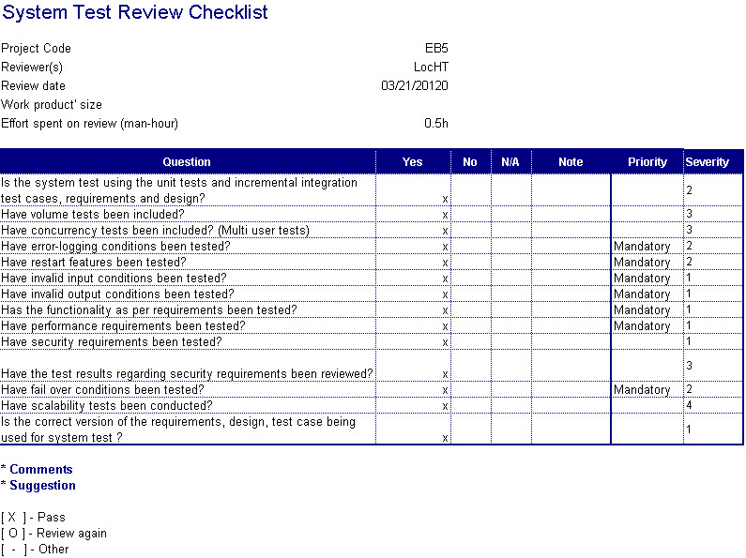

Figure : Checklists

For further information, references file Checklist\_System Test Review.xls, folder Report 5 Test case, CD Source

## Defect Log

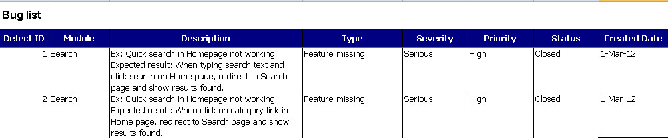

Figure : Defect Log

For further information, references file DefectLog.xls, folder Report 5 Test case, CD Source

## Other material (if any)

Reference: Standard Test Plan [www.cs.bham.ac.uk](http://www.cs.bham.ac.uk/) (updated: 21 March 2012)

# Report No.6: Software User’s Manual

## Installation Guide

### Requirements

* IIS 5.0 or above
  + References:
    - Windows Vista/7: <http://learn.iis.net/page.aspx/28/installing-iis-on-windows-vista-and-windows-7/>
    - Windows XP: <http://www.microsoft.com/resources/documentation/windows/xp/all/proddocs/en-us/iiiisin2.mspx?mfr=true>
* Server 2008: <http://learn.iis.net/page.aspx/29/installing-iis-7-and-above-on-windows-server-2008-or-windows-server-2008-r2/>
* SQL Server 2008 R2 (Express)
  + References:
    - <http://blogs.msdn.com/b/petersad/archive/2009/11/13/how-to-install-sql-server-2008-r2-express-edition-november-ctp.aspx>
    - <http://social.technet.microsoft.com/wiki/contents/articles/install-sql-server-2008-r2-express.aspx>
* .Net Framework 4.0
  + Download and install at: <http://www.microsoft.com/download/en/details.aspx?id=17851>

### Web Application Deployment

#### Create web application folder

* Create a folder for web application in IIS folder (default: C:\inetpub\wwwroot\)

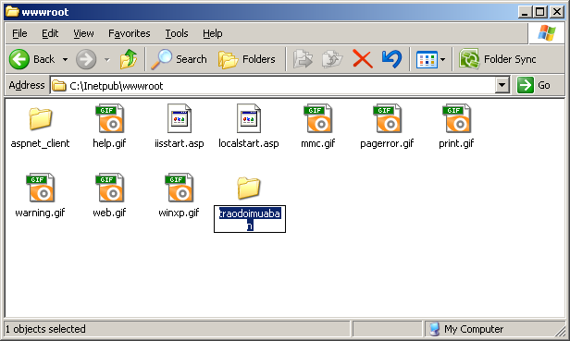

Figure : Create web app in IIS folder

* Copy deployment packet into web application folder and extract:

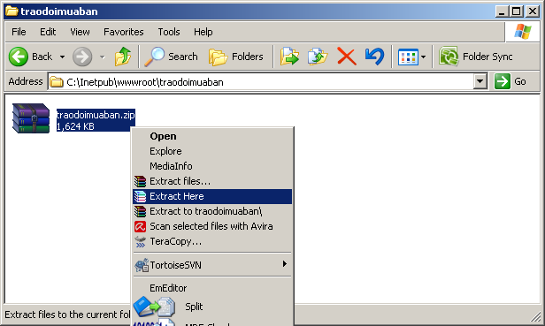

Figure : Copy deployment packet and extract

* After extraction finish, you can remove deployment packet.

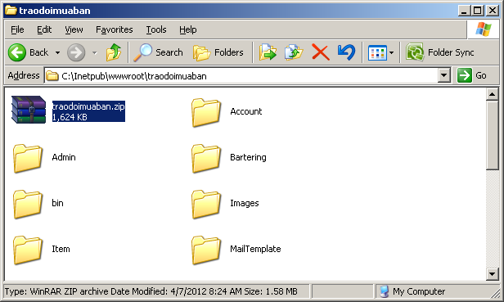

Removable

Figure : File .RAR can be removed after extracted

#### Create web application in IIS

Make sure SQL Server is installed and running. Do the following steps:

##### Windows XP (IIS 5)

* Start IIS manager: Start > Run > “inetmgr”

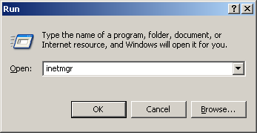

* Right click one created folder, choose Properties:

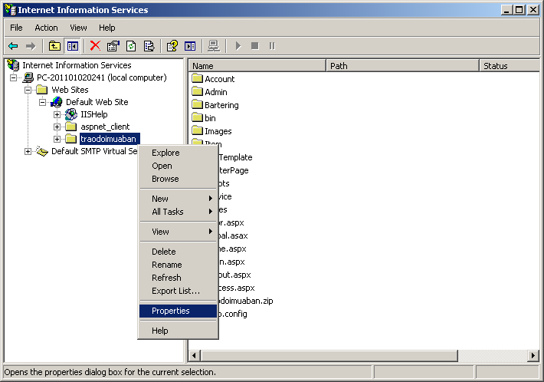

* After that click Create button within tab Directory

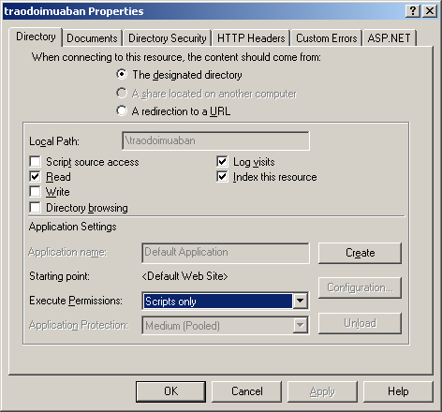

* Input the name for the web application in Application name text box

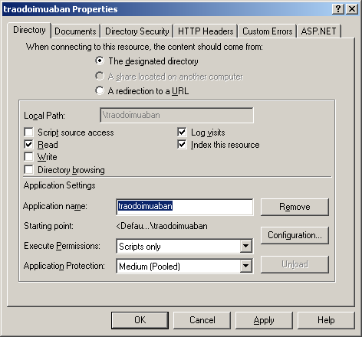

* Set default document in Documents Tab, and then click Ok.

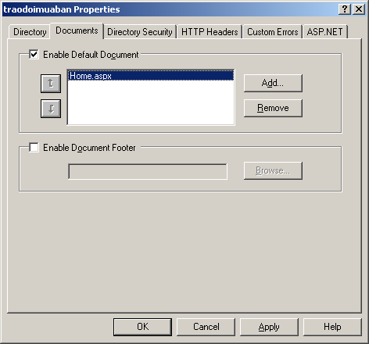

##### Windows Vista/7 and later (IIS 6, 7+)

* Start IIS manager: Start > Type “inetmgr” in the *“Search program and files*” box

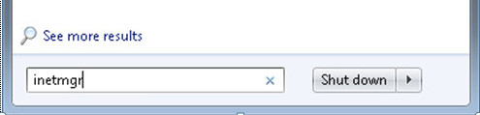

* In the Connections pane, expand the Sites node. Right-click the site for which you want to create an application, and click Add Application.

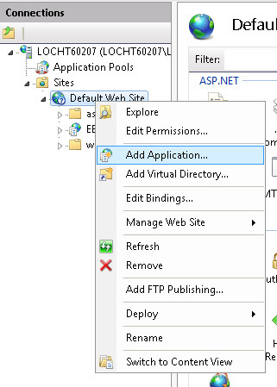

* In the **Alias** text box, type a value for the application URL, such as **E-bartering**. This value is used to access the application in a URL. In the **Physical path** text box, type the physical path of the application's folder, or click the browse button (**...**) to navigate the file system to find the folder.

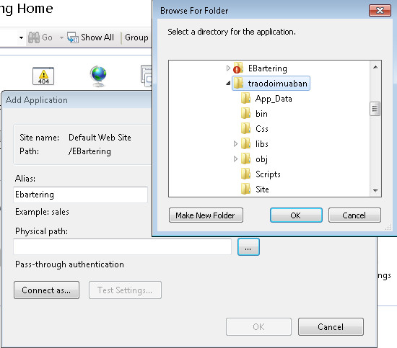

* Click **OK, then OK once more**.

#### 6.1.2. Web Application Deployment

* Go to web application folder (\traodoimuaban), open Web.config and config for the following:

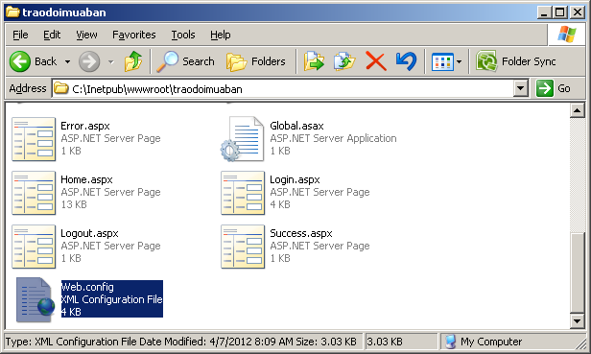

* File path and file name for log file:

|  |
| --- |
| <configuration>  …  <log4net>  <appender name="RollingFileAppender" type="log4net.Appender.RollingFileAppender">  <file value="EBartering.log"/>  … |

* Connection string:

|  |
| --- |
| <configuration>  …  <connectionStrings>  <add name="EB5ConnectionString" connectionString="Data Source=.\SQLEXPRESS;AttachDbFilename=|DataDirectory|\EB5.mdf;uid=\*\*\*;pwd=\*\*\*;Database=EB5" providerName="System.Data.SqlClient" />  …  Provide account with role sysadmin |

* Web application setting:

|  |
| --- |
| <configuration>  … <appSettings>  <!--GMail config-->  <add key="GMailServer" value="smtp.gmail.com"/>  Provide account gmail to send mail  <add key="GMailPort" value="587"/>  <add key="GmailUsername" value="\*\*\*"/>  <add key="GmailPassword" value="\*\*\*"/>  <add key="GmailFrom" value="traodoimuaban.com"/>  <!--Mail templates path-->  <add key="MailTemplate\_ActivateLink" value="~/MailTemplate/ActivateLink.txt"/>  <add key="MailTemplate\_RegisterComplete" value="~/MailTemplate/ActivateLink.txt"/>  <add key="MailTemplate\_ResetPassword" value="~/MailTemplate/ResetPassword.txt"/>  <!--Image upload config-->  <add key="UploadFolder" value="~/Uploads"/>  <add key="ThumbnailFolder" value="~/Uploads/Thumbnails"/>  <add key="UploadImageMaxWidth" value="500"/>  <add key="UploadImageMaxHeight" value="350"/>  <add key="UploadThumbnailSize" value="75"/>  <!--Comments display config-->  <add key="NumberCommentPerPage" value="5"/>  </appSettings> |

## User’s Guide

### User’s guide for guests:

#### Register

* Click on “Đăng kí” button in home page.

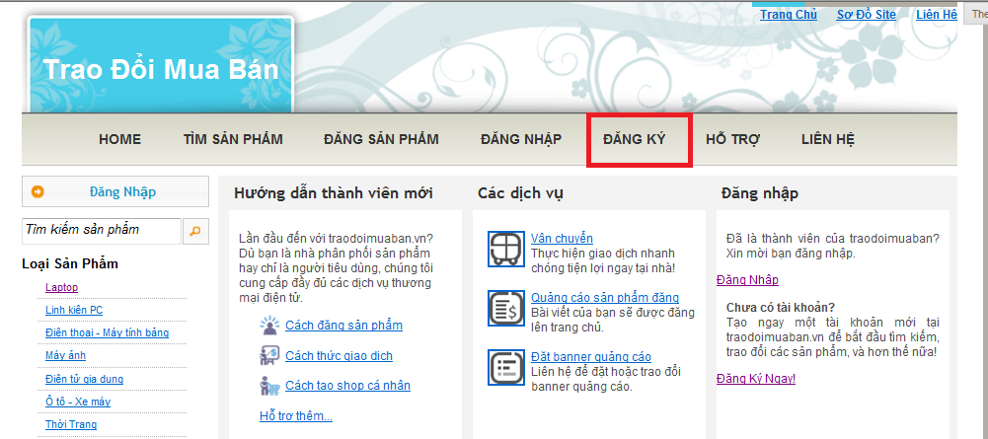

* Read the rules carefully, then tick on the check box, and click “Đăng kí” to continue.

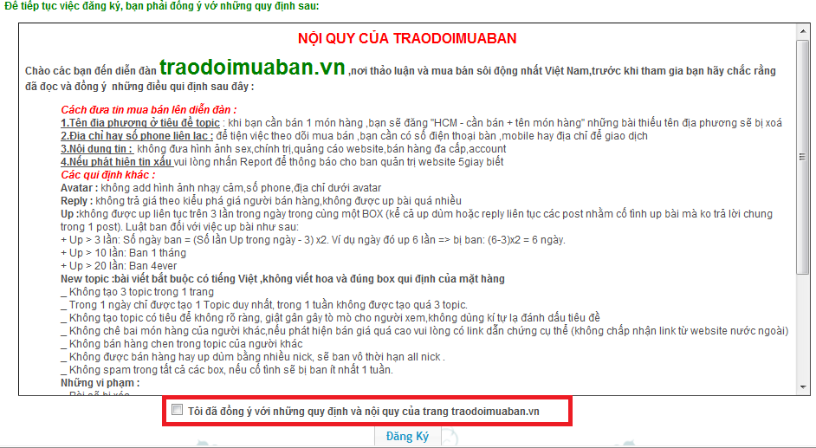

* Input the information, \* means require fields. Then click “Tạo tài khoản” to continue.

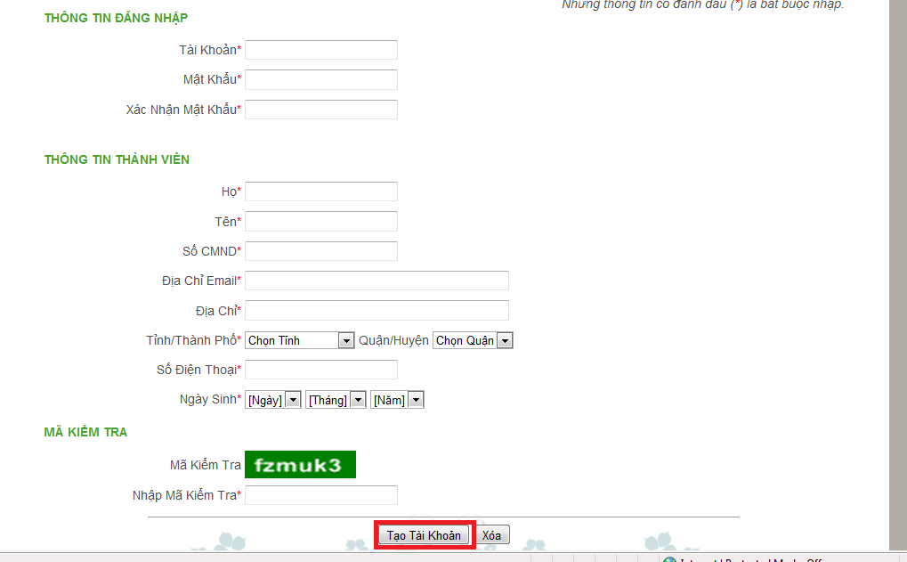

* If create new account successfully, a “Successful” page will be displayed.

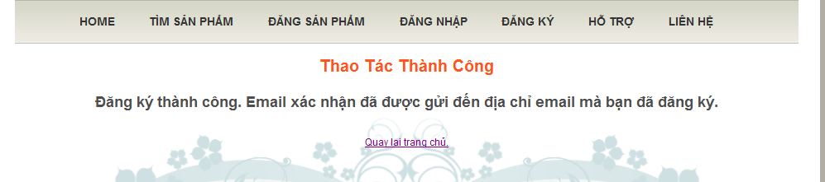

#### Quick search

* Click “Tìm sản phẩm” button on home page to go to search page.

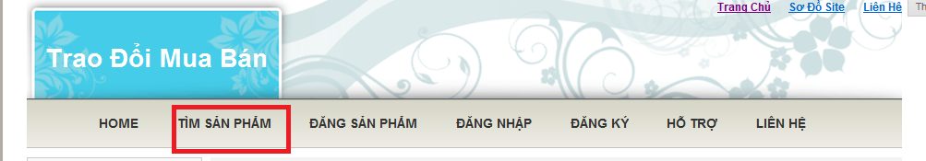

* As default, the first 10 items will be shown on the page, sorted by date.

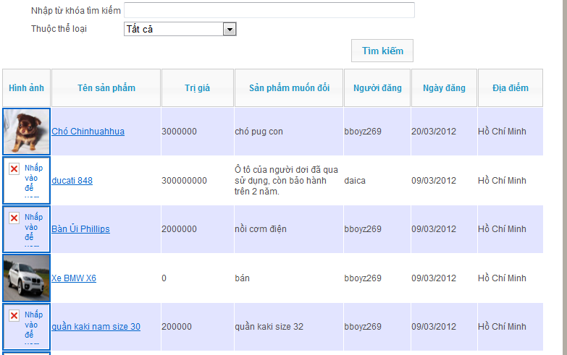

* Input keywords to search by item name or expected items, and choose a category for searching.

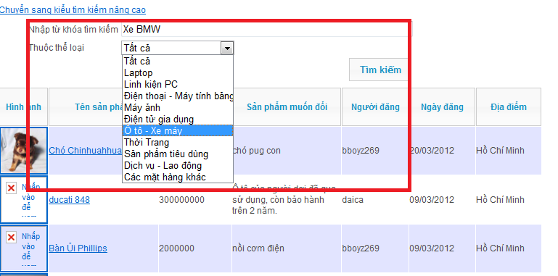

#### View item details

* Click on any item thumbnail, or item name to view item details (go to ViewItemsDetails page)

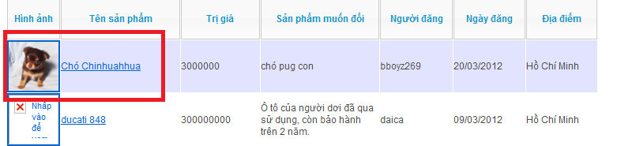

* More information of the selected item will be showed. Users have to log in to send barter request.

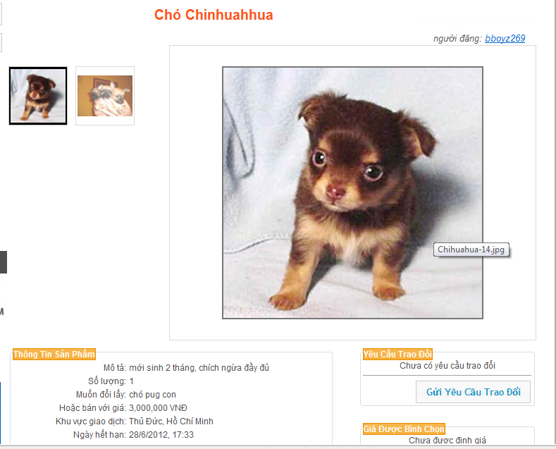

### User’s guide for members:

#### Log in/out:

* Click “Đăng nhập” button on home page.

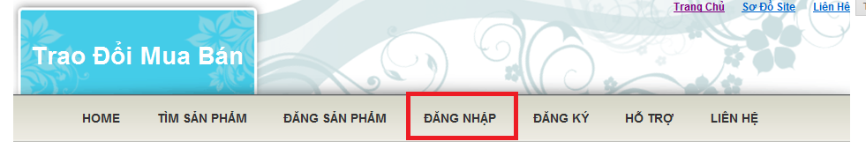

* In login page, input User ID and Password, then click “Đăng nhập” button to continue.
* Tick on “Tự động đăng nhập” to keep logging in after close browser.(Not recommend in public network)

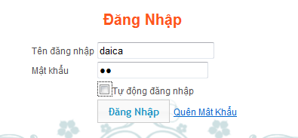

* This is the screen after user logged in the website.

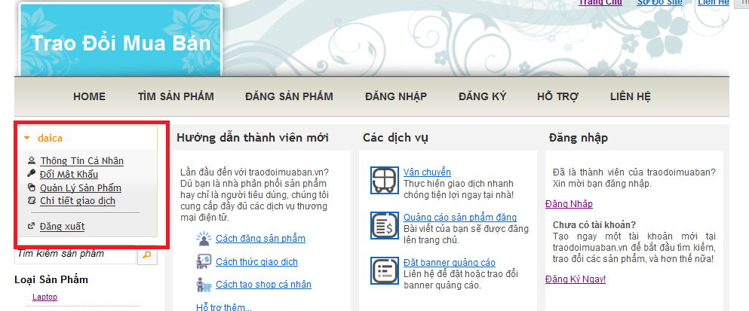

* Click on “Đăng xuất” button to log out.

#### Reset password:

* Click on “Quên mật khẩu” button.

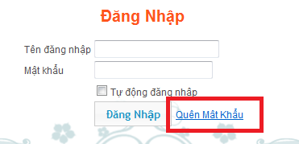

* Input registered email or User ID, then click “Nhập” button.

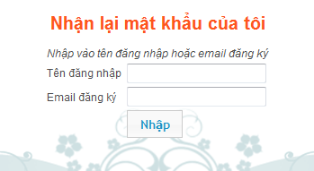

* Display successful page after input valid data.

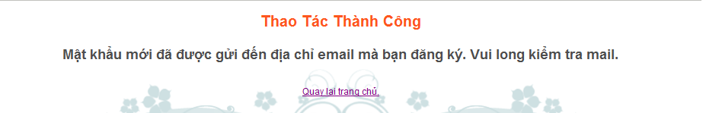

#### Advance search:

* In quick search page, click “Chuyển sang tìm kiếm nâng cao”.

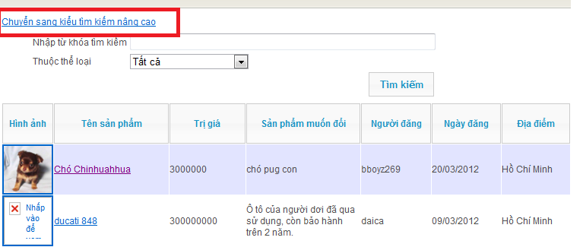

* More search conditions will appears, input/choose the conditions, and then click “Tìm kiếm” to continue searching.

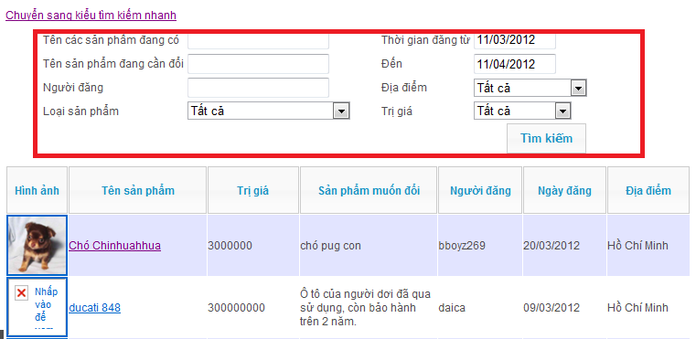

#### Private information management:

* Click on “Thông tin cá nhân” up on logging in.

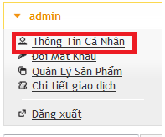

* Double click on the information to change, and then click to update.

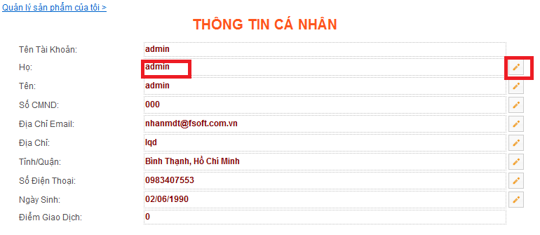

#### Change password:

* Click on “Đổi mật khẩu” after logging in.

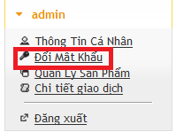

* Input required information, and then click “Đổi mật khẩu” to continue

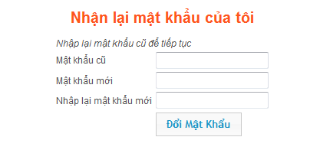

* Display successful page after input valid data.

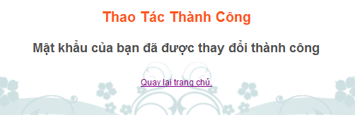

#### Post item:

* Click “Đăng sản phẩm” button on home page.

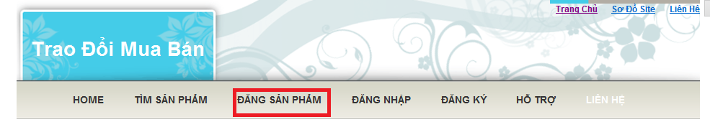

* Input required fields, and then click “Đăng sản phẩm” to continue.

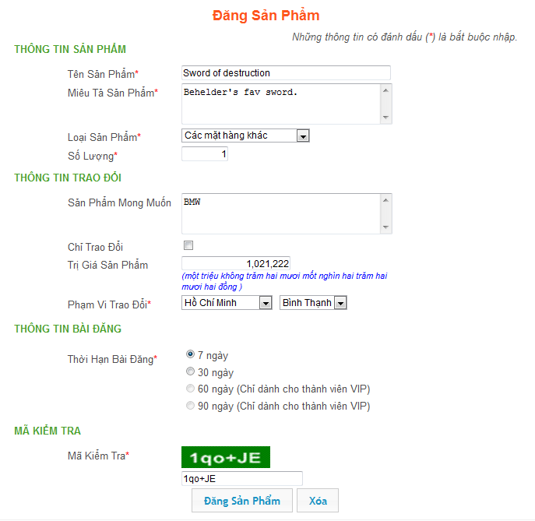

* Click “Thêm ảnh” to add more images for the item.
* After selecting all desired images, click “Bắt đầu tải lên” to upload the images.

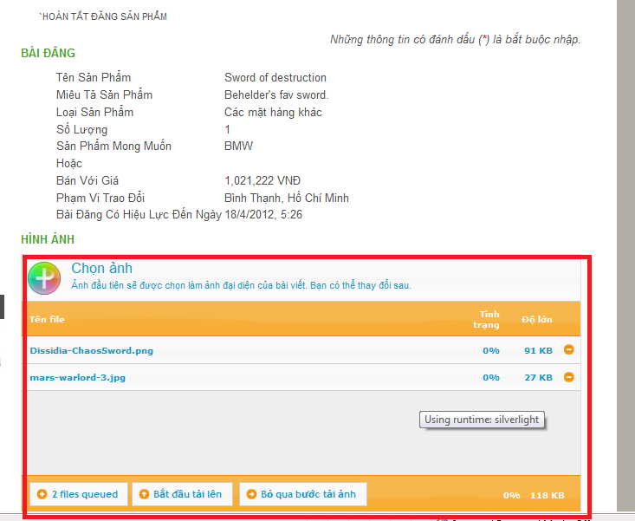

* If the image is posted successfully, a successful page will be displayed.

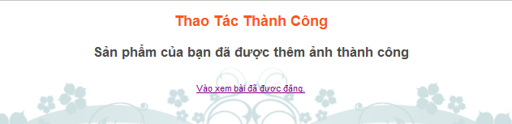

#### Item management:

* Click on “Quản lí sản phẩm” after logging in.

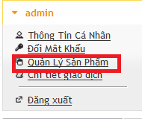

* Click to close the items, to update the item, and to make sticky request for this item.

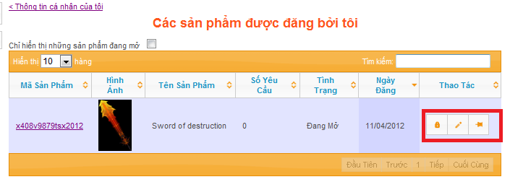

#### Close/Open item:

* Click to close the items.

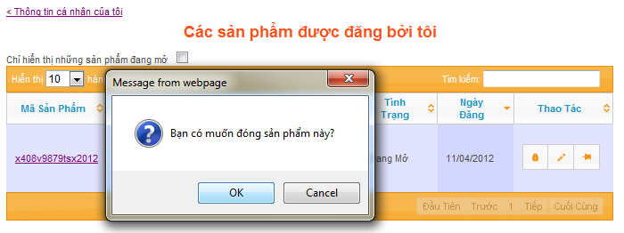

* Click to open the item.

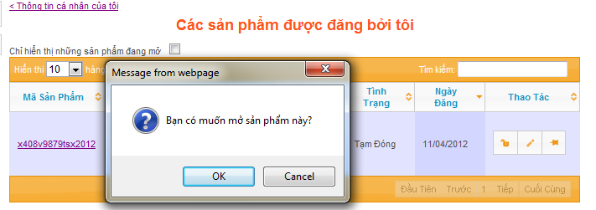

#### Update item:

* Update the information, and then click “Hoàn tất” to continue.

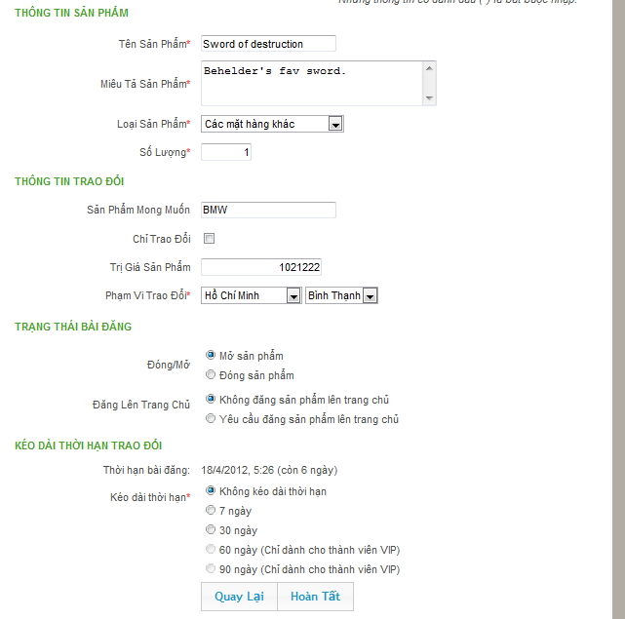

* Tick on the check boxes, then click “Lưu” to delete the images.
* Click “Up thêm hình” to add more image.

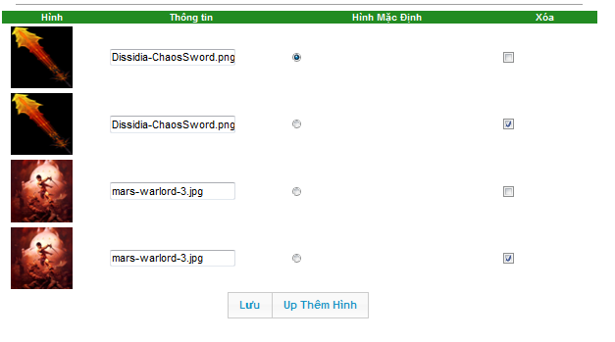

#### Transaction management:

* Click “Quản lí giao dịch” to manage barter request.

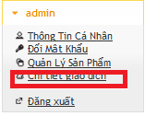

* Click the barter request on the left column to view details.

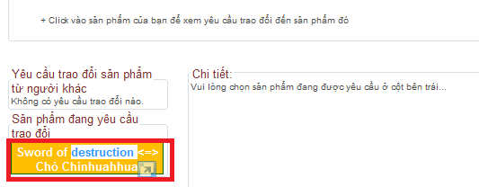

#### Evaluate price:

* In view item details page, click on “Bình chọn giá” to give suggested price for the item.

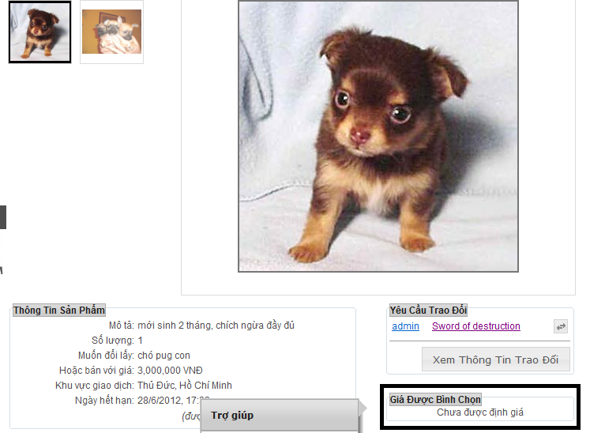

* Input the evaluate price, then click “Bình chọn” button.

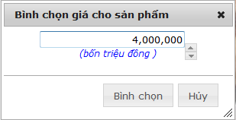

* A confirm box will be showed, after click “Bình chọn” button, a successful page will be showed.

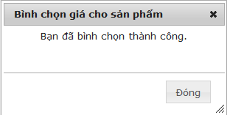

#### Add comments:

* In view item details page, input the comments, then click “Gửi” to add comment for the item.

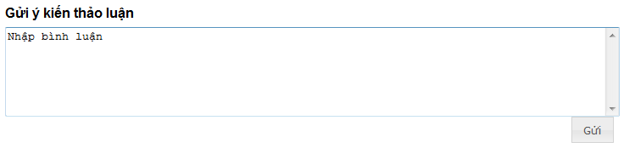

#### Create barter request:

* In view item details page. Click “Gửi yêu cầu trao đổi” to continue.

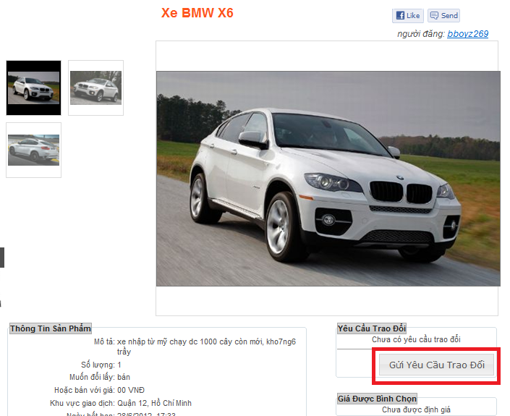

* Click to choose one item to barter, input the required information, then click “Yêu cầu trao đổi” to continue.

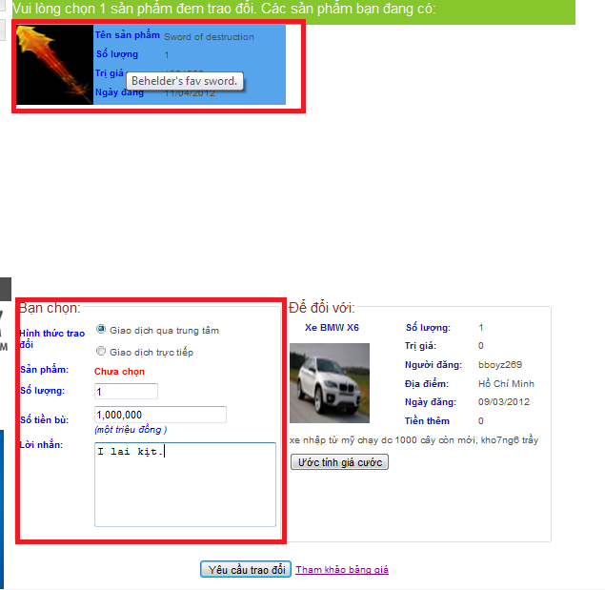

* If create barter request successfully, a message box will be displayed.

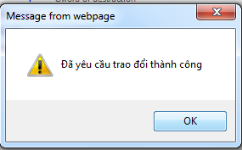

* Click “Ước tính giá cước” to see the estimated shipping fee.

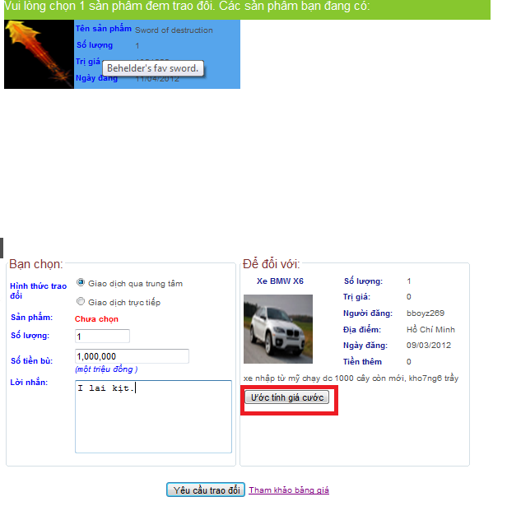

* A pop-up will be displayed, show the shipping fee of selected item follow its category.

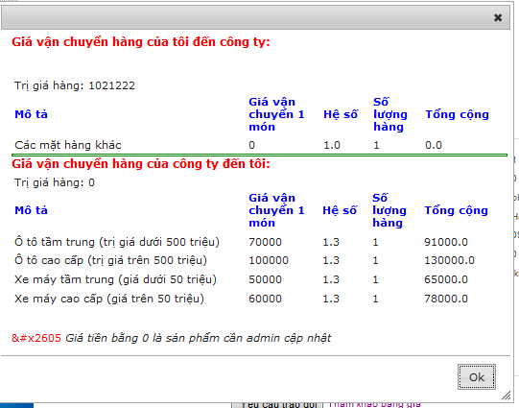

* Click on link “Tham khảo bảng giá” to see the estimated shipping fee for all item’s category.

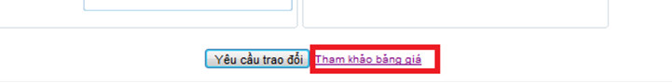

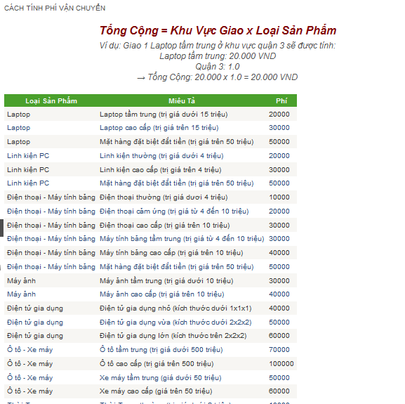

### User’s guide for admin:

#### Login/out:

In admin page, input User ID and password, then click “đăng nhập” to login.

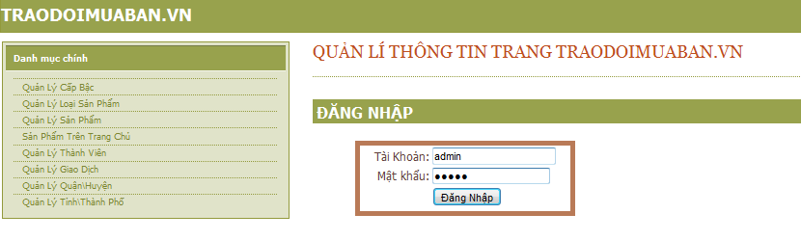

#### Role management

* Click on “Quản lí cấp bậc” in admin page to continue.

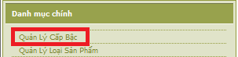

* Click Edit to update the roles, click “Thêm mới” to add new roles.

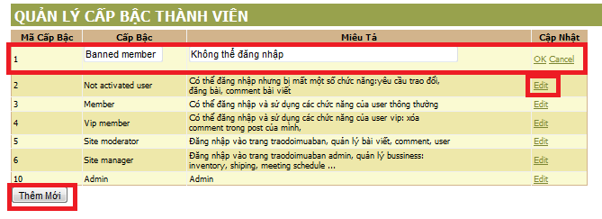

#### Category management:

* Click on “Quản lí loại sản phẩm” in admin page to continue.

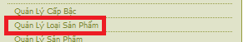

* Click Edit to update the category, click “Thêm mới loại sẩn phẩm” to add new category.

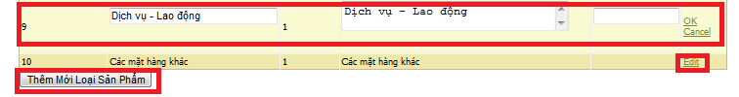

#### Item management:

* Click on “Quan lí sản phẩm” in admin page to continue.

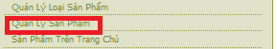

* Click “Đóng” to close item as admin role.



#### Item management:

* Click on “Sản phẩm trên trang chủ” in admin page to continue.

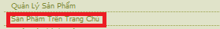

* Tick on “Hiển thị sản phẩm hết hạn” to filter expire items, type the item name on “Tìm kiếm” text box to search for specific items, click “Cập nhật” to update the expire date for 1 item.

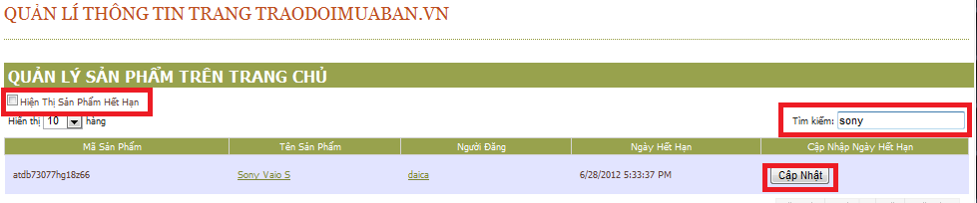

#### Users account management:

* Click “Quản lí thành viên” on admin page to continue.

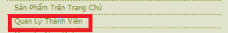

* Type user account ID into “Tìm kiếm” text box to search for specific user IDs.

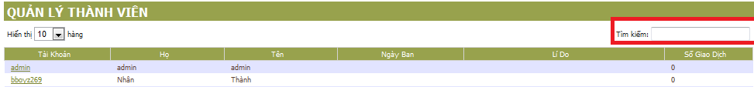

#### District management:

* Click “Thêm mới quận/huyện” to continue.
* Choose one city to view the districts. Click “Thêm mới Quận/Huyện” to add new districts.

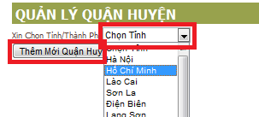

Click Edit to update district information.

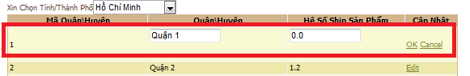

#### Province management:

* Click “Thêm mới tỉnh/thành phố” in admin page to continue.
* Type into “Tìm kiếm” textbox to search for specifics provinces. Click “Thêm mới Tình/Thành phố” to add more provinces.

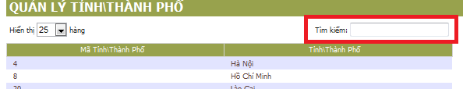

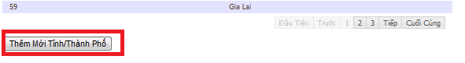

#### Manage transaction

* Click “Quản lý giao dịch” on menu bar in admin page to continue.

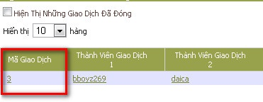

* Click on transaction code to view and modify information of transaction.
* Click on button “Chỉnh sửa”, then Edit and press Ok to save to Database.
  + Transaction status includes “Đang giao dịch”, “Đã hoàn tất”, “Hủy”.
  + Barterer’ status includes “Chờ công ty lấy hàng”, “Công ty đã lấy hàng”, “Chờ công ty giao hàng”, “Công ty đã giao hàng”, “Hủy”

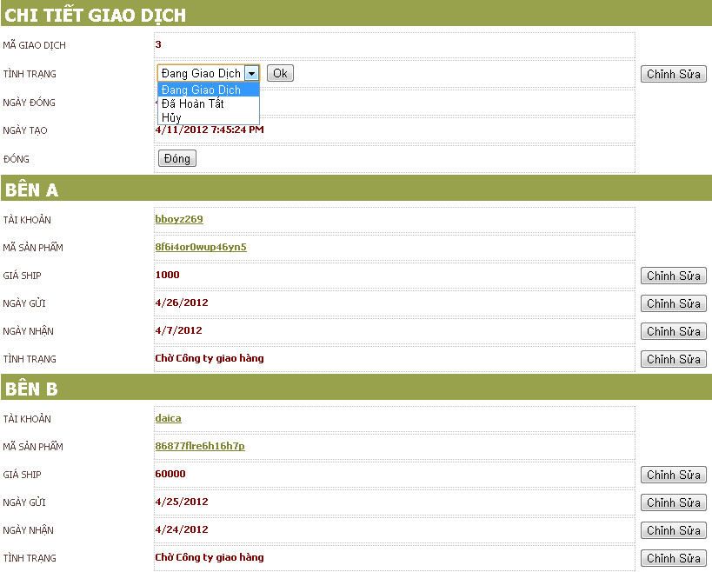

#### Manage Inventory

* Click on “Quản lý nhận sản phẩm” on menu bar.
* Click button “Nhận sản phẩm” and input data to insert new items that company’s keeping.

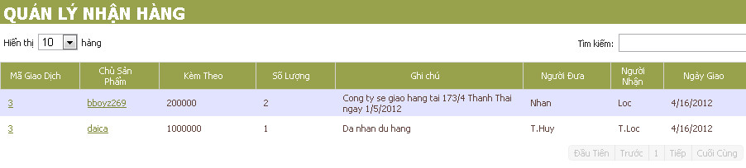

1. Including required deliverables and delivery time, if applicable [↑](#footnote-ref-1)